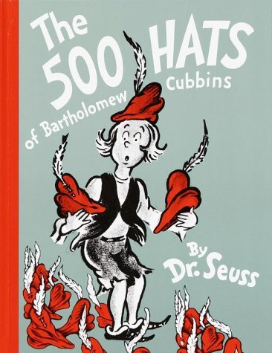
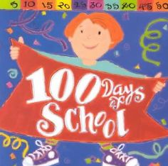
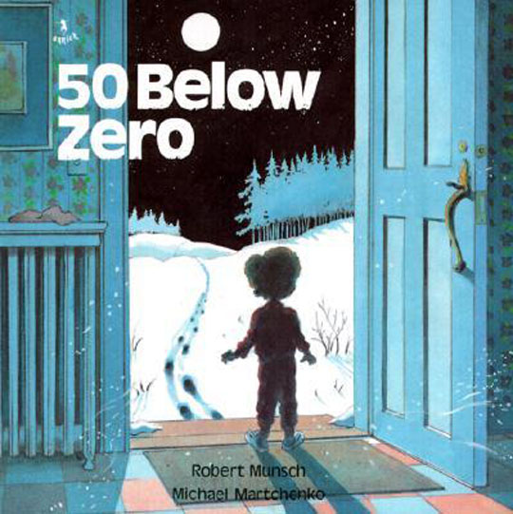
Reading Counts quiz titles. Blue titles are series books.
Call #: FIC = Fiction. E = Everybody (picture books) # = Nonfiction L = Language

TITLE - in alphabetical order | AUTHOR | CALL # | READING LEVEL | POINTS
4 Pups and a Worm | Seltzer, Eric | E SEL | 1.5 | 1
50 below zero | Munsch, Robert | E MUN | 3.1 | 2
100 days of school | Harris, Trudy | E 100 | 2.2 | 1
500 Hats of Bartholomew Cubbin | Seuss, Dr. | E SEU | 3.7 | 3
20,000 leagues under the sea | Verne, Jules | FIC VER | 8.1 | 23

A
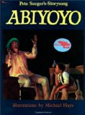
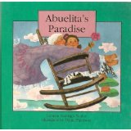
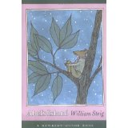
Reading Counts quiz titles. Blue titles are series books.
Call #: FIC = Fiction. E = Everybody (picture books) # = Nonfiction
“A” titles Back to top | AUTHOR | CALL # | READING LEVEL |  | POINTS
A. Lincoln and me | Bordon, Louise | E BOR | 2.7 |  | 2
Abel’s Island | Steig, William | FIC STE | 5.5 |  | 5
Abiyoyo | Seeger, Pete | 398.2 ABI | 3.2 |  | 2
Abraham Lincoln | D’Aulaire, Ingri | 921 LIN | 4.9 |  | 3
Abran paso a los patitos | McCloskey | L E MCC | 2.0 |  | 2
Abuela | Dorros, Arthur | E DOR | 3.5 |  | 2
Abuelita’s Paradise | Nodar, Carmen | E NOD | 4.1 |  | 2
Across the Stream | Ginsburg, Mirra | E GIN | 1.2 |  | 1
Adaline Falling Star | Osborne, Mary P | FIC OSB | 4.1 |  | 8
Adam of the Road | Gray, Elizabeth | FIC GRA | 5.9 |  | 12
Addie's Bad Day | Robins, Joan | E ROB | 1.5 |  | 1
Addy's Little Brother | Porter, Connie | FIC TRI | 4.1 |  | 3
Adventures Of Capt. Underpants | Pilkey, Dav | FIC PIL | 3.5 |  | 3
Adventures of Hucklebery Finn | Twain, Mark | FIC TWA | 5.9 |  | 24
Adventures of Marco Polo | Wiesmuller, D | E WIE | 2.8 |  | 2
Adventures of Tom Sawyer, The | Twain, Mark | FIC TWA | 5.9 |  | 15
Aekyung's Dream | Paek, Min | L FIC PAE | 3.4 |  | 2
After the Rain | Mazer, Norma | FIC MAZ | 4.7 |  | 14
Afternoon of the Elves | Lisle, Janet T | FIC LIS | 5.1 |  | 8
Again, Josefina! | Tripp, Valerie | FIC TRI | 4.1 |  | 3
Aggie's Home | Nixon, Joan L | FIC NIX | 3.9 |  | 5
Ah, Music | Aliki | 780 ALI | 3.1 |  | 2
Aida | Price, Leontyne | 782.1 PRI | 5.9 |  | 3
Air Pollution | Donald, Rhonda | 363.739 | 5.3 |  | 3
Akhenaten Adventure | Kerr, P. B. | FIC KER | 6.5 |  | 21
Akiak | Blake, Robert J. | E BLA | 2.9 |  | 2
Alabama | Davis, Lucile | 976.1 DAV |  | 9.0 | 6
Alaska (America the Beautiful) | Walsh, Donna | 979.8 WAL |  | 8.5 | 6
Albert | Napoli, Donna J | E NAP |  | 2.3 | 2
Albert the Albatross | Hoff, Syd | E HOF |  | 2.1 | 1
Alexander & the Wind-Up Mouse | Lionni, Leo | E LIO |  | 4.7 | 2
Alexander And-Terrible…Day | Viorst, Judith | E VIO |  | 3.9 | 2
Alexander Who Used to be Rich | Viorst, Judith | E VIO |  | 3.5 | 2
Alexander Who's Not Going to get up | Viorst, Judith | E VIO |  | 3.7 | 2
Alexander Graham Bell | MacLeod, Elizab | 921 GRA |  | 5.9 | 3
Alice the Fairy | Shannon, David | E SHA |  | 2.1 | 1
Alice’s Adventures in Wonderland | Carroll, Lewis |  |  | 6.1 | 12
Aliens Don’t Wear Braces | Dadey, Debbie | FIC DAD |  | 3.5 | 3
All About Deer | Arnosky, Jim | 599.73 ARN |  | 5.6 | 2
All About Frogs | Arnosky, Jim | 597.8 ARN |  | 3.9 | 2
All About Money | Roberson, Erin | 332.4 ROB |  | 2.2 | 1
All Kinds of Families | Simon, Norma | 301.42 SIM |  | 2.9 | 2
All Pigs Are Beautiful | King-Smith, D | E KIN |  | 4.9 | 2
All the Colors of the Earth | Hamanaka, S | E HAM |  | 3.1 | 1
All the Stars in the Sky: The Santa Fe | McDonald, M | FIC McD |  | 5.5 | 10
Alphabatics | MacDonald, Sus | E MAC |  | 1.1 | 1
Alphabet City | Johnson, Stephe | 411 JOH |  | 1.5 | 1
Always room for one more | Leodhos, S Nic | 398.8 NIC |  | 3.9 | 1

Amazing Bone | Steig, William | FIC STE | 3.8 | 2
Amazing Gorillas! | Thomson, Sarah | 599.88 THO | 3.7 | 1
Amazing Grace | Hoffman, Mary | E HOF | 4.1 | 2
Amazing Life-Benjamin Franklin | Giblin, James C | 921 FRA | 5.8 | 4
Amazing Whales | Thomson, Sarah | 599.5 THO | 3.4 | 1
Amber Brown is not a crayon | Danziger, Paula | FIC DAN | 3.8 | 3
Amber Brown is Feeling Blue | Dansiger, Paula | FIC DAN | 3.9 | 3
Amber on the Mountain | Johnston, Tony | E JOH | 4.3 | 2
Amelia & Eleanor go for a ride | Ryan, Pam M | E RYA | 3.4 | 2
Amelia Bedelia | Parish, Peggy | E PAR | 2.5 | 1
Amelia Bedelia goes camping | Parish, Peggy | E PAR | 1.5 | 1
Amelia Bedelia’s Family Album | Parish, Peggy | E PAR | 2.5 | 2
America's champion swimmer | Adler, David A. | 797.2 ADL | 3.4 | 2
American Eagle | Wilson, Jon | 306.4 WIL | 4.2 | 2
Among the Hidden | Haddix, Margare | FIC HAD | 5.9 | 8
Among the Betrayed | Haddix, Margare | FIC HAD | 5.9 | 10
Among the Imposters | Haddix, Margare | FIC HAD | 5.2 | 10
Among the Barons | Haddix, Margare | FIC HAD | 5.7 | 10
Among the Enemy | Haddix, Margare | FIC HAD | 5.5 | 12
Amos and Boris | Steig, William | E STE | 3.7 | 2
Amos Fortune, Free Man | Yates, Elizabeth | 921 FOR | 5.8 | 9
Amos gets famous | Paulsen, Gary | FIC PAU | 4.5 | 3
Anansi the Spider | McDermott, G | E MCD | 3.2 | 1
Anastasia Again | Lowry, Lois | Fic LOW | 4.9 | 7
Anastasia on her own | Lowry, Lois | Fic LOW | 5.4 | 9
Anastasia, ask your analyst | Lowry, Lois | Fic LOW | 5.9 | 5
Ancient Cliff Dwellers Of... | Arnold, Caroline | 978.8 ARN | 6.3 | 3
Ancient Egypt | Haslam, Andrew | 932 HAS | 6.2 | 3
Ancient Egyptians | Kerr, Daisy | 932 KER | 3.6 | 2
Ancient Romans | Kerr, Daisy | 937 KER | 3.5 | 2
Ancient Rome and Pompeii (MTH) | Osborne, Mary P | 937 OSB | 4.3 | 4
And Now Miguel | Krumgold, Josep | FIC KRU | 6.6 | 14
And the Dish Ran Away With the Sp. | Stevens, Janet | E STE | 2.5 | 2
And then what happened Paul Revere | Fritz, Jean | 921 REV | 4.1 | 3
And to think that I saw it on Mulberry | Seuss, Dr. | E SEU | 3.2 | 2
Andrew’s Loose Tooth | Munsch, Robert | E MUN | 2.8 | 2
Andy and the Lion | Daugherty, Jame | E DAU | 3.1 | 1
Andy Shane & the very bossy... | Jacobson, Jenni | E JAC | 3.3 | 2
Angel child, dragon child | Surat, Michele | E SUR | 2.8 | 2
Angela’s Airplane | Munsch, Robert | E MUN | 2.5 | 2
Angels Don’t Know Karate | Dadey, Debbie | FIC DAD | 2.6 | 3
Animal Ark: Cat in the Crypt | Baglio, Ben M. | FIC BAG | 4.1 | 7
Animal Ark: Cats at the Campgrd | Baglio, Ben M. | FIC BAG | 4.1 | 7
Animal Ark: Goat in the Garden | Baglio, Ben M. | FIC BAG | 3.8 | 6
Animal Ark: Goose on the Loose | Baglio, Ben M. | FIC BAG | 4.5 | 7
Animal Ark: Hound at the Hospital | Baglio, Ben M. | FIC BAG | 4.2 | 7
Animal Ark: Husky in a Hut | Baglio, Ben M. | FIC BAG | 4.1 | 7
Animal Ark: Lamb in the Laundry | Baglio, Ben M. | FIC BAG | 4.1 | 7
Animal Ark: Pony on the Porch | Baglio, Ben M. | FIC BAG | 4.5 | 5
Animal Ark: Puppy in a Puddle | Baglio, Ben M. | FIC BAG | 4.2 | 7
Animal Fact/Animal Fable | Simon, Seymour | 591 SIM | 3.6 | 3
Animals of the Sea and Shore | Squire, Ann | 591.769 | 4.9 | 3
Animals should not wear clothing | Barrett, Judi | E BAR | 2.8 | 1
Animorphs: Change, The | Applegate, K. A. | FIC APP | 5.2 | 9
Animorphs: Encounter | Applegate, K. A. | FIC APP | 5.2 | 8
Animorphs: Extreme, The | Applegate, K. A. | FIC APP | 5.5 | 8
Animorphs: Forgotten, The | Applegate, K. A. | FIC APP | 5.2 | 9
Animorphs: Hork-Bajir Chronicles | Applegate, K. A. | FIC APP | 5.2 | 10
Animorphs: Invasion | Applegate, K. A. | FIC APP | 5.1 | 10
Animorphs: Message, The | Applegate, K. A. | FIC APP | 5.3 | 8
Animorphs: Predator, The | Applegate, K. A. | FIC APP | 5.1 | 8
Animorphs: Reaction, The | Applegate, K. A. | FIC APP | 5.3 | 8
Animorphs: Reunion, The | Applegate, K. A. | FIC APP | 5.4 | 8
Animorphs: Solution, The | Applegate, K. A. | FIC APP | 5.3 | 8
Animorphs: Suspicion, The | Applegate, K. A. | FIC APP | 5.3 | 8
Animorphs: Visitor | Applegate, K. A. | FIC APP | 5.2 | 9
Anna Banana and Me | Blegvad, Lenore | E BLE | 2.9 | 2
Anne of Green Gables | Montgomery, L. | FIC MON | 5.9 | 22
Annie and the Old One | Miles, Miska | FIC MIL | 3.2 | 2
Annie and the Wild Animals | Brett, Jan | E BRE | 2.5 | 1
Ant and the elephant, The | Peet, Bill | E PEE | 3.9 | 2
Ant Cities | Dorros, Arthur | 595.79 DOR | 3.1 | 2
Ants and other insects | Schulte, Mary | 595.7 | 1.6 | 1
Apples, and pumpkins | Rockwell, Anne | E ROC | 2.7 | 1
Apples, apples, apples | Wallace, Nancy | E WAL | 1.9 | 2
Apprenticeship of Lucas... | DeFelice, Cynth | FIC DEF | 5.5 | 7
Are You My Mother? | Eastman, P.D. | E EAS | 1.5 | 1
Armadillo From Amarillo, The | Cherry, Lynne | E CHE | 4.4 | 2
Arnie and the new kid | Carlson, Nancy | E CAR | 1.8 | 1
Around the World in 80 Days | Verne, Jules | FIC VER | 8.5 | 15
Arrow to the Sun | McDermott, Ger | 291.2 MCD | 2.6 | 1
Art Lesson, The | dePaola, Tomie | E DEP | 2.5 | 2
Art of keeping cool | Lisle | Fic Far | 5.3 | 12
Artemis Fowl | Colfer, Eoin | FIC COL | 6.2 | 14
Artemis Fowl: Arctic Incident | Colfer, Eoin | FIC COL | 6.2 | 15
Artemis Fowl: The Lost Colony | Colfer, Eoin | FIC COL | 6.2 | 20
Artemis Fowl Eternity Code | Colfer, Eoin | FIC COL | 6.2 | 17
Artemis Fowl Opal Deception | Colfer, Eoin | FIC COL | 6.2 | 18
Artemis Fowl File, The | Colfer, Eoin | FIC COL | 5.6 | 9
Arthur & Scare-Your-Pants-Off | Brown, Marc | FIC BRO | 3.5 | 3
Arthur and the True Francine | Brown, Marc | E BRO | 2.4 | 1
Arthur Babysits | Brown, Marc | E BRO | 2.7 | 2
Arthur Goes to Camp | Brown, Marc | E BRO | 2.7 | 2
Arthur Meets the President | Brown, Marc | E BRO | 3.2 | 2
Arthur Tricks the Tooth Fairy | Brown, Marc | E BRO | 1.9 | 1
Arthur’s April Fool | Brown, Marc | E BRO | 3.1 | 2
Arthur’s Baby | Brown, Marc | E BRO | 2.5 | 1
Arthur’s Birthday | Brown, Marc | E BRO | 2.7 | 2
Arthur’s Chicken Pox | Brown, Marc | E BRO | 2.5 | 2
Arthur’s Computer Disaster | Brown, Marc | E BRO | 2.2 | 2
Arthur’s Eyes | Brown, Marc | E BRO | 2.2 | 1
Arthur’s Family Vacation | Brown, Marc | E BRO | 3.3 | 2
Arthur’s First Sleepover | Brown, Marc | E BRO | 2.4 | 2
Arthur’s Halloween | Brown, Marc | E BRO | 2.5 | 2
Arthur’s New Puppy | Brown, Marc | E BRO | 2.5 | 2
Arthur’s Nose | Brown, Marc | E BRO | 2.3 | 1
Arthur’s Pet Business | Brown, Marc | E BRO | 2.5 | 2
Arthur’s Teacher Trouble | Brown, Marc | E BRO | 3.8 | 2
Arthur’s Thanksgiving | Brown, Marc | E BRO | 2.5 | 2
Arthur’s Tooth | Brown, Marc | E BRO | 2.5 | 2
Arthur’s TV Trouble | Brown, Marc | E BRO | 2.5 | 2
Arthur’s Valentine | Brown, Marc | E BRO | 2.6 | 1
Arthur: Buster’s Dino Dilemma | Brown, Marc | FIC BRO | 4.2 | 3
Ashanti to Zula: African... | Musgrove, Marg | 960 MUS | 5.3 | 2
Ask Nurse Pfaff, She'll help... | Flanagan, Alice | 371.42 FLA | 3.3 | 1
Atalanta's Race: A Greek Myth | Climo, Shirley | 398.21 CLI | 4.1 | 3
Attack of the Jack-O'Lantern | Stine, R. L. | FIC STI | 4.1 | 6
Attention Deficit Disorder | Silverstein, Dr. | 618.92 | 4.5 | 3
Aunt Chip–Triple Creek Dam | Polacco, Patricia | E POL | 3.5 | 2
Aunt Flossie's Hats & Crab... | Howard, Elizabe | E HOW | 3.6 | 2
(Postcards from) Australia | Arnold, Helen | 994 ARN | 3.3 | 2
Autobus magico: mariposa y el mo... | Cole, Joanna | L E COL | 3.8 | 3
Autobus magico va contra la corri... | Cole, Joanna | L E COL | 3.8 | 3
Autobus magico: se salpica todo... | Cole, Joanna | L E COL | 3.1 | 2
Autobus magico: muestra y cuenta... | Cole, Joanna | L E COL | 3.4 | 3
Autobus magico: en el cuerpo de Ra.. | Cole, Joanna | L E COL | 3.2 | 2

B
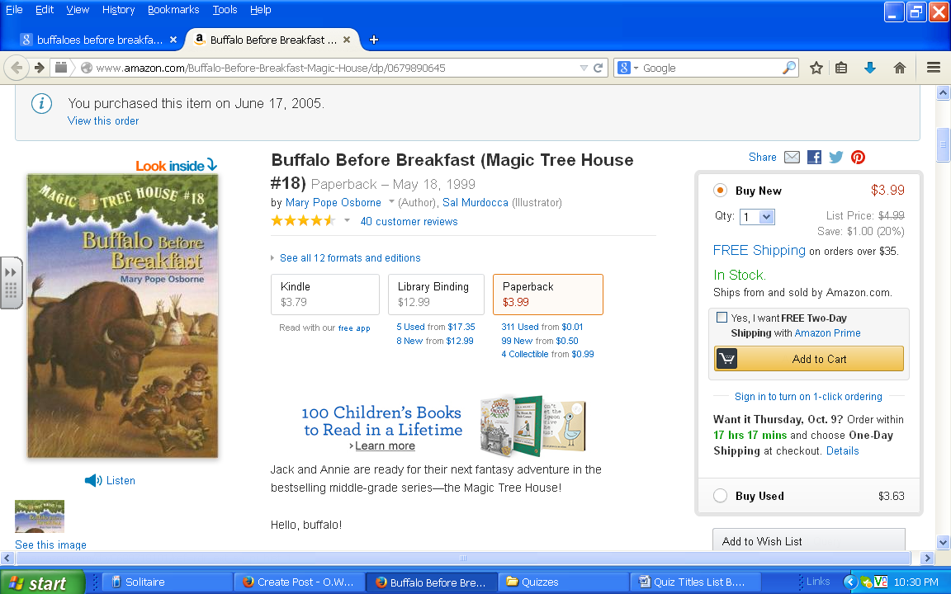
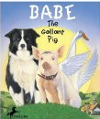
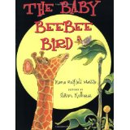
Reading Counts Quiz Titles B titles in blue are series
Call #: FIC = Fiction E = Everybody (Picture books) # = Nonfiction L = Language
"B" titles Back to top | AUTHOR | CALL # | READING LEVEL | POINTS
Babe and I, The | Adler, David | E ADL | 3.5 | 1
Babe, the Gallant Pig | King-Smith | FIC KIN | 5.8 | 6
Baboushka and the Three Kings | Robbins, R | E ROB | 4.5 | 2
Babushka Baba Yaga | Polacco, P | E POL | 4.5 | 2
Baby Alligator | Clarke, | 597.98 CLA | 2.1 | 2
Baby Beebee Bird, The | Massie, D | E MAS | 1.9 | 1
Bad Beginning, The | Snicket, L | FIC SNI | 6.1 | 7
Bad Case of Stripes, A | Shannon, D | E SHA | 3.5 | 2
Backyard Detective: Critters... | Bishop, Nic | 591.75 BIS | 4.5 | 3
Bad Kitty | Bruel, Nick | E BRU | 1.4 | 1
Bailey Goes Camping | Henkes, K | E HEN | 1.8 | 1
Ballot box battle, The | McCully, E | 921 STA | 3.6 | 2
Baloney, Henry P. | Scieszka, Jon | E SCI | 2.9 | 1
Band Of Angels, A | Hopkinson, D | FIC HOP | 3.6 | 3
Banner in the Sky | Ullman, James | FIC ULL | 6.3 | 16
Barefoot: Escape on the Underground Railroad | Edwards, Pamela | E EDW | 4.2 | 2
GooseBumps: Barking Ghost, | Stine, R. L. | FIC STI | 4.2 | 6
Bartholomew and the Oobleck | Seuss, Dr. | E SEU | 3.7 | 3
Baseball Fever | Hurwitz, Johanna | FIC HUR | 5.1 | 4
Basho and the river stones | Myers, Tim | E BAS
Bat Loves The Night | Davies, Nicola | E DAV | 2.5 | 2
Batallas del cuerpo, Las (spanish: Battle of the Body) | Gelman, Rita | L 611 GEL | 2.6 | 2
Bats at the beach | Lies, Brian | E BRI | 1.5 | 1
Battle of the Labyringh, The | Riordan, Rick | FIC RIO | 3.0 | 21
Be ready at eight | Parish, Peggy | E PAR | 2.2 | 2
Bear Called Paddington, A | Bond, Michael | FIC BON | 5.7 | 5
Bear stays up for Christmas | Wilson, Karma | 394.2 CHR | 2.2 | 1
Bears on Hemlock Mountain, The | Dalgliesh, Alice | E DAL | 3.5 | 2
Bears on wheels/counting bk | Berenstain, Stan | E BER | 1.2 | 1
Beatrice doesn't want to | Numeroff, Laura | E NUM | 1.2 | 1
Beauty and the beast | Brett, Jan | 398.2 BRE | 3.9 | 5
Because of Winn-Dixie | DiCamillo, Kate | FIC DIC | 4.1 | 7
Becoming Naomi Leon | Ryan, Pam M | FIC RYA | 5.0 | 11
Bed-Knob and Broomstick | Norton, Mary | FIC NOR | 5.4 | 8
Bedhead | Palatini, Margie | E PAL | 2.4 | 2
Bee My Valentine | Cohen, M | E COH | 2.8 | 2
Bee-Bim Bop | Park, Linda | E PAR | 1.8 | 1
Bee Tree, The | Polacco, Patricia | E POL | 4.6 | 2
Beethoven Lives Upstairs | Nichol, Barbara | E NIC | 4.8 | 3
Beezus and Ramona | Cleary, Beverly | FIC CLE | 4.8 | 5
Belle Prater’s Boy | White, Ruth | FIC WHI | 5.5 | 8
Ben and Me | Lawson, Robert | FIC LAW | 4.5 | 3
Ben’s Trumpet | Isadora, Rachel | E ISA | 3.6 | 1
Bengal Tiger | Eckart, Edana |  | 1.7 | 1
Berenstain B: Bermuda Triangle | Berenstain, Stan | E BER | 3.5 | 3
Berenstain B: Comic Valenti | Berenstain, Stan | E BER | 3.5 | 2
Berenstain B: Bad Dream | Berenstain, Stan | E BER | 2.9 | 2
Berenstain B: Bad Habit | Berenstain, Stan | E BER | 3.2 | 2
Berenstain B: Blame Game | Berenstain, Stan | E BER | 4.2 | 2
Berenstain B: Double Dare | Berenstain, Stan | E BER | 3.1 | 2
Berenstain B: Forget their manners | Berenstain, | E BER | 3.1 | 2
Berenstain B: Homework | Berenstain, Stan | E BER | 3.5 | 2
Berenstain Bears: In Crowd | Berenstain, Stan | E BER | 3.8 | 2
Berenstain B: Mama's new job | Berenstain, Stan | E BER | 3.3 | 2
Berenstain B: Messy Room | Berenstain, Stan | E BER | 3.7 | 2
Berenstain B: Missing Dinos | Berenstain, Stan | E BER | 2.9 | 1
Berenstain Bears: on the moon | Berenstain, | E BER | 1.7 | 1
Berenstain B: Play Ball | Berenstain, Stan | E BER | 3.5 | 2
Berenstain B: School Scandal | Berenstain, Stan | E BER | 3.6 | 4
Berenstain Bears’ Thanksgiving | Berenstain, Stan | E BER | 3.5 | 2
Berenstain B: Too much junk | Berenstain, Stan | E BER | 3.2 | 2
Berenstain B: Too much pressure | Berenstain, Stan | E BER | 3.8 | 2
Berenstain Bears: Too Much TV | Berenstain, Stan | E BER | 3.2 | 2
Berenstain Bears: Trouble/Friends | Berenstain, Stan | E BER | 3.5 | 2
Berenstain B: Trouble/money | Berenstain, Stan | E BER | 2.7 | 2
Berenstain B: : Trouble/pets | Berenstain, Stan | E BER | 2.8 | 2
Berenstain B: Truth | Berenstain, Stan | E BER | 3.1 | 2
Beyond the Valley of Thorns | Carman, Patrick | FIC CAR | 6.0 | 14
BFG, The | Dahl, Roald | FIC DAH | 5.8 | 7
Big Al | Clements, Andrew | E CLE | 2.9 | 2
Big Cheese For The White House | Fleming, Candace | E FLE | 3.5 | 2
Big Chickens | Helakosi, L | E HEL | 2.6 | 1
Big Game, The | Gikow, Louise | E GIK | 1.3 | 1
Big Red Barn | Brown, Margaret | E BRO | 1.9 | 1
Big Snow | Hader, Berta | E HAD | 3.2 | 2
Big Wave | Buck, Pearl S. | FIC BUC | 4.9 | 4
Bigfoot Doesn’t Square Dance | Dadey, Debbie | FIC DAD | 3.5 | 3
Biggest Bear, The | Ward, Lynn | E WAR | 3.7 | 2
Biggest Boy, The | Henkes, Kevin | E HEN | 1.9 | 1
Bill Pickett Rodeo-Ridin’ | Davis, Andrea | 921 PIC | 5.9 | 2
Bit By Bit | Sanfield, Steve | 398.21 | 4.3 | 2
Blabber Mouse | Kelley, True | E KEL | 2.8 | 2
Black and White | Macaulay, David | E MAC | 4.3 | 2
Black Beauty | Sewell, Anna | FIC SEW | 6.4 | 14
Black Cauldron, The | Alexander, Lloyd | FIC ALE | 5.9 | 12
Black Diamond | McKissack, Patr | 796.357MCK | 6.9 | 6
Black Holes | Davis, Amanda | 523.8 DAV | 3.8 | 2
Black Lagoon:Bully from | Thaler, Mike | E THA | 3.3 | 1
Black Lagoon:Class from | Thaler, Mike | E THA | 2.6 | 1
Black Lagoon: Class Pet from | Thaler, Mike | E THA | 2.1 | 1
Black Lagoon: Custodian from | Thaler, Mike | E THA | 2.9 | 1
Black Lagoon: Dentist from | Thaler, Mike | E THA | 3.3 | 1
Black Lagoon: Field Day from | Thaler, Mike | E THA | 3.3 | 2
Black Lagoon: Gym Teacher | Thaler, Mike | E THA | 2.9 | 1
Black Lagoon: Librarian | Thaler, Mike | E THA | 3.9 | 1
Black Lagoon:Principal from | Thaler, Mike | E THA | 2.3 | 1
Black Lagoon: School bus driver | Thaler, Mike | E THA | 2.8 | 1
Black Lagoon:Teacher from | Thaler, Mike | E THA | 2.1 | 1
Black Lagoon:Talent Show | Thaler, Mike | E THA | 3.5 | 2
Black Pearl, The | O’Dell, Scott | FIC ODE | 5.3 | 7
Black Stallion | Farley, Walter | Fic Far | 6.5 | 12
Black Stallion returns | Farley Walter | Fic Far | 6.2 | 11
Black Stallion revolts | Farley Walter | Fic Far | 4.8 | 16
Black Star, Bright Dawn | O’Dell, Scott | FIC ODE | 6.8 | 6
Black Storm Comin' | Wilson, Diane | FIC WIL | 5.4 | 18
Blackwater Swamp | Wallace, Bill | FIC WAL | 4.9 | 7
Blizzard of the Blue Moon | Osborne, Mary P | FIC OSB | 3.1 | 5
Blubber | Blume, Judy | FIC BLU | 4.3 | 5
Blue and the Gray, The | Bunting, Eve | E BUN | 3.6 | 2
Blue Willow | Gates, Doris | FIC GAT | 6.4 | 9
Blues Of Flats Brown, The | Myers, Walter D | E MYE | 3.1 | 2
Blues Singers | Lester, Julius | 781.64 LES | 4.9 | 4
Bluestem | Arrington, Franc | FIC ARR | 4.3 | 7
Boats (Rockwell) | Rockwell, Anne | E ROC | 2.1 | 1
Boats, Boats, Boats | Ruane, Joanna | E RUA | 1.5 | 1
Bogeymen Don’t Play Football | Dadey, Debbie | FIC DAD | 3.2 | 3
Bone #1: Out from Boneville | Smith, Jeff | 741 SMI | 3.7 | 4
Bone #2: The Great Cow Race | Smith, Jeff | 741 SMI | 3.7 | 4
Bone: Rock Jaw | Smith, Jeff | 741 SMI | 3.5 | 3
Bone: The dragonslayer | Smith, Jeff | 741 SMI | 6.2 | 6
Bony-Legs | Cole, Joanna | 398.2 COL | 2.4 | 2
Boo! | McNaughton, Coli | E NAU | 2.5 | 1
Book of Three, The | Alexander, Lloyd | FIC ALE | 5.5 | 12
Book! Book! Book! | Bruss, Deborah | E BRU | 1.9 | 1
Boom Boom Boom! | Seuss, Dr. |  | 1.3 | 2
Born Free | Adamson, Joy | 599.7 ADA | 7.8 | 13
Borreguita and the Coyote | Aardema, Verna | 398.24 AAR | 4.5 | 2
Borrowers, The | Norton, Mary | FIC NOR | 5.9 | 7
Borrowers Afield, The | Norton, Mary | FIC NOR | 6.1 | 10
Borrowers Afloat, The | Norton, Mary | FIC NOR | 5.8 | 8
Borrowers Aloft, The | Norton, Mary | FIC NOR | 5.6 | 9
Boston Coffee Party | Rappaport, D | E RAP | 3.1 | 2
Boston Jane: An adventure | Holm, Jennifer | FIC HOL | 5.9 | 15
Bounce, Tigger, Bounce | Gaines, Isabel | E GAI | 1.7 | 1
Boxcar: Boxcar Children, The | Warner, Gert | FIC WAR | 3.2 | 6
Boxcar: Chocolate Sundae | Warner, Gert | FIC WAR | 3.9 | 6
Boxcar: Lighthouse mystery | Warner, Gert | FIC WAR | 3.2 | 6
Boxcar Mystery at Peacock Hall | Warner, Gert | FIC WAR | 3.3 | 5
Boxcar Mystery at the ballpark | Warner, Gert | FIC WAR | 3.3 | 6
Boxcar Mystery of the purple po | Warner, Gert | FIC WAR | 3.7 | 6
Boxcar Mystery of the queen's jewels | Warner, Gert | FIC WAR | 3.7 | 5
Boxcar Mystery of the stolen sword | Warner, Gert | FIC WAR | 3.9 | 5
Boxcar Mystery of the black raven | Warner, Gert | FIC WAR | 3.1 | 6
Boxcar Niagra Falls mystery | Warner, Gert | FIC WAR | 3.6 | 6
Boxcar Pizza mystery, The | Warner, Gert | FIC WAR | 3.8 | 6
Boxcar Surprise Island | Warner, Gert | FIC WAR | 3.3 | 7
Boxcar Yellow house Mystery | Warner, Gert | FIC WAR | 3.1 | 7
Boxes for Katje | Fleming | E Fle | 2.3 | 2
Boy in the Drawer, The | Munsch, Robert | E MUN | 3.1 | 1
Boy of the Painted Cave | Denzel, Justin | FIC DEN | 5.8 | 7
Boy of the Three Year Nap | Snyder, Dianne | E SNY | 3.7 | 2
Bravo, Livingstone Mouse | Edwards, P | E EDW | 2.4 | 2
Bread Bread Bread | Morris, Ann | E MOR | 1.5 | 1
Breaking Through | Jimenez, Franci | FIC JIM | 5.5 | 12
Brian’s Winter | Paulsen, Gary | FIC PAU | 7.3 | 9
Bridge to Terabithia | Paterson, K | FIC PAT | 6.1 | 7
Brighty of the Grand Canyon | Henry, Marguerite | FIC HEN | 5.8 | 9
Bringing the Rain to Kapiti | Aardema, Verna | E AAR | 3.7 | 2
Bronze Bow, The | Speare, Elizabeth | FIC SPE | 6.5 | 16
Brothers (Yin) | Yin |  | 3.0 | 2
Bruce Coville’s Book of Nightmares | Coville, Bruce | SC BRU | 4.5 | 8
Bruh Rabbit and the Tar Baby Girl | Hamilton, Virgini | 398.2 HAM | 2.7 | 2
Buck Stops Here, The | Provensen, Alice | 920 PRO | 6.1 | 2
Bud, Not Buddy | Curtis, Christophe | FIC CUR | 5.2 | 12
Buffalo before breakfast (MTH) | Osborne, Mary | FIC OSB | 2.5 | 3
Buffalo Bill and the Pony | Coerr, Eleanor | E COE | 2.5 | 2
Buffalo Gal | Wallace, Bill | FIC WAL | 5.5 | 8
Buffalo Hunt | Freedman, Russell | 978 FRE | 6.3 | 3
Bully from the Black Lagoo | Thaler, Mike | E THA | 3.3 | 1
Bunnicula | Howe, Deborah | FIC HOW | 4.9 | 4
Bunnicula strikes again | Howe, James | FIC HOW | 4.7 | 5
Bunny Cakes | Wells, Rosemary | E WEL | 1.9 | 1
Bunny Money | Wells, Rosemary | E WEL | 2.8 | 1
Bunyans, The | Wood, Audrey | E WOO | 3.9 | 2
Buried City of Pompeii | Tanaka, Shelley | 937.6 TAN | 5.9 | 4
Burp! | Swanson, Diane | 612.3 SWA | 5.9 | 4
Bus For Us, The | Bloom, Suzanne | E BLO | 1.3 | 1
Buster’s Dino Dilemma | Brown, Marc | FIC BRO | 4.2 | 3
Busy Day at Mr. Kang's Gro | Flanagan, Alice | 381 FLA | 3.5 | 1
Butter Battle Book, The | Seuss, Dr. | E SEU | 3.5 | 2
Butterflies & Moths (TrueBk | Brimner, Larry | 595.78 BRI | 4.1 | 3
Butterfly, The | Polacco, Patricia | E POL | 4.1 | 3
By the Shores of Silver Lake | Wilder, Laura | FIC WIL | 5.5 | 13

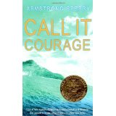
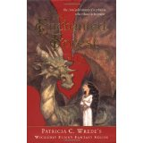
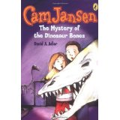
C
Reading Counts Quiz titles: C blue titles are series
Call #: FIC = Fiction E = Everybody (picture books) # = Nonfiction L = Language
"C" titles | AUTHOR | CALL # | READING LEVEL | POINTS
Cabin Faced West, The | Fritz, Jean | FIC FRI | 4.8 | 5
Caddie Woodlawn | Brink, Carol | FIC BRI | 5.3 | 11
Cake For Herbie, A | Mathers, Petra | E MAT | 2.2 | 1
Calico Bush | Field, Rachel | FIC FIE | 6.4 | 14
Calico Captive, The | Speare, Elizabeth | FIC SPE | 6.9 | 12
California Gold Rush | Roop, Peter | 979.4 ROO | 3.6 | 3
California Gold Rush, The | Stein, R. Conrad | 979.4 STE | 5.6 | 3
California – America the Beautiful | Heinrichs, Ann | 979.4 HEI | 9.0 | 6
Call It Courage | Sperry, Armstrong | FIC SPE | 5.8 | 5
Call of the Wild, The | London, Jack | FIC LON | 7.3 | 9
Calling on Dragons | Wrede, Patricia | FIC WRE | 7.2 | 14
Cam Jansen-Mystery-Dinosaur Bones | Adler, David A. | FIC ADL | 3.2 | 3
Cam Jansen-Mystery-Babe Ruth Base | Adler, David A. | FIC ADL | 2.7 | 3
Cam Jansen & the snowy day mys | Adler, David A. | FIC ADL | 2.7 | 4
Cam Jansen & the first day of school | Adler, David A. | FIC ADL | 2.9 | 3
Can I be Good? | Taylor, Livingst | E TAY | 1.7 | 1
Can I have a Stegosaurus Mom? | Grambling, Lois | E GRA | 2.6 | 1
Can You See the Chalkboard? 2001 | Silverstein, Dr. A | 617.7 SIL | 4.4 | 3
Can You See the Wind? | Fowler, Allan | 551.51 | 3.2 | 1
Canada (Postcards from) | Dawson, Zoe | 971 DAW | 3.3 | 2
Captain Underpants:Attack of Talkin | Pilkey, Dav | FIC PIL | 4.2 | 3
Captain Underpants:Perilous Plot... | Pilkey, Dav | FIC PIL | 3.5 | 3
Captain Underpants: Invasion of | Pilkey, Dav | FIC PIL | 3.5 | 3
Captain Underpants: Wrath of | Pilkey, Dav | FIC PIL | 3.5 | 4
Captain Underpants:Booger Boy 1 | Pilkey, Dav | FIC PIL | 3.9 | 3
Captain Underpants: Booger Boy 2 | Pilkey, Dav | FIC PIL | 3.5 | 3
Capture (Guardians Of Ga'Hoole) | Lasky, Kathryn | FIC LAS | 4.5 | 11
Carlos and the Cornfield | Stevens, Jan | L E STE | 2.5 | 2
Carlos and the skunk | Stevens, Jan | L E STE | 3.1 | 3
Carrot Seed, The | Krauss, Ruth | E KRA | 2.2 | 1
Carry On, Mr. Bowditch | Latham, Jean Lee | FIC LAT | 5.1 | 14
Case of the Baker Street Irregular | Newman, Robert | FIC NEW | 5.1 | 11
Case of the Lion Dance, The | Yep, Laurence | FIC YEP | 4.8 | 12
Cassie Loves Beethoven | Arkin, Alan | FIC ARK | 4.7 | 8
Castle of Llyr, The | Alexander, Lloyd | FIC ALE | 6.5 | 9
Castle on Viola Street, A | DiSalvo, DyAnne | E DIS | 3.5 | 2
Castles, caves, and honeycombs | Ashman, Linda | E ASH | 1.8 | 1
Cat in the Crypt (Animal Ark) | Baglio, Ben | Fic Bag | 4.1 | 7
Cat in the Hat Comes Back, The | Seuss, Dr. | E SEU | 1.2 | 2
Cat in the Hat, The | Seuss, Dr. | E SEU | 1.2 | 2
Cat Who Went to Heaven, The | Coatsworth, Elizab | FIC COA | 6.6 | 4
Caterpillow Fight, The | McBratney, Sam | E MCB | 1.5 | 1
Cats at the Campground (Animal Ark) | Baglio, Ben | FIC BAG | 4.1 | 7
Cats in Krasinski Square (CYRM2006) | Hesse, Karen | FIC HES | 4.7 | 3
Catwings | Le Guin, Ursula | Fic Leg | 4.5 | 3
Catwings return | Le Guin, Ursula | Fic Leg | 4.8 | 3
Cay, The | Taylor, Theodore | Fic Tay | 6.3 | 6
Cello of Mr. O, The | Cutler, Jane | E CUT | 3.4 | 2
Century Farm | Peterson, Cris | 636.2 PET | 4.8 | 2
Cesar: Si, Se Puede | Bernier-Grand, Ca | 811 BER | 5.7 | 5
Chair for My Mother, A | Williams, Vera B. | E WIL | 3.8 | 2
Chameleon, Chameleon | Colwey, Joy | 597.95 COW | 1.3 | 1
Chameleons and other... amazing skin | Labella, Susan | 573.5 LAB | 2.1 | 1
Champ, The (Muhammad Ali) | Bolden, T | 921 ALI | 5.4 | 3
Change, The (Animorphs) | Applegate, K | FIC APP | 5.2 | 9
Chanticleer and the Fox | Cooney, B | 821 COO | 3.5 | 2
Charlie and the Chocolate Factory | Dahl, R | FIC DAH | 5.9 | 8
Charlie Bone and... Castle of Mirrors | Nimmo, Jenny | FIC NIM | 5.4 | 16
Charlie Bone and the Invisible Boy | Nimmo, Jenny | FIC NIM | 5.3 | 15
Charlie Bone and the Time Twister | Nimmo, Jenny | FIC NIM | 5.4 | 15
Charlie Needs a Cloak | dePaola, Tomie | 646.4 DEP | 1.9 | 1
Charlotte’s Web | White, E.B. | FIC WHI | 4.9 | 6
Chasing Vermeer | Balliett, Blue | FIC BAL | 5.6 | 6
Chato Goes Cruisin' | Soto, Gary | E SOT | 3.1 | 1
Chato y su cena | Soto, Gary | L E SOT | 4.5 | 2
Chato’s Kitchen | Soto, Gary | E SOT | 4.5 | 2
Cherries and Cherry Pits | Williams, Vera B. | E WIL | 3.9 | 2
Chester the Wordly Pig | Peet, Bill | E PEE | 3.7 | 2
Chester’s Way | Henkes, Kevin | E HEN | 3.1 | 2
Chick and the Duckling, The | Ginsburg, Mirra | E GIN | 1.3 | 1
Chicka Chicka Boom Boom | Martin, Bill | E MAR | 1.9 | 1
Chicken Soup for the Kid’s Soul | Canfield, Jack | 158 CHI | 6.1 | 18
Chicken Sunday | Polacco, Patricia | E POL | 4.8 | 2
Child of the Owl | Yep, Laurence | FIC YEP | 6.5 | 13
Children of the Dust Bowl | Stanley, Jerry | 371.96 STA | 6.5 | 5
Children of the Wild West | Freedman, Russell | 305.2 FRE | 7.5 | 4
Children's Book of America | Bennett, William | 973 CHI | 4.9 | 6
China (2003) | Fontes, Justine | 951 | 3.9 | 3
Chipmunk at Hollow Tree Lane | Sherrow, V | 599.32 SHE | 3.7 | 2
Chocolate Sundae Mystery (Boxcar) | Warner, G | FIC WAR | 3.9 | 6
Christmas in Camelot (Magic TreeH) | Osborne, Mary | FIC OSB | 3.1 | 3
Christopher Columbus | Krensky, Stephen | 970.01 KRE | 3.6 | 2
Christopher Mouse | Wise, William | Fic Wis | 6.2 | 7
Chronicles of Narnia: The horse and | Lewis, C. S. | FIC LEW | 5.8 | 11
Chronicles of Narnia: The last battle | Lewis, C. S. | FIC LEW | 5.8 | 9
Chronicles of Narnia: Lion, Witch... | Lewis, C. S. | FIC LEW | 6.1 | 9
Chronicles of Narnia: The magician's | Lewis, C. S. | FIC LEW | 5.6 | 11
Chronicles of Narnia: Prince Caspian | Lewis, C. S. | FIC LEW | 5.6 | 10
Chronicles of Narnia: The silver chair | Lewis, C. S. | FIC LEW | 5.7 | 11
Chronicles of Narnia: The voyage of | Lewis, C. S. | FIC LEW | 5.5 | 12
Chrysanthemum | Henkes, Kevin | E HEN | 4.2 | 2
Cinder-Elly | Minters, Frances | E MIN | 4.2 | 2
Cinderella's rat | Meddaugh, Susan | E MED | 2.6 | 1
Cinderella | McClintock, Barba | 398.2 McC | 3.2 | 1
Class Clown | Hurwitz, Johanna | FIC HUR | 4.6 | 4
Class from the Black Lagoon | Thaler, M | E THA | 2.6 | 1
Class Pet from the Black Lagoon | Thaler, M | E THA | 2.1 | 1
Class President | Hurwitz, Johanna | FIC HUR | 4.3 | 4
Clementine (CYRM) | Pennypacker, S | FIC PEN | 4.5 | 5
Cleveland Lee's Beale Street Band | Flowers, Art | E FLO | 3.2 | 2
Click Clack Moo, Cows that type | Cronin, Doreen | E CRO | 1.3 | 1
Clifford and the Big Parade | Bridwell, Norman | E BRI | 2.7 | 1
Clifford Goes to Dog School | Bridwell, Norman | E BRI | 2.1 | 1
Clifford Keeps Cool | Bridwell, Norman | E BRI | 2.6 | 1
Clifford Takes a Trip | Bridwell, Norman | E BRI | 1.9 | 1
Clifford the Firehouse Dog | Bridwell, Norman | E BRI | 1.3 | 1
Clifford To the Rescue | Bridwell, Norman | E BRI | 1.3 | 1
Clifford y el dia de la pascua | Bridwell, Norman | L E BRI | 1.6 | 1
Clifford's Christmas | Bridwell, Norman | E BRI | 1.7 | 1
Clifford's Family | Bridwell, Norman | E BRI | 1.5 | 1
Clifford’s First School Day | Bridwell, Norman | E BRI | 2.1 | 1
Clifford’s First Sports Day | Bridwell, Norman | E BRI | 2.2 | 1
Clifford's Halloween | Bridwell, Norman | E BRI | 1.8 | 1
Clifford's Kitten | Bridwell, Norman | E BRI | 1.5 | 1
Clifford's Manners | Bridwell, Norman | E BRI | 1.9 | 1
Clifford’s Spring Clean-up | Bridwell, Norman | E BRI | 2.2 | 1
Clifford's Thanksgiving visit | Bridwell, Norman | E BRI | 1.8 | 1
Clifford's Tricks | Bridwell, Norman | E BRI | 1.5 | 1
Clocks and More Clocks | Hutchins, Pat | E HUT | 1.9 | 1
Cloudy With a Chance of Meatballs | Barrett, Judi | E BAR | 3.2 | 2
Coal Miner’s Bride | Campbell, Susan | FIC CAM | 5.5 | 11
Cold Fire (The Circle Opens) | Pierce, Tamora | FIC PIE | 6.1 | 19
Colonial Life | Kalman, Bobbie | 973.2 KAL | 3.5 | 3
Colonial Town: Williamsburg | Kalman, Bobbie | 975.5 KAL | 3.5 | 3
Colorado – America the Beautiful | Blashfield, Jean F. | 978.8 BLA | 9.0 | 6
Come Sing, Jimmy Jo | Paterson, Katherin | FIC PAT | 4.9 | 13
Comets and Asteroids | Davis, Amanda | 523.6 DAV | 3.9 | 2
Coming on home soon | Woodson, J | E Woo | 2.6 | 3
Connecticut – America the Beautiful | McNair, Sylvia | 974.6 MCN | 9.0 | 6
Conservation | Petersen, Christine | 333.7 PET | 8.3 | 3
Coolies | Yin | E YIN | 3.8 | 2
Corduroy | Freeman, Don | E FRE | 3.2 | 2
Courage of Sarah Noble, The | Dalgliesh, A | FIC DAL | 4.4 | 3
Cousins | Hamilton, Virginia | FIC HAM | 5.5 | 8
Cowboys and cow towns of the Wi... | Savage, Jeff | 978 SAV | 5.4 | 5
Cowboys of the Wild West | Freedman, Russell | 978 FRE | 5.2 | 5
Cow-tail Switch | Courlander, Harol | 398.2 COU | 5.1 | 5
Crabs, Lobsters, and Shrimps | Lassieur, Allison | 595.3 LAS | 5.9 | 3
Crawdad Creek | Sanders, Scott | E SAN | 3.7 | 2
Crazy Lady | Conly, Jane Leslie | FIC CON | 4.9 | 10
Cricket in Times Square, The | Selden, George | FIC SEL | 5.9 | 8
Crickwing | Cannon, Janell | E CAN | 4.1 | 2
Crispin: At the edge of the world | Avi | FIC AVI | 5.2 | 11
Crispin: The cross of lead | Avi | FIC AVI | 6.1 | 13
Crooked Kind of Perfect, A | Urban, Linda | FIC URB | 4.0 | 8
Crow Boy | Yashima, Taro | E YAS | 2.9 | 2
Crystal and Gem | Symes, R. F. | 552 SYM | 6.8 | 6
Cuckoo Clock of Doom GooseBumps | Stine, R. L. | FIC STI | 3.4 | 4
Cupid Doesn’t Flip Hamburgers | Dadey, Debbie | FIC DAD | 3.5 | 3
Curious George Goes to a Choco... | Rey, Margret & H | E REY | 2.5 | 2
Curious George Makes Pancakes | Rey, Margret & H | E REY | 2.3 | 2
Curious George Rides a Bike | Rey, H. A. | E REY | 2.9 | 2
Curse of the Mummy’s Tomb, The | Stine, R.L. | FIC STI | 4.9 | 7
Custodian from the Black Lagoon | Thaler, Mike | E THA | 2.9 | 1
Cyclops Doesn’t Roller Skate | Dadey, Debbie | FIC DAD | 3.5 | 3
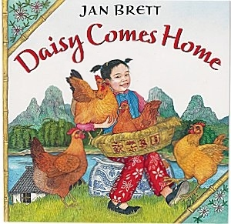
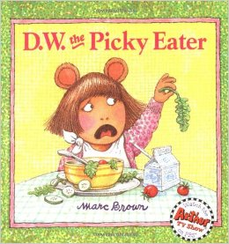
D
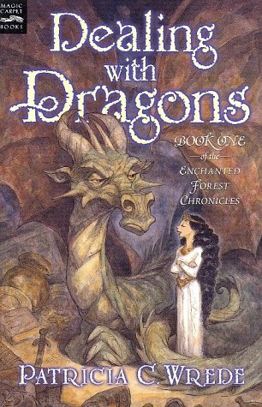
Reading Counts Quiz Titles D titles in blue are series
Call #: FIC = Fiction E = Everybody (Picture books) # = Nonfiction L = Language
"D" titles | AUTHOR | CALL # | READING LEVEL | POINTS
D.W. All Wet | Brown, Marc | E BRO | 1.6 | 1
D.W. Flips | Brown, Marc | E BRO | 1.9 | 1
D.W. Rides Again! | Brown, Marc | E BRO | 2.1 | 1
D.W. the Picky Eater | Brown, Marc | E BRO | 2.9 | 1
D.W. Thinks Big | Brown, Marc | E BRO | 2.1 | 1
D.W.'s Library Card | Brown, Marc | E BRO | 2.1 | 2
D.W., Go to Your Room! | Brown, Marc | E BRO | 1.9 | 1
Dad, Jackie, and me | Uhlberg, Myron | E UHL | 4.0 | 2
Daisy Comes Home | Brett, Jan | E BRE | 3.2 | 2
Dancing with the Indians | Medearis, Angela | E MED | 2.9 | 1
Danny And The Dinosaur | Hoff, Syd | E HOF | 2.7 | 2
Danny And The Dinosaur Go to Camp | Hoff, Syd | E HOF | 1.8 | 1
Dark Frigate, The | Hawes, Charles | FIC HAW | 5.5 | 15
Dark Hills Divide, The | Carman Patrick | FIC CAR | 6.0 | 14
Dark is Rising, The | Cooper, Susan | FIC COO | 7.1 | 19
Dark, The | Munsch, Robert | E MUN | 2.8 | 1
Dark Thirty: Southern Tales | McKissack, Patric | FIC MCK | 6.9 | 6
Daughter of the Mountains | Rankin, Louise | FIC RAN | 6.8 | 11
David Goes to School | Shannon, David | E SHA | 2.9 | 1
David’s Father | Munsch, Robert | E MUN | 3.7 | 2
Davy Crockett, Young Rifleman | Parks, Aileen W | 921 CRO | 4.1 | 7
Dawn (Warriors: New Prophecy) | Hunter, Erin | FIC HUN | 4.8 | 18
Day Jimmy's Boa Ate the Wash | Noble, Trinka H | E NOB | 3.7 | 1
Day of Tears: a novel in dialogue | Lester, Julius | FIC LES | 5.6 | 9
Day of the Dragon King | Osborne, Mary P | FIC OSB | 2.3 | 3
Days with Frog and Toad | Lobel, Arnold | E LOB | 2.1 | 2
Dealing with Dragons | Wrede, P | FIC WRE | 7.3 | 10
Dealing with Feeling Left Out | Middleton, Don | 302.5 MID | 3.9 | 2
Dear America: I thought my soul would rise and fly | Hansen, J | FIC HAN | 4.8 | 7
Dear America: Journal of James Edmond Pease | Murphy, J | FIC MUR | 6.8 | 10
Dear America: Journal of Jasper Jonathan Pierce | Rinaldi, Ann | FIC RIN | 6.5 | 9
Dear America: Journal of Jedediah Barstow | Levine, E | FIC LEV | 5.5 | 9
Dear America: Journal of Sean Sullivan, The | Durbin, W | FIC DUR | 5.7 | 7
Dear America: Journal of William Thomas Emerson | Denenberg, B | FIC DEN | 4.8 | 6
Dear America: Land of the Buffalo Bon | Bauer, Marion | FIC BAU | 4.9 | 10
Dear America: Love Thy Neighbor | Turner, Ann | FIC TUR | 4.9 | 10
Dear America: So far from home | Denenberg, B | FIC DEN | 3.5 | 5
Dear America: When will this cruel war | Denenberg, B | FIC DEN | 6.5 | 4
Dear America: Winter of the red snow | Gregory, K | FIC GRE | 4.8 | 7
Dear Bear | Harrison, Joanna | E HAR | 2.6 | 1
Dear Ellen Bee: A Civil War scrapbk.. | Lyons, Mary E | FIC LYO | 5.4 | 9
Dear Mr. Henshaw | Cleary, Beverly | FIC CLE | 4.7 | 5
Dear Mrs. LaRue | Teague, Mark | E TEA | 3.1 | 2
Death of the Iron Horse | Goble, Paul | E GOB | 4.1 | 2
Deep Blue Sea, The | Wood, Audrey | E WOO | 1.4 | 1
Defenders, The | McGovern, Ann | 920 MCG | 5.5 | 5
Dentist from the Black Lagoon | Thaler, Mike | E THA | 3.3 | 1
Dentists Take Care of our Mouths | Greene, Carol | 617.6 GRE | 2.2 | 1
Desert Song | Johnston, Tony | E JOH | 2.2 | 1
Detective LaRue: letters from...invest | Teague, Mark | E TEA | 4.7 | 3
Diary of a Wimpy Kid: | Kinney, Jeff | FIC KIN | 5.3 | 7
Diary of a Wimpy Kid: Rodrick.. | Kinney, Jeff | FIC KIN | 5.3 | 8
Diary of a Wimpy Kid: The last straw | Kinney, Jeff | FIC KIN | 6.4 | 8
Dicey’s Song | Voigt, Cynthia | FIC VOI | 5.2 | 17
Dick Whittington and His Cat | Brown, Marcia | FIC BRO | 4.1 | 2
Dig, Wait, Listen | Sayre, April P | E SAY | 1.6 | 1
Dingoes at Dinnertime (MTH) | Osborne | FIC OSB | 3.5 | 3
Dinosaur Babies | Penner, Lucille R | 567.9 PEN | 1.8 | 1
Dinosaur Babies | Zoehfeld, Kathlee | 567.9 ZOE | 3.8 | 2
Dinosaur Bones | Aliki | 567.9 ALI | 2.5 | 2
Dinosaur Cousins? | Most, Bernard | 567.9 MOS | 3.6 | 2
Dinosaur Dinners | Davis, Lee | 567.9 DAV | 2.5 | 2
Dinosaur Hunters | McMullan, Kate | 567.9 MCM | 4.1 | 3
Dinosaurs (Gibbons) | Gibbons, Gail | 567.9 GIB | 3.5 | 2
Dinosaurs Before Dark (MTH) | Osborne, Mary P | FIC OSB | 2.5 | 3
Dinosaurs (Worldwise) | Steedman, Scott | 567.9 STE | 6.8 | 3
Discovery Of The Americas, The | Maestro, Betsy | 917.04 MAE | 5.5 | 3
Disoriented Express (Wishbone) | Strickland, Brad | FIC WIS | 5.1 | 9
Do unto otters, a book about manners | Keller, Laurie | E KEL | 2.3 | 1
Dog Called Kitty, A | Wallace, Bill | FIC WAL | 4.4 | 6
Dogsong | Paulsen, Gary | FIC PAU | 5.8 | 8
Dollhouse Murders, The | Wright, Betty R | FIC WRI | 5.8 | 9
Dolphins at Daybreak | Osborne | FIC OSB | 2.2 | 3
Don't let the pigeon drive the bus | Willems, Mo | E WIL | 1.0 | 1
Don’t You Know There’s A War On? | Stevenson, James | 921 STE | 4.3 | 2
Dona Flor | Mora, Pat | E MOR | 3.6 | 1
Door in the Wall | DeAngeli, Margueri | FIC DEA | 3.1 | 7
Doorbell Rang, The | Hutchins, Pat | E HUT | 2.1 | 1
Dot the Fire dog | Desimini, L | 628.9 DES | 1.9 | 1
Down Cut Shin Creek | Appelt, K | 027.7 APP | 5.9 | 4
Downtown Boy | Herrera, Juan | FIC HER | 4.4 | 9
Dr. Seuss's ABC | Seuss, Dr. | E SEU | 3.1 | 1
Dracula Doesn’t Drink Lemonade | Dadey, Debbie | FIC DAD | 4.2 | 3
Dragon of Lonely Island, The | Rupp, Rebecca | FIC REB | 6.7 | 9
Dragon of the Red Dawn | Osborne, Mary P | FIC OSB | 3.3 | 5
Dragon Prince, The | Yep, Lawrence | 398.2 YEP | 4.8 | 2
Dragon Rider | Funke, Cornelia | FIC FUN | 4.9 | 22
Dragon Trouble | Koller, J | FIC KOL | 2.8 | 4
Dragon’s Gate | Yep, Laurence | FIC YEP | 6.1 | 13
Dragon's Nest (Dragons of Deltora) | Rodda, Emily | FIC ROD | 4.5 | 9
Dragonfly's Tale | Rodanas, K | 398.21 | 5.4 | 2
Dragonling, The | Koller, J | FIC KOL | 4.5 | 3
Dragons Don’t Cook Pizza | Dadey, Debbie | FIC DAD | 2.8 | 3
Dragons Of Blueland, The | Gannett, R | FIC GAN | 4.6 | 3
Dragon's nest (Dragons of Deltora) | Rodda, Emily | Fic Rod | 4.5 | 9
Dragonwings | Yep, Laurence | FIC YEP | 6.1 | 14
Dream Jar, The | Pryor, Bonnie | E PRY | 4.2 | 2
Dream Wolf | Goble, Paul | E GOB | 3.5 | 2
Drinking Gourd, The | Monjo, F. N. | E MON | 2.1 | 2
Droon: Into the Land of the Lost | Abbott, Tony | FIC ABB | 3.4 | 4
Droon: Journey to the Volcano | Abbott, Tony | FIC ABB | 3.1 | 4
Droon: Magic Escapes, The | Abbott, Tony | FIC ABB | 3.1 | 6
Droon: Quest for the Queen | Abbott, Tony | FIC ABB | 3.1 | 4
Droon: Race to Doobesh | Abbott, Tony | FIC ABB | 3.1 | 5
Droon: Riddle of Zorfendorf Castle | Abbott, Tony | FIC ABb | 3.1 | 5
Drummer Hoff | Emberley, Barbar | 398.8 EMB | 3.5 | 1
Duck In the Truck | Alborough, Jez | E ALB | 1.6 | 1
Duck On A Bike | Shannon, David | E SHA | 1.8 | 1
Ducks in Muck | Haskings, Lori | E HAS | 1.1 | 1
Dumpy La Rue | Winthrop, Elizabe | E WIN | 2.4 | 1
Dunc and Amos &-Red Tattoos | Paulsen, Gary | FIC PAU | 4.9 | 3
Dunc's Halloween | Paulsen, Gary | FIC PAU | 4.9 | 3
Dwyane Wade | Smallwood, John | 796.323 | 7.9 | 3
E
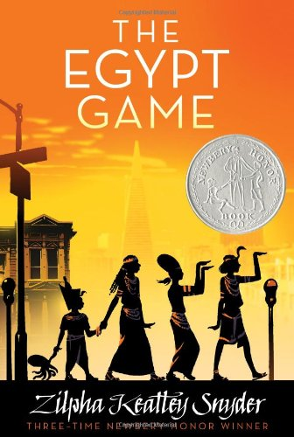
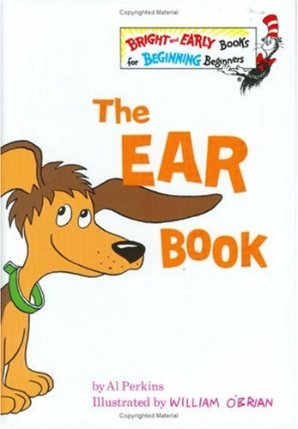
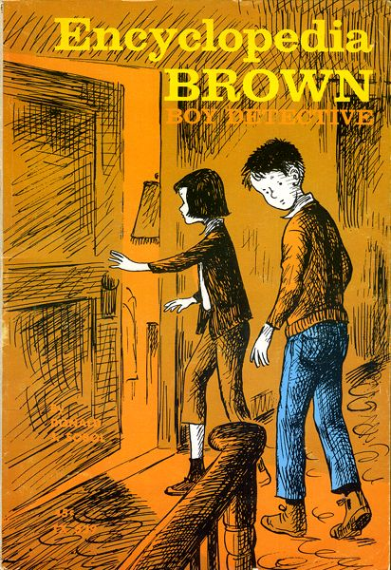
Reading Counts Quiz Titles E titles in blue are series
Call #: FIC = Fiction E = Everybody (Picture books) # = Nonfiction L = Language
"E" titles | AUTHOR | CALL # | READING LEVEL | POINTS
Each Little Bird that Sings | Wiles, D | FIC WIL | 4.3 | 10
Ear Book, The | Perkins, Al | E PER | 2.4 | 1
Earth (Galaxy) | Kipp, Steven | 550 KIP | 2.5 | 3
Earth: Our Planet in Space | Simon, Seymour | 525 SIM | 4.1 | 2
Earthquake in the early morning | Osborne, Mary P | FIC OSB | 2.4 | 4
Earthworms: Underground Farmers | Lauber, Patricia | 595 LAU | 4.8 | 4
Easter (True Book) | Sanders, Nancy | 394.2667SAN | 4.0 | 3
Eating Fractions | McMillan, Bruce | 513.2 McM | 1.3 | 1
Eating the Plates | Penner, L | 394.1 PEN | 5.2 | 3
Edison Mystery, The | Gutman, Dan | FIC GUT | 5.1 | 8
Egg Tree, The | Milhous, Katheri | 394 MIL | 3.5 | 2
Egypt game, The | Snyder, Zilpha | Fic Sny | 5.9 | 12
Egyptian Box, The | Curry, Jane Loui | FIC CUR | 5.6 | 11
Egyptian Cinderella | Climo, Shirley | 398.2 CLI | 3.5 | 2
Elena's Serenade | Geeslin, Campb | E GEE | 4.3 | 2
Elijah of Buxton | Curtis, Christop | FIC CUR | 7.5 | 17
Elizabeth Blackwell: Girl... | Henry, Joanne L | 921 BLA | 3.5 | 7
Elizabeth I | Lasky, Kathryn | FIC LAS | 4.8 | 8
Ella Enchanted | Levine, Gail C. | FIC LEV | 5.1 | 11
Ellen Tebbits | Cleary, Beverly | FIC CLE | 4.2 | 5
Elves Don’t Wear Hard Hats | Dadey, Debbie | FIC DAD | 4.1 | 3
Emma's Journal | Moss, Marissa | FIC MOS | 5.2 | 5
Emily’s Runaway Imagination | Cleary, Beverly | FIC CLE | 4.8 | 8
Emma’s Magic Winter | Little, Jean | E LIT | 2.3 | 2
Emperor and the Kite, the | Yolen, Jane |  | 3.7 | 2
Encounter, The | Applegate, K. A. | FIC APP | 5.2 | 8
Encyclopedia Brown/MysteriousHan | Sobol, Donald | FIC SOB | 4.6 | 4
Encyclopedia Brown/Boy Detective | Sobol, Donald | FIC SOB | 3.9 | 6
Encyclopedia Brown/Book of Strange | Sobol, Donald | 363.2 SOB | 4.8 | 6
Encyclopedia Brown/Slippery Salam | Sobol, Donald | FIC SOB | 4.8 | 5
Encyclopedia Brown Carries On | Sobol, Donald | FIC SOB | 4.1 | 4
Encyclopedia Brown sets the pace | Sobol, Donald | FIC SOB | 4.6 | 4
Encyclopedia Brown takes the case | Sobol, Donald | FIC SOB | 3.9 | 4
Encyclopedia Brown Tracks –Down | Sobol, Donald | FIC SOB | 3.9 | 4
Encyclopedia Brown-Pitch | Sobol, Donald | FIC SOB | 3.9 | 4
Enchanted Forest:Calling onDragons | Wrede, Patricia | FIC WRE | 7.4 | 14
Enchanted Forest: Dealing w/Dra | Wrede, Patricia | FIC WRE | 7.3 | 10
Enchanted Forest: Searching for Dra | Wrede, Patricia | FIC WRE | 6.5 | 14
Enchanted Forest:Talking toDragons | Wrede, Patricia | FIC WRE | 6.8 | 16
End, The/Series of Unfortunate Events | Snickey, Lemon | FIC SNI | 6.8 | 14
Enormous Carrot | Vagin, Vladimir | 398.2 VAG | 3.1 | 1
Eragon | Paolini, Christop | FIC PAO | 7.8 | 32
Erandi's Braids | Madrigal, Antoni | E MAD | 4.5 | 2
Ersatz Elevator, The (Series of Unfort) | Snicket, Lemony | FIC SNI | 6.7 | 11
Escape from Slavery, Five journeys to | Rapparot, D | 973 RAP | 5.8 | 4
Esperanza Rising | Ryan, Pam | FIC RYA | 5.5 | 11
Everybody Cooks Rice | Dooley, Norah | 641.6 DOO | 4.4 | 2
Everything on a Waffle | Horvath, P | FIC HOR | 5.9 | 10
Explorers of North America | January, B | 970.01 JAN | 4.4 | 2
Extreme, The | Applegate, K | FIC APP | 5.5 | 8
Eyes of Gray Wolf, The | London, Jonatha | E LON | 4.1 | 1
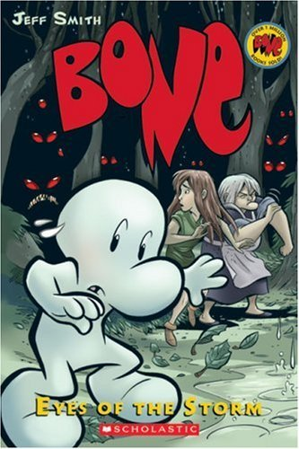  Eyes of the storm (Bone 3) | Smith, Jeff | 741 Smi | 3.6 | 7

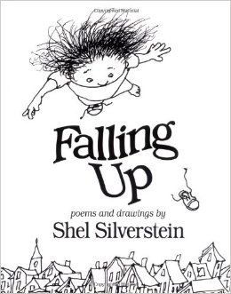
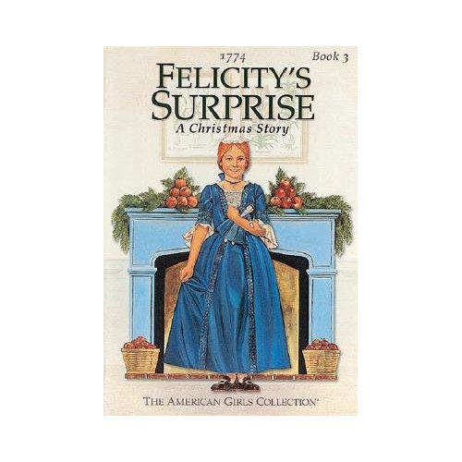
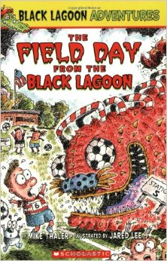
F
Reading Counts Quiz Titles F titles in blue are series
Call #: FIC = Fiction E = Everybody (Picture books) # = Nonfiction L = Language
"F" titles | AUTHOR | CALL # | READING LEVEL | POINTS
Fables | Lobel, Arnold | FIC LOB | 5.1 | 2
Facts and fictions of Minna Pr | Maclachlan, P | Fic Mac | 5.4 | 5
Falling Up | Silverstein | 811 SIL | 3.5 | 5
Family Under the Bridge, The | Carlson, Natalie | FIC CAR | 5.1 | 4
Fanny’s Dream | Buehner, Caraly | E BUE | 2.8 | 2
Fantastic Frogs! | Robinson, F | 597.8ROB | 1.4 | 1
Fantastic Mr. Fox | Dahl, Roald | FIC DAH | 4.9 | 3
Faraway Home | Kurtz, J | E KUR | 3.4 | 2
Farmer Boy | Wilder, Laura In | FIC WIL | 4.3 | 12
Farmer Brown Shears his Sheep | Sloat, Teri | E SLO | 2.1 | 1
Farmer, The | Ludy, Mark | E LUD | 3.6 | 2
Father Bear Comes Home | Minarik, E | E MIN | 2.4 | 2
Favorite Medieval Tales | Osborne, Mary P | 398.2 OSB | 4.8 | 5
Felicity's Surprise (American Girls) | Tripp, Valerie | FIC TRI | 5.5 | 4
Felicity's Dancing Shoes (American) | Tripp, Valerie | FIC TRI | 4.3 | 3
Felita | Mohr, N | FIC MOH | 5.2 | 4
Fellowship of the Ring (Lord of the R | Tolkien, J. R. R. | FIC TOL | 8.1 | 34
Ferno the Fire Dragon | Blade, A | FIC BLA | 3.7 | 4
Fever, 1793 | Anderson, Lauri | FIC AND | 7.6 | 13
Field Day from... Black Lagoo | Thaler, M | E THA | 3.3 | 2
Field Guide, The | Black, Holly | FIC BLA | 4.1 | 4
Fine, Fine School, A | Creech, Sharon | E CRE | 2.7 | 2
Fine White Dust, A | Rylant, Cynthia | FIC RYL | 4.7 | 5
Fire and Ice (Warriors) | Hunter, Erin | FIC HUN | 5.2 | 17
Fire Bug Connection, The | George, Jean | FIC GEO | 4.7 | 6
Fire Station | Munsch, Robert | E MUN | 3.1 | 2
Firefighters A to Z | Demarest, Chris | 628.9DEM | 1.8 | 1
First Day Jitters | Danneberg, Julie | E DAN | 2.6 | 1
First Dog, The | Brett, Jan | E BRE | 2.8 | 2
Fish is Fish | Lionni, Leo | E LIO | 3.3 | 1
Five Smooth Stones: Hope's di | Gregory, K | FIC GRE | 3.1 | 5
Flag we Love, The | Ryan, Pam Mun | 929.9RYA | 4.3 | 1
Flat Stanley | Brown, Jeff | FIC BRO | 4.4 | 3
Fledgling, The | Langton, Jane | FIC LAN | 5.8 | 8
Flip-Flop Girl | Paterson Katheri | FIC PAT | 5.4 | 7
Florida (America the Beautiful) | Heinrichs, Ann | 975.9 HEI | 8.7 | 6
Flossie and the Fox | McKisssack, Pat | PB M | 3.2 | 2
Fly Away Home | Bunting, Eve | E BUN | 4.3 | 2
Flying Flea Callie, And Me | Wallace, Carol | FIC WAL | 3.9 | 4
Follow The Drinking Gourd | Winter, Jeanette | E WIN | 3.9 | 2
Following Fake Man | Holmes, B | Fic Hol | 4.5 | 11
Foot Book, The | Seuss, Dr. | E SEU | 1.1 | 1
Footprints in the Sand | Benjamin, Cynth | 591 BEN | 1.3 | 1
Forging Freedom | Talbott, Hudson | 940.53 | 4.9 | 4
Forgotten, The | Applegate, K.A. | FIC APP | 5.2 | 9
Fortress of the Treasure Queen | Abbott, Tony | FIC ABB | 3.1 | 5
Fossils Tell of Long Ago | Aliki | 560 ALI | 2.1 | 2
Fourth Grade is a Jinx | McKenna, Colle | FIC MCK | 5.3 | 7
Fourth Grade Rats | Spinelli, J | Fic Spi | 4.3 | 3
Fourth of July Story, The | Dalgliesh, Alice | 973.3 DAL | 3.5 | 2
Fox in Socks | Seuss, Dr. | E SEU | 2.6 | 2
France (Postcards From) | Arnold, Helen | 944 ARN | 2.8 | 3
Frankenstein Doesn’t Plant Petunias | Dadey, Debbie | FIC DAD | 2.9 | 3
Franklin's Bicycle Helmet | Bourgeois, Paule | E BOU | 2.2 | 2
Franklin's Canoe Trip | Bourgeois, Paule | E BOU | 2.3 | 2
Frederick | Lionni, Leo | E LIO | 3.8 | 1
Frederick Douglas: Leader | McKissack, Patri | 921 DOU | 2.8 | 2
Freedom Summer | Wiles, Deborah | FIC WIL | 2.7 | 2
Freight Train | Crews, Donald | E CRE | 1.5 | 1
Friends | Heine, Helme | E HEI | 3.5 | 1
Friends | Martin, Ann | SC FRI | 6.0 | 11
Friends, The | Yumoto, Kazumi | FIC YUM | 4.2 | 11
Friendship for Today (CYRM) | McKissack, Patri | FIC MCK | 3.5 | 10
Frindle | Clements, Andre | FIC CLE | 4.8 | 5
Frog and Toad are Friends | Lobel, Arnold | E LOB | 2.4 | 2
Frog and Toad Together | Lobel, Arnold | E LOB | 2.3 | 2
Frog Prince Continued, The | Scieszka, Jon | E SCI | 4.7 | 2
Frog Thing, A (CYRM) | Drachman, Eric | E DRA | 2.1 | 1
Frog Went A-Courtin’ | Langstaff, John | E LAN | 2.7 | 1
Froggy Goes To School | London, Jonatha | E LON | 2.5 | 1
Froggy Goes To Bed | London, Jonatha | E LON | 2.1 | 1
Froggy Learns to Swim | London, Jonatha | E LON | 2.5 | 1
Froggy Plays Soccer | London, Jonatha | E LON | 2.1 | 1
Froggy's Baby Sister | London, Jonatha | E LON | 2.2 | 1
Froggy's Best Christmas | London, Jonatha | E LON | 2.2 | 1
Froggy's First Kiss | London, Jonatha | E LON | 2.8 | 2
From Acorn To Oak Tree | Kottke, Jan | 583 KOT | 1.4 | 1
From Caterpillar to Butterfly | Heiligman, Debo | 595.78 HEI | 2.8 | 2
From Far Away | Munsch, Robert | E MUN | 2.8 | 2
From One To One Hundred | Sloat, Teri |  | 1.5 | 1
From Pictures To Words | Stevens, Janet | 741.6 STE | 3.5 | 2
From Tadpole to Frog | Pfeffer, Wendy | 597.8 PFE | 2.5 | 1
From the Mixed Up Files of Mrs.Basi | Konigsburg, E.L. | FIC KON | 6.8 | 9
Funny Little Woman, The | Mosel, Arlene | 398.2 MOS | 3.5 | 2
Further Adventures-Hank-Cowdog | Erickson, John R | FIC ERI | 5.4 | 7
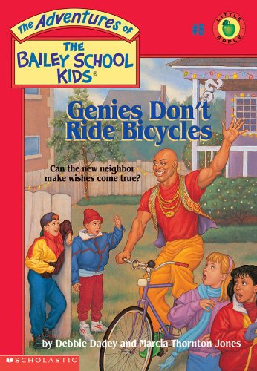
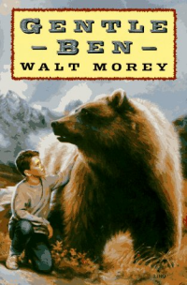
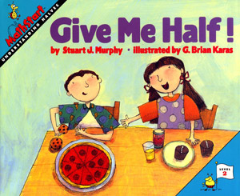
G
Reading Counts Quiz Titles G titles in blue are series
Call #: FIC = Fiction E = Everybody (Picture books) # = Nonfiction L = Language
"G" | AUTHOR | CALL # | READING LEVEL | POINTS
Game of Silence, The | Erdrich, Louise | FIC ERD | 5.9 | 13
Game of Sunken Places, The | Anderson, M.T. | FIC AND | 3.5 | 13
Garden of Abdul Gasazi, The | Van Allsburg, Chris | E VAN | 4.7 | 2
Gardener, The | Stewart, Sarah | E STE | 3.5 | 2
Gargoyles Don’t Drive School Buses | Dadey, Debbie | FIC DAD | 3.5 | 3
Gathering of Days, A | Blos, Joan | FIC BLO | 6.1 | 8
Gathering the Sun | Ada, Alma Flor | L 861 ADA | 4.1 | 2
Gemstones | Squire, Ann | 553.8 SQU | 5.9 | 3
Genies Don't Ride Bicycles | Dadey, Debbie | FIC DAD | 3.5 | 3
Gentle Ben | Morey, Walt | FIC MOR | 5.1 | 13
George and Martha | Marshall, James | E MAR | 2.8 | 2
George And Martha One Fine Day | Marshall, James | E MAR | 2.7 | 1
George Washington (Harness) | Harness, Cheryl | 921 WAS | 4.7 | 3
Georgia – America the Beautiful | Robinson, Nancy | 978.8 ROB | 8.8 | 6
Germs Make Me Sick! | Berger, Melvin H. | 616.9 BER | 2.8 | 2
Germs! Germs! Germs! | Katz, Bobbi | 616 KAT | 1.5 | 1
Gettysburg Address, The | Lincoln, Abraham | 973.734 LIN | 4.9 | 3
Ghost Town At Sundown | Osborne, Mary P | FIC OSB | 2.2 | 3
Ghosts Don’t Eat Potato Chips | Dadey, Debbie | FIC DAD | 3.7 | 3
Giant Hug, The | Horning, Sandra | E HOR | 1.9 | 1
Gift Of The Crocodile | Sierra, Judy | 398.2 SIE | 3.3 | 2
Giggle, Giggle, Quack | Cronin, Doreen | E CRO | 1.9 | 1
Gila Monsters Meet You At... | Sharmat, Weinman | E SHA | 2.9 | 2
Gilberto and the Wind | Ets, Marie Hall | E ETS | 1.8 | 2
Gilgamesh The Hero | McCaughrean, G | 398.2 MCC | 5.0 | 7
Ginger | Voake, Charlotte | E VOA | 2.9 | 1
Ginger Pye | Estes, Eleanor | FIC EST | 5.8 | 13
Gingerbread Man (Anthology) | Bell, Sally | 398.2 BEL | 1.5 | 1
Giraffe and a Half | Silverstein, Shel | E SIL | 3.1 | 2
Giraffe and the Pelly and Me | Dahl, Roald | FIC DAH | 3.9 | 3
Girl Named Disaster, A | Farmer, Nancy | FIC FAR | 5.9 | 15
GooseBumps: Girl who cried mons | Stine, R. L. | FIC STI | 4.1 | 7
Girl Who Loved Wild Horses | Goble, Paul | E GOB | 4.7 | 2
Girl Who Spun Gold, The | Hamilton, Virginia | E HAM | 4.1 | 7
Give Me Back My Pony | Betancourt, Jeanne | FIC BET | 3.4 | 4
Give Me Half! | Murphy, Stuart J. | 513.26 MUR | 1.8 | 1
Giver, The | Lowry, Lois | FIC LOW | 5.9 | 9
Giving Thanks | Swamp, Chief Jake | 299 SWA | 4.1 | 1
Giving Tree, The | Silverstein, Shel | E SIL | 2.9 | 1
Glasses For D.W. | Brown, Marc | E BRO | 1.9 | 1
Glorious Flight: Across the Channel | Provensen, Martin | 921 BLE | 3.5 | 2
Go, Dog, Go | Eastman, P.D. | E EAS | 1.4 | 1
Go-Around Dollar, The | Adams, B Johnston | 332.4 ADA | 4.9 | 2
Goat In The Garden | Baglio, Ben M. | FIC BAG | 3.8 | 6
God Bless America (Munsinger) | Berlin, Irving | 782.4 BER | 1.7 | 1
Goggles! | Keats, Ezra Jack | E KEA | 2.9 | 1
Goin' Someplace Special | McKissack, Patricia | E MCK | 3.3 | 2
Gold Coin, The | Ada, Alma Flor | E ADA | 3.7 | 2
Gold Fever | Kay, Verla | E KAY | 2.6 | 1
Golden Goblet, The | McGraw, Eloise J. | FIC MCG | 6.4 | 11
Golden Sandal, The | Hickox, Rebecca A. | 398.2 HIC | 5.9 | 2
Goldilocks and the Three Bears | Aylesworth, Jim | 398.22 AYL | 3.9 | 2
Goldilocks and the Three Bears | Marshall, James | 398.2 MAR | 3.5 | 2
Goldilocks & The Three Bears | Miles, Betty | 398.2 MIL | 1.4 | 1
Golem | Wisniewski, David | 398.21 WIS | 4.1 | 2
Good Dog (Gottfried | Gottfried, Maya | 811 GOT | 2.8 | 2
Good Dog, The | Avi | FIC AVI | 4.1 | 9
Good Driving, Amelia Bedelia | Parish, Herman | E PAR | 2.8 | 2
Good Morning, Gorillas | Osborne, Mary P | FIC OSB | 2.3 | 3
Good Night, Good Knight | Thomas, Shelly M | E THO | 1.9 | 2
Good-bye, Chicken Little | Byars, Betsy | FIC BYA | 5.2 | 5
Goose | Bang, Molly | E BAN | 1.9 | 1
Goose on the Loose | Baglio, Ben | FIC BAG | 4.5 | 7
GooseBumps: Attack of the Jack-O'L | Stine, R. L. | FIC STI | 4.1 | 6
GooseBumps: Barking Ghost, The | Stine, R. L. | FIC STI | 4.2 | 6
GooseBumps: Cuckoo Clock of D.. | Stine, R. L. | FIC STI | 3.4 | 4
GooseBumps: Curse of the Mumm.. | Stine, R. L. | FIC STI | 4.9 | 7
GooseBumps: Girl who cried mons | Stine, R. L. | FIC STI | 4.1 | 7
GooseBumps: Haunted School, The | Stine, R. L. | FIC STI | 4.2 | 6
GooseBumps: I live in your basem.. | Stine, R. L. | FIC STI | 4.2 | 6
GooseBumps Let's get invisible: | Stine, R. L. | FIC STI | 4.5 | 7
GooseBumps Monster Blood: | Stine, R. L. | FIC STI | 4.9 | 7
GooseBumps: My hairiest adven... | Stine, R. L. | FIC STI | 3.7 | 7
GooseBumps:Night of the living du | Stine, R. L. | FIC STI | 4.8 | 7
GooseBumps:One Day at Horrorla | Stine, R. L. | FIC STI | 4.4 | 6
GooseBumps:Return of the mummy | Stine, R. L. | FIC STI | 4.6 | 6
GooseBumps:Scarecrow walks at m | Stine, R. L. | FIC STI | 4.7 | 6
GooseBumps:Welcome to dead hou | Stine, R. L. | FIC STI | 4.9 | 7
GooseBumps:Werewolf skin | Stine, R. L. | FIC STI | 4.4 | 6
GooseBumps: Why I'm afraid of bee | Stine, R. L. | FIC STI | 4.8 | 6
GooseBumps: You can't scare me | Stine, R. L. | FIC STI | 4.8 | 6
Gorilla Doctors | Turner, Pamela S. | 333.95 TUR | 5.9 | 6
Gracias The Thanksgiving Turkey | Cowley, Joy | E COW | 2.8 | 2
Grandad Bill's Song | Yolen, Jane | E YOL | 4.2 | 3
Grandfather's Journey | Say, Allen | E SAY | 4.2 | 3
Grandmas At Bat | McCully, Emily | E McC | 1.7 | 2
Grandmas At The Lake | McCully, Emily | E McC | 1.7 | 2
Grandpa's Mountain | Reeder, Carolyn | FIC REE | 5.9 | 9
Granny And The Desperadoes | Parish, Peggy | E PAR | 2.2 | 2
Granny Torrelli Makes Soup | Creech, Sharon | FIC CRE | 4.5 | 6
Grannyman, The | Schachner, Judith | E SCH | 3.9 | 2
Graphic Alphabet | Pelletier, David |  | 1.1 | 1
Gray Wolf, Red Wolf | Hinshaw, Dorothy | 599.74 HIN | 6.1 | 3
Great Cow Race (Bone) | Smith, Jeff | 741.5 SMI | 3.7 | 4
Great Day for Up! | Seuss, Dr. | E SEU | 1.9 | 1
Great Fire, The | Murphy, Jim | 977.3 MUR | 6.9 | 7
Great Gilly Hopkins, The | Paterson, Katherine | FIC PAT | 5.3 | 8
Green Eggs and Ham | Seuss, Dr. | E SEU | 2.2 | 2
Gregor and the Curse of the Warmblo | Collins, Suzanne | FIC COL | 5.3 | 16
Gregor and the Prophecy of Bane | Collins, Suzanne | FIC COL | 5.3 | 15
Gregor the Overlander | Collins, Suzanne | FIC COL | 4.9 | 14
Gremlins Don’t Chew Bubblegum | Dadey, Debbie | FIC DAD | 5.2 | 3
Grim Grotto, (Series of Unfortunate) | Snicket, Lemony | FIC SNI | 8.6 | 11
Grouch Ladybug, The | Carle, Eric | E CAR | 3.3 | 2
Growing Up in Coal Country | Campbell, Susan | 331.3 CAM | 7.3 | 6
Growing Vegetable Soup | Ehlert, Lois | E EHL | 1.7 | 1
Guardians Of Ga'Hoole: Capture | Lasky, Kathryn | FIC LAS | 4.5 | 11
Guardians Of Ga'Hoole: Hatchling | Lasky, Kathryn | FIC LAS | 4.5 | 11
Guardians Of Ga'Hoole: Journey | Lasky, Kathryn | FIC LAS | 4.5 | 11
Guardians Of Ga'Hoole: Shattering | Lasky, Kathryn | FIC LAS | 4.5 | 11
Gunfighters of the Wild West | Savage, Jeff | 978 SAV | 5.7 | 5
Gym Teacher from the Black Lagoon | Thaler, Mike | E THA | 2.9 | 1
Gymnastics (True Book) | Ditchfield, Christin | 796.44 | 4.5 | 3
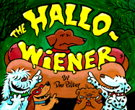
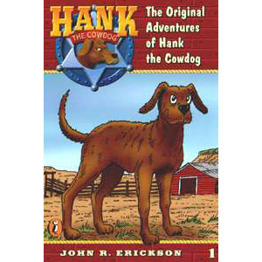
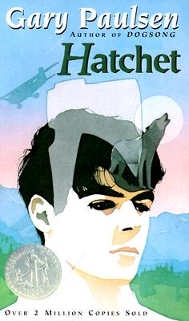
H
Reading Counts Quiz Titles H titles in blue are series
Call #: FIC = Fiction E = Everybody (Picture books) # = Nonfiction L = Language
H | AUTHOR | CALL # | READING LEVEL | POINTS
Hallo-Wiener, The | Pilkey, Dav | E PIL | 2.8 | 2
Halloween Joker, (Wishbone) | Capeci, Anne | FIC WIS | 5.1 | 11
Halmoni's Day | Bercaw, Edna C | E BER | 3.6 | 2
Hank the Cowdog: Further Adventures | Erickson, John R | FIC ERI | 5.4 | 7
Hank the Cowdog/Halloween | Erickson, John R | FIC ERI | 3.5 | 6
Hank the Cowdog: The Fling | Erickson, John R | FIC ERI | 3.9 | 7
Hank the Cowdog/Secret Laundry | Erickson, John R | FIC ERI | 3.5 | 7
Hank the Cowdog: VanishingFishHook | Erickson, John R. | FIC ERI | 3.5 | 7
Hank the Cowdog: Saddle House Mys | Erickson, John R. | FIC ERI | 3.5 | 7
Hansel and Gretel | Lesser, Rika | 398.2 LES | 4.2 | 2
Hansel y Gretel (spanish version) | Grimm, Brothers | L398.2GRI | 3.8 | 2
Happy Birthday, Addy (Amer Girls) | Porter, Connie R | FIC TRI | 4.7 | 3
Happy Birthday, Samantha (AmerGirls) | Tripp, Valerie | FIC TRI | 5.1 | 3
Happy Birthday, Josephina (AmerGirls) | Tripp, Valerie | FIC TRI | 5.9 | 3
Happy Feet | Michelson, R | E MIC | 3.4 | 3
Hard-to-See Animals | Fowler, Allan | 591.47FOW | 2.8 | 1
Harriet the Spy | Fitzhugh, Louise | FIC FIT | 6.2 | 11
Harriet Tubman: Conductor | Petry, Ann | 921 TUB | 5.9 | 13
Harry Potter & the Chamber of Secrets | Rowling, J.K. | FIC ROW | 5.9 | 18
Harry Potter & the Goblet of Fire | Rowling, J.K. | FIC ROW | 5.9 | 37
Harry Potter & the Half-Blood Prince | Rowling, J.K. | FIC ROW | 6.5 | 34
Harry Potter & Order of the Phoenix | Rowling, J.K. | FIC ROW | 5.9 | 49
Harry Potter & the Prisoner of Azkaban | Rowling, J.K. | FIC ROW | 5.9 | 22
Harry Potter & the Sorcerer’s Stone | Rowling, J.K. | FIC ROW | 5.3 | 16
Harry Potter & the Deathly Hallows | Rowling, J.K. | FIC ROW | 7.4 | 42
Hatchet | Paulsen, Gary | FIC PAU | 6.3 | 10
Hatching Magic | Downer, Ann | FIC DOW | 5.2 | 6
Hatchling (Guardians Of Ga'Hoole) | Lasky, Kathryn | FIC LAS | 4.5 | 11
Hats, Hats, Hats | Morris, Ann | E MOR | 1.5 | 1
Haunted Animals (True Ghost Storie | Zullo, Allan | 133.1 ZUL | 4.8 | 8
Haunted Campers (True Ghost Storie | Zullo, Allan | 133.1 ZUL | 5.1 | 10
Haunted Kids (True Ghost Stories | Zullo, Allan | 133.1 ZUL | 5.4 | 10
Haunted Schools (True Ghost Stories | Zullo, Allan | 133.1 ZUL | 5.4 | 10
Haunted Teachers (True Ghost Storie | Zullo, Allan | 133.1 ZUL | 5.2 | 9
Haunted School, The (Goosebumps) | Stine, R. L. | FIC STI | 4.2 | 6
Haunted Castle On Hallows Eve | Osborne, Mary P | FIC USB | 3.1 | 4
Have You Seen My Duckling? | Tafuri, Nancy | E TAF | 1.5 | 1
Hawaii – America the Beautiful | Hintz, Martin | 996.9 HIN | 9.0 | 6
Hawk Bandits of Tarkoom (Droon) | Abbot, Tony | FIC ABB | 3.2 | 5
Hawk, I’m Your Brother | Baylor, Byrd | E BAY | 3.3 | 2
Hawk Bandits of Tarkoom, The | Abbott, Tony | FIC ABB | 3.2 | 5
Heart, The | Simon, Seymour | 611 SIM | 4.8 | 2
Heat (Lupica) | Lupica, Mike | FIC LUP | 5.5 | 14
Heaven | Johnson, Angela | FIC JOH | 5.2 | 6
Heidi | Spyri, Johanna | FIC SPY | 7.9 | 15
Helen Keller | Davidson, Margaret | 921 KEL | 3.9 | 3
Hello Ocean | Ryan, Pam Munoz | E RYA | 3.1 | 1
Hello, Goodbye Window, The | Juster, Norton | E JUS | 3.3 | 1
Help! I’m a Prisoner in the Library | Clifford, Eth | FIC CLI | 5.2 | 4
Help! I'm trapped-first day... | Todd, Strasser | FIC TOD | 5.1 | 6
Henry & Mudge and the Bedtime Thum | Rylant, Cynthia | E RYL | 2.4 | 2
Henry & Mudge and the Wild Wind | Rylant, Cynthia | E RYL | 2.2 | 2
Henry & Mudge Get the Cold Shivers | Rylant, Cynthia | E RYL | 2.1 | 2
Henry & Mudge Under the Yellow Moo | Rylant, Cynthia | E RYL | 2.4 | 2
Henry & Mudge & Happy Cat | Rylant, Cynthia | E RYL | 1.5 | 2
Henry & Mudge In the Sparkle Days | Rylant, Cynthia | E RYL | 2.7 | 2
Henry & Mudge & Careful Cousin | Rylant, Cynthia | E RYL | 2.3 | 2
Henry & Mudge& Starry Night | Rylant, Cynthia | E RYL | 2.1 | 1
Henry & Mudge In Puddle Trouble | Rylant, Cynthia | E RYL | 2.2 | 2
Henry & Mudge In the Green... | Rylant, Cynthia | E RYL | 2.5 | 2
Henry & Mudge & the Wild Wind | Rylant, Cynthia | E RYL | 2.2 | 2
Henry & Mudge & Annie's Good... | Rylant, Cynthia | E RYL | 2.5 | 2
Henry & the Buccaneer Bunnies | Crimi, Carolyn | E CRI | 3.9 | 1
Henry and Beezus | Cleary, Beverly | FIC CLE | 5.7 | 6
Henry and Ribsy | Cleary, Beverly | FIC CLE | 5.1 | 5
Henry and the Clubhouse | Cleary, Beverly | FIC CLE | 5.6 | 6
Henry and the Paper Route | Cleary, Beverly | FIC CLE | 5.1 | 6
Henry Huggins | Cleary, Beverly | FIC CLE | 4.2 | 5
Henry Hikes to Fitchburg | Johnson, D. B. | E JOH | 2.3 | 1
Henry Reed, Inc | Robertson, Keith | FIC ROB | 5.7 | 11
Henry Reed's Baby-sitting | Robertson, Keith | FIC ROB | 5.5 | 8
Henry Reed's Think Tank | Robertson, Keith | FIC ROB | 4.2 | 6
Hercules Doesn’t Pull Teeth | Dadey, Debbie | FIC DAD | 2.8 | 3
Hershel and the Hanukkah Goblins | Kimmel, Eric A. | E KIM | 3.2 | 2
Hey, Al | Yorinks, Arthur | E YOR | 4.7 | 1
Hi! Fly Guy | Arnold, Tedd | E ARN | 1.6 | 1
Hidden Worlds: looking...Microscop | Kramer, Stephen | 570 KRA | 6.5 | 4
High Tide in Hawaii (Magic Tree H | Osborne, Mary P | FIC OSB | 2.3 | 3
Higher Power of Lucky, The | Patron, Susan | FIC PAT | 5.5 | 9
Hilda Must be Dancing (CYRM) | Wilson, Karma | E WIL | 3.0 | 1
Hill of Fire (anthology) | Lewis, Thomas P. | FIC LEW | 1.9 | 1
Historia de Ping, La (Spanish) | Flack, Marjorie | E FLA | 3.6 | 2
History News: Medicine, The | Gates, Phil | 610 GAT | 4.8 | 4
Hitty: Her First Hundred Years | Field, Rachel | FIC FIE | 8.1 | 15
Hive for the Honeybee, A | Lally, Soinbhe | FIC LAL | 7.8 | 9
Hobbit, The | Tolkien, J.R.R. | FIC TOL | 8.1 | 21
Hole in the Dyke (anthology) | Green, Norma | E GRE | 2.5 | 2
Holes | Sachar, Louis | FIC SAC | 5.2 | 12
Holly, Reindeer, and Colored Lights | Barth, Edna | 394.2 BAR | 5.4 | 5
Home Place, The | Dragonwagon, Cresc | E DRA | 4.5 | 2
Homecoming | Voigt, Cynthia | FIC VOI | 5.5 | 24
Homer Price | McCloskey, Robert | FIC McC | 7.3 | 6
Homes Around the World | Kalman, Bobbie | 392.36KAL | 1.5 | 2
Homesick: My Own Story | Fritz, Jean | FIC FRI | 5.5 | 9
Homework Machine, The | Gutman, Dan | FIC GUT | 3.7 | 7
Honest Abe | Kunhardt, Edith | 921 LIN | 3.3 | 2
Honest-to-goodness Truth, The | McKissack, P | E MCK | 3.3 | 2
Honey Makers, The | Gibbons, Gail | 595.79 GIB | 4.1 | 2
Honoring Our Ancestors | Rohmer, Harriet | 759.13HON | 4.8 | 2
Honus and Me | Gutman, Dan | FIC GUT | 3.5 | 5
Hooray for Diffendoofer Day | Seuss, Dr. | E SEU | 3.9 | 2
Hooway for Wodney Wat | Lester, Helen | E LES | 2.5 | 2
Hoot | Hiaasen, Carl | FIC HIA | 5.8 | 15
Hop on Pop | Seuss, Dr. | E SEU | 1.1 | 1
Hork-Bajir Chronicles (Animorphs) | Applegate, K. A. | FIC APP | 5.2 | 10
Horrible Harry & the Dungeon | Kline, Suzy | E KLI | 3.5 | 3
Horrible Harry & the Dragon War | Kline, Suzy | E KLI | 3.2 | 3
Horrible Harry at Halloween | Kline, Suzy | 394.2 KLI | 3.1 | 3
Horrible Harry & Holidaze | Kline, Suzy | E KLI | 3.5 | 3
Horse and His Boy, The | Lewis, C.S. | FIC LEW | 5.8 | 11
Horton Hatches the Egg | Seuss, Dr. | E SEU | 3.6 | 2
Horton Hears a Who! | Seuss, Dr. | E SEU | 3.8 | 2
Hostile Hospital (Unfortunate events | Snicket, L | FIC SNI | 6.8 | 11
Hot and Cold Summer | Hurwitz, Johanna | FIC HUR | 5.2 | 5
Hot-Air Henry | Calhoun, Mary | E CAL | 4.3 | 2
Hound at the Hospital (Animal Ark) | Baglio, Ben | FIC BAG | 4.2 | 7
Hour of the Olympics (Magic Tree H) | Osborne, Mary P | FIC OSB | 2.2 | 3
House for Hermit Crab | Carle, Eric | 595.3 CAR | 3.2 | 2
House is a House for Me, A | Hoberman, Mary A | E HOB | 2.9 | 2
House of Dies Drear | Hamilton, | FIC HAM | 5.9 | 13
House of Sixty Fathers, The | DeJong, Meindert | FIC DEJ | 5.5 | 9
House on the Cliff | Dixon, | FIC DIX | 6.1 | 10
House Spider's Life, A | Himmelman, John | 595.4 HIM | 2.6 | 1
How Do Dinosaurs Get Well Soon? | Yolen, Jane | audioEYOL | 1.9 | 1
How Do Dinosaurs Say Good Night? | Yolen, Jane | E YOL | 2.2 | 1
How do Dinosaurs Eat... | Yolen, Jane | E YOL | 2.2 | 1
How I Became a Pirate | Long, M | E LON | 2.3 | 2
How Many Days to America? | Bunting, Eve | E BUN | 3.2 | 2
How the Grinch Stole Christmas | Seuss, Dr. | E SEU | 3.6 | 2
How to Eat Fried Worms | Rockwell, Thomas | FIC ROC | 3.5 | 4
How to Hide a Butterfly & ... | Heller, Ruth | 595.7 HEL | 2.8 | 1
How to Hide an Octopus...(ant) | Heller, Ruth | 591.92 HEL | 2.9 | 1
How We Crossed the West | Schanzer, Rosalyn | 917.804SCH | 4.2 | 3
How Whales Walked Into the Sea | McNulty, Faith | 599.5 MCN | 4.8 | 2
Hunches in Bunches | Seuss, Dr. | E SEU | 2.9 | 2
Hundred Dresses, The | Estes, Eleanor | FIC EST | 4.5 | 3
Hundred Penny Box, The | Mathis, Sharon Bell | E MAT | 4.1 | 3
Hunting of the Last Dragon | Jordan, Sherryl | FIC JOR | 6.4 | 13
Hurricanes (What on Earth?) | Chambers, Catherin | 551.55 CHA | 4.9 | 3
Hurry Home, Candy | DeJong, Meindert | FIC DEJ | 5.4 | 9
Hush! A Thai Lullaby | Ho, Minfong | E HO | 3.9 | 1
Husky in a Hut (Animal Ark) | Baglio, Ben | FIC BAG | 4.1 | 7

