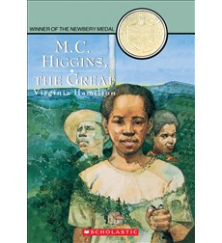
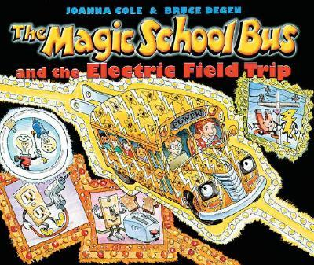
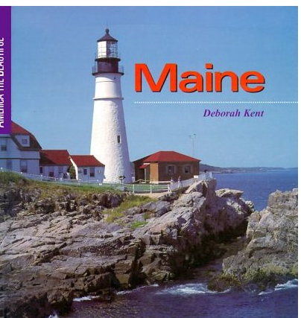
Reading Counts quiz titles. Blue titles are series books.
Call #: FIC = Fiction. E = Everybody (picture books) # = Nonfiction L = Language
M | AUTHOR | CALL # | READING LEVEL | POINTS
M.C. Higgins, The Great | Hamilton, Virginia | FIC HAM | 6.2 | 16
Madeline | Bemelmans, Ludw | E BEM | 3.8 | 3
Madeline’s Rescue | Bemelmans, Ludw | E BEM | 3.4 | 1
Magic Escapes, The (Droon) | Abbott, Tony | FIC ABB | 3.1 | 6
Magic of Spider Woman, The | Duncan, Lois | 398.2 DUN | 4.9 | 3
Magic School Bus and the Electric Field Trip | Cole, Joanna | 621.3 COL | 3.5 | 2
Autobus magico: mariposa y el mo... | Cole, Joanna | L E COL | 3.8 | 3
Autobus magico va contra la corri... | Cole, Joanna | L E COL | 3.8 | 3
Autobus magico: se salpica todo... | Cole, Joanna | L E COL | 3.1 | 2
Autobus magico: muestra y cuenta... | Cole, Joanna | L E COL | 3.4 | 3
Autobus magico: en el cuerpo de Ra.. | Cole, Joanna | L E COL | 3.2 | 2
Magician's Nephew, The (Narnia) | Lewis, C.S | FIC LEW | 5.6 | 11
Maine - America the Beautiful | Kent, Deborah | 947.1 KEN | 8.7 | 6
Magic Tree House:
Aftenoon on the Amazon (MTH) | Osborne, Mary P | FIC OSB | 3.1 | 3
Blizzard of the Blue Moon (MTH) | Osborne, Mary P | FIC OSB | 3.1 | 5
Buffalo Before Breakfast (MTH) | Osborne, Mary P | FIC OSB | 2.5 | 3
Civil War on Sunday (MTH) | Osborne, Mary P | FIC OSB | 2.3 | 4
Day of the Dragon King (MTH) | Osborne, Mary P | FIC OSB | 2.3 | 3
Dingos at Dinnertime (MTH) | Osborne, Mary P | FIC OSB | 3.5 | 3
Dolphins at Daybreak (MTH) | Osborne, Mary P | FIC OSB | 2.2 | 3
Earthquake – Early Morning (MTH) | Osborne, Mary P | FIC OSB | 2.4 | 4
Ghost Town at Sundown (MTH) | Osborne, Mary P | FIC OSB | 2.2 | 3
Good Morning, Gorillas (MTH) | Osborne, Mary P | FIC OSB | 2.3 | 3
High Tide in Hawaii (MTH) | Osborne, Mary P | FIC OSB | 2.3 | 3
Hour of the Olympics (MTH) | Osborne, Mary P | FIC OSB | 2.2 | 3
Knight at Dawn, The (MTH) | Osborne, Mary P | FIC OSB | 2.5 | 3
Lions at Lunchtime (MTH) | Osborne, Mary P | FIC OSB | 2.8 | 3
Midnight on the Moon (MTH) | Osborne, Mary P | FIC OSB | 2.1 | 3
Mummies in the Morning (MTH) | Osborne, Mary P | FIC OSB | 3.5 | 3
Night of the Ninjas (MTH) | Osborne, Mary P | FIC OSB | 2.1 | 3
Pirates Past Noon (MTH) | Osborne, Mary P | FIC OSB | 2.5 | 3
Pirates: a Nonfiction... (MTH) | Osborne, Will | FIC OSB | 2.9 | 3
Polar Bears Past Bedtime (MTH) | Osborne, Mary P | FIC OSB | 3.2 | 3
Revolutionary War on Wed. (MTH) | Osborne, Mary P | FIC OSB | 2.2 | 3
Stage Fright on a Summer Ni (MTH) | Osborne, Mary P | FIC OSB | 2.4 | 3
Sunset of the Sabertooth (MTH) | Osborne, Mary P | FIC OSB | 2.8 | 3
Thanksgiving on Thursday (MTH) | Osborne, Mary P | FIC OSB | 2.2 | 3
Tigers at Twilight (MTH) | Osborne, Mary P | FIC OSB | 2.3 | 3
Tonight on the Titanic (MTH) | Osborne, Mary P | FIC OSB | 2.2 | 3
Twister on Tuesday (MTH) | Osborne, Mary P | FIC OSB | 2.4 | 3
Vacation Under the Volcano (MTH) | Osborne, Mary P | FIC OSB | 2.2 | 3
Viking Ships at Sunrise (MTH) | Osborne, Mary P | FIC OSB | 2.3 | 3
Magician's Nephew, The (Narnia) | Lewis, C.S. | FIC LEW | 5.6 | 11
Maine - America the Beautiful | Kent, Deborah | 974.1 KEN | 8.7 | 6
Make Way for Ducklings | McCloskey, Rober | E MCC | 3.1 | 2
Malcolm X: Fire Burning... | Myers, Walter | 921 X | 3.5 | 3
Mama, Do You Love Me? | Joosse, Barbara | E JOO | 1.9 | 1
Man Who Walked Between the Towers, | Gerstein, Mordicai | 921GER/Audio | 2.5 | 1
Mandy | Edwards, Julie | FIC EDW | 4.8 | 9
Maniac Magee | Spinelli, Jerry | FIC SPI | 5.4 | 8
Many Moons | Thurber, James | FIC THU | 4.1 | 3
Margaret and Margarita/Margarita y Margaret | Reiser, Lynn | L E REI | 1.9 | 1
Margarita y Margaret | Reiser, Lynn | L E RIE | 1.5 | 1
Maria's Comet | Hopkinson, Debora | E HOP | 3.9 | 2
Marie Antoinette: Princess... | Lasky, Kathryn | FIC LAS | 5.5 | 8
Marie Curie: A Brilliant Life | MacLeod, Elizabet | 921 CUR | 5.4 | 4
Marlfox (Redwalll) | Jacques, Brian | FIC JAC | 6.9 | 21
Mars (Galaxy) | Kipp, Steven L. | 523.43 KIP | 2.5 | 3
Martial Arts | Knotts, Bob | 796.8 KNO | 3.9 | 3
Martians Don’t Take Temperatures (Bailey) | Dadey, Debbie | FIC DAD | 3.5 | 3
Martin the Warrior (Redwall) | Jacques, Brian | FIC JAC | 5.5 | 20
Marvin K. Mooney, Will You Please Go Now! | Seuss, Dr. | E SEU | 2.4 | 1
Mary Celeste | Yolen, Jane | FIC YOL | 5.7 | 2
Mary on Horseback | Wells, Rosemary | 610.73 WEL | 5.5 | 3
Maryland - America the Beautiful | Burgan, Michael | 975.2 BUR | 8.8 | 6
Massachusetts - America the Beautiful | McNair, Sylvia | 974.4 MCN | 9.0 | 6
Matchlock Gun, The | Edmonds, Walter | FIC EDM | 5.7 | 3
Math Curse | Scieszka, Jon | E SCI | 3.8 | 2
Matilda | Dahl, Roald | FIC DAH | 5.2 | 10
Matilda Bone | Cushman, Karen | FIC CUS | 6.3 | 10
Max's Chocolate Chicken | Wells, Rosemary | E WEL | 1.5 | 1
May Bird and the Ever After | Anderson, Jodi L | FIC AND | 4.8 | 19
May Bird Among the Stars | Anderson, Jodi L | FIC AND | 4.8 | 14
May I Bring a Friend? | De Regniers, Beatri | E DER | 3.4 | 1
McBroom Tells the Truth | Fleishman, Sid | FIC FLE | 3.9 | 2
McBroom's Ghost | Fleishman, Sid | FIC FLE | 4.8 | 2
McElligot’s Pool | Seuss, Dr. | E SEU | 3.7 | 2
Mean Soup | Everitt, Betsy | E EVE | 1.1 | 1
Meet Addy (American Girls) | Porter, Connie R | FIC TRI | 5.1 | 3
Meet Felicity (American Girls) | Tripp, Valerie | FIC TRI | 5.2 | 3
Mercury (Galaxy) | Kipp, Steven L. | 523.41 KIP | 2.5 | 3
Mercy Watson Goes for a Ride | DiCamillo, Kate | FIC DIC | 2.3 | 2
Mermaids Don’t Run Track | Dadey, Debbie | FIC DAD | 3.5 | 3
Message, The (Animorphs) | Applegate,K.A. | FIC APP | 5.3 | 8
Mexico | Fontes, Justine | 972 FON | 4.0 | 3
Mice and Beans | Ryan, Pam Munoz | E RYA | 2.7 | 2
Mice Twice | Low, Joseph | E LOW | 2.1 | 2
Michigan - America the Beautiful | Hintz, Martin | 977.4 HIN | 9.0 | 6
Midnight (Warriors, New Prophesy) | Hunter, Erin | FIC HUN | 5.6 | 18
Midnight for Charlie Bone | Nimmo, Jenny | FIC NIM | 5.4 | 15
Midnight Fox, The | Byars, Betsy | FIC BYA | 5.1 | 8
Midnight on the Moon (MTH) | Osborne, Mary P | FIC OSB | 2.1 | 3
Midwife's Apprentice, The | Cushman, Karen | FIC CUS | 5.2 | 7
Mieko and the Fifth Treasure | Coerr, Eleanor | FIC COE | 5.9 | 3
Millicent and the Wind | Munsch, Robert | E MUN | 4.1 | 2
Millicent Min, Girl Genius | Yee, Lisa | FIC YEE | 5.5 | 13
Millie waits for the mail | Steffensmeier, A | E STE | 2.0 | 1
Minn of the Mississippi | Holling, Clancy | FIC HOL | 4.7 | 6
Minty: A Story of Young Harriet Tubman | Schroeder, Alan | FIC SCH | 3.9 | 2
Miracles on Maple Hill | Sorensen, Virginia | FIC SOR | 6.1 | 12
Miraculous.. Edward Tulane | DiCamillo, Kate | FIC DIC | 4.5 | 6
Mirandy and Brother Wind | McKissack, P | E MCK | 3.5 | 2
Mirette on the High Wire | McCully, Emily | E MCC | 4.1 | 2
Miserable Mill, The | Snicket, Lemony | FIC SNI | 6.6 | 9
Miss Bindergarten Stays Home | Slate, Joseph | E SLA | 2.1 | 1
Miss Bindergarten Celebrates | Slate, Joseph | E SLA | 2.4 | 1
Miss Hickory | Bailey, Carolyn | FIC BAI | 5.2 | 6
Miss Nelson is Missing! | Allard, Harry | E ALL | 3.1 | 2
Miss Rumphius | Cooney, Barbara | audio E COO | 2.9 | 2
Miss Smith's Incredible Storybook | Garland, M | E GAR | 3.7 | 1
Miss Spider's ABC | Kirk, David | E KIR | 1.9 | 1
Missing May | Rylant, Cynthia | FIC RYL | 6.7 | 5
Mississippi - America the Beautiful | George, Charles | 976.2 GEO | 9.0 | 6
Missouri - America the Beautiful | Hintz, Martin | 977.8 HIN | 8.8 | 6
Misty of Chincoteague | Henry, Marguerite | FIC HEN | 5.8 | 5
Mitch and Amy | Cleary, Beverly | FIC CLE | 5.1 | 9
Moffats, The | Estes, Eleanor | FIC EST | 4.2 | 10
Moira’s Birthday | Munsch, Robert | E MUN | 2.5 | 2
Molly Bannaky | McGill, Alice | E MCG | 4.9 | 3
Molly's Pilgram | Cohen, Barbara | FIC COH | 2.8 | 3
Momma, Where Are You From? | Bradby, Marie | E BRA | 3.5 | 1
Monk Camps Out | McCully, Emily A. | E MCC | 1.6 | 1
Monkey Island | Fox, Paula | FIC FOX | 6.5 | 7
Monkeys and Other Mammals | Schulte, Mary | 599 SCH | 1.8 | 1
Monster Blood: GooseBumps | Stine, R. L | FIC STI | 4.9 | 7
Monsters Don’t Scuba Dive | Dadey, Debbie | FIC DAD | 3.5 | 3
Moon, The | Carruthers, Margaret | 523.3 CAR | 7.4 | 1
Moon, The | Lassieur, Allison | 523.3 LAS | 3.2 | 3
Moon Dragon, The | Abbott, Tony | FIC ABB | 3.5 | 5
Moon Was At A Fiesta, The | Gollub, Matthew | E GOL | 3.2 | 2
Moongame | Asch, Frank | E ASC | 3.1 | 1
Moonrise (Warriors New Prophesy) | Hunter, Erin | FIC HUN | 5.2 | 17
Moorchild, The | McGraw, Eloise | FIC MCG | 5.4 | 12
Moosetache | Palantini, Margie | E PAL | 2.8 | 2
More More More, Said the Baby | Williams, Vera B. | E WIL | 2.3 | 1
More Perfect Union, A | Masestro, Betsy | 342.73 MAE | 5.2 | 2
More Sideways Arithmetic...Wayside School | Sachar, Louis | FIC SAC | 5.1 | 3
More Than Anything Else | Bradby, Marie | E BRA | 3.1 | 2
Morning Girl | Dorris, Michael | FIC DOR | 6.3 | 4
Morris's Disappearing Bag | Wells, Rosemary | E WEL | 2.9 | 1
Mortimer | Munsch, Robert | E MUN | 2.8 | 1
Moss Flower (Redwall) | Jacques, Brian | FIC JAC | 6.9 | 24
Most Beautiful Roof In-World | Lasky, Kathryn | 574.5 LAS | 4.2 | 4
Mount Olympus Basketball | O'Malley, Kevin | E OMA | 2.7 | 2
Mountain Pose | Wilson, Nancy H. | FIC WIL | 5.5 | 13
Mountains | Simon, Seymour | 551.432 | 5.3 | 2
Mouse and the Motorcycle, The | Cleary, Beverly | FIC CLE | 4.1 | 7
Mouse Mess | Riley, Linnea | E RIL | 1.5 | 1
Mouse Tales | Lobel, Arnold | E LOB | 2.6 | 2
Mouse TV | Novak, Matt | E NOV | 2.6 | 1
Mr. Bear's Vacation | Gliori, Debi | E GLI | 2.4 | 2
Mr. Brown Can Moo! Can You? | Seuss, Dr. | E SEU | 2.9 | 1
Mr. Lincoln's Way | Polacco, Patricia | E POL | 3.2 | 2
Mr. Maxwell's Mouse | Asch, Frank | E ASC | 4.2 | 3
Mr. Popper's Penguins | Atwater, Richard | FIC ATW | 4.9 | 5
Mrs. Frisby & the Rats of NIMH | O’Brien, Robert | FIC OBR | 5.8 | 10
Ms. Frizzle's Achient Egypt | Cole, Joanna | 932 COL | 3.1 | 2
MSB Explores the Senses | Cole, Joanna | 612.8 COL | 3.5 | 2
MSB In The Time of Dinosaurs | Cole, Joanna | 567.9 COL | 3.3 | 2
MSB Inside a Beehive | Cole, Joanna | 595.79 COL | 3.7 | 2
MSB Inside a Hurricane | Cole, Joanna | E COL | 3.6 | 2
Mud Puddle | Munsch, Robert | E MUN | 3.5 | 2
Mufaro’s Beautiful Daughters | Steptoe, John | E STE | 5.2 | 2
Muggie Maggie | Cleary, Beverly | FIC CLE | 5.1 | 5
Mummies & Pyramids (MagicTreeH non fic) | Osborne, Will | FIC OSB | 2.9 | 3
Mummies Don’t Coach Softball (Bailey Sch) | Dadey, Debbie | FIC DAD | 3.5 | 3
Mummies in the Morning (Magic Tree H) | Osborne, Mary Pope | FIC OSB | 3.5 | 3
Muncha! Muncha! Muncha! | Fleming, Candace | E FLE | 2.6 | 1
Mutt In The Iron Muzzle, The (Wishbone) | Friedman, Michael J | FIC WIS | 4.4 | 8
My Baseball Book | Gibbons, Gail | 796.357 GIB | 2.8 | 1
My Basketball Book | Gibbons, Gail | 796.323 GIB | 2.8 | 2
My Best Friend | Hutchins, Pat | E HUT | 1.6 | 1
My Best Friend (Rodman) | Rodman, Mary Ann | E ROD | 1.9 | 1
My Brother Sam is Dead | Collier, James | FIC COL | 5.8 | 10
My Brother, Ant | Byars, Betsy | E BYA | 2.2 | 2
My Brother's Keeper: Virginia's diary (My Amer) | Osborne, Mary Pope | FIC OSB | 3.1 | 5
My Football Book | Gibbons, Gail | 796.332 GIB | 2.8 | 2
My Freedom Trip | Park, Frances | 951.93 PAR | 2.6 | 2
My Friend Flicka | O’Hara, Mary | FIC OHA | 6.8 | 20
My Friend Rabbit | Rohmann, Eric | E ROH | 2.3 | 1
My Grandmother’s Journey | Cech, John | E CEC | 4.8 | 2
My hairiest adventure (GooseBumps) | Stine, R. L. | FIC STI | 3.7 | 7
My Heart Is On The Ground (Dear Amer) | Rinaldi, Ann | FIC RIN | 5.2 | 10
My House | Jensen, Patricia | E JEN | 1.5 | 1
My House Has Stars | McDonald, Megan | E MCD | 3.4 | 2
My Light | Bang, Molly | 621.47 | 2.7 | 1
My Lucky Day (CYRM) | Kasza, Keiko | E KAS | 1.5 | 1
My Mama Had A Dancing Heart | Gray, LibbaMoore | E GRA | 4.5 | 1
My Many Colored Days | Seuss, Dr. | E SEU | 1.5 | 1
My Name Is Celia | Brown, Monica | L 782.421 BRO | 2.6 | 1
My New School | Hall, Kirsten | E HAL | 1.4 | 1
My New Town | Hall, Kirsten | E HAL | 1.2 | 1
My Rows and Piles of Coins | Mollel, TololwaM. | E MOL | 4.1 | 2
My Side of the Mountain | George, Jean | FIC GEO | 6.7 | 8
My Soccer Book | Gibbons, Gail | 796.334 GIB | 2.8 | 1
My Visit to the Dinosaurs | Aliki | 568 ALI | 2.8 | 2
Mysterious Miss Slade | King-Smith, Dick | FIC KIN | 5.6 | 5
Mysterious Island, The (Droon) | Abbott, Tony | FIC ABb | 3.1 | 4
Mystery At the Ballpark, The (Boxcar) | Warner, Gertrude C. | FIC WAR | 3.3 | 6
Mystery at the Ski Jump (Nancy Drew) | Keene, Carolyn | FIC KEE | 6.5 | 7
Mystery at Peacock Hall, The (Boxcar) | Warner, Gertrude C. | FIC WAR | 3.3 | 5
Mystery at the Club Sandwich (CYRM) | Cushman, Doug | E CUS | 4.0 | 2
Mystery of the Black Raven (Boxcar) | Warner, Gertrude C. | FIC WAR | 3.1 | 6
Mystery of the Cupboard, The (IndianInC) | Banks, Lynne Reid | FIC BAN | 6.1 | 12
Mystery of the Flying Orange | Kellogg, Steven | E KEL | 2.2 | 1
Mystery of the Purple Pool (Boxcar) | Warner, Gertrude C. | FIC WAR | 3.7 | 6
Mystery of the Queen's Jewels (Boxcar) | Warner, Gertrude C. | FIC WAR | 3.7 | 5
Mystery of the Stolen Sword (Boxcar) | Warner, Gertrude C. | FIC WAR | 3.9 | 5
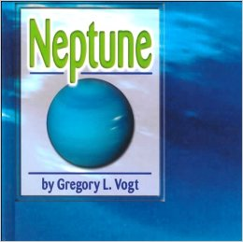  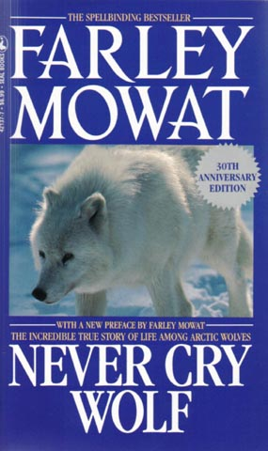  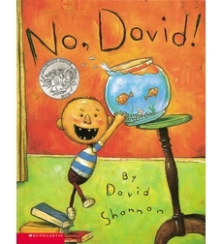  N | AUTHOR | CALL # | READING LEVEL | POINTS
N Back to top
Nacho and Lolita | Ryan, Pam | 398.2 RYA | 4.8 | 3
Name Jar, The | Choi, Yangsook | E CHO | 2.9 | 2
Napping House, The | Wood, Audrey | E WOO | 3.2 | 1
Nate the Great and the Lost List | Sharmat, Marjorie | FIC SHA | 2.5 | 3
Nature's Green Umbrella | Gibbons, Gail | 574.5 GIB | 4.8 | 3
Nebraska - America the Beautiful | McNair, Sylvia | 978.2 MCN | 8.7 | 6
Neptune (Galaxy) | Vogt, Gregory L. | 523.48 VOG | 2.5 | 3
Nettie’s Trip South | Turner, Ann | FIC TUR | 3.8 | 2
Never Cry Wolf | Mowat, Farley | 599.74 MOW | 7.5 | 13
New Coat For Anna, A | Ziefert, Harriet | E ZIE | 3.1 | 2
New Dinos: Latest Finds! | Tanaka, Shelley | 567.9 TAN | 5.7 | 4
New Jersey - America the Beautiful | Stein, R. Conrad | 974.9 STE | 8.9 | 6
New Kids in Town | Bode, Janet |  | 5.7 | 6
New Mexico - America the Beautiful | Kent, Deborah | 978.9 KEN | 8.9 | 6
New York - America the Beautiful | Heinrichs, Ann | 974.7 HEI | 8.8 | 6
Newts and Other Amphibians | Schulte, Mary | 597.8 SCH | 1.8 | 1
Niagra Falls Mystery, The (Boxcar) | Warner, Gertrude C. | FIC WAR | 3.6 | 6
Night Journey | Lasky, Kathryn | FIC LAS | 5.4 | 8
Night of the living dummy : GooseBumps | Stine, R. L. | FIC STI | 4.8 | 7
Night of the Gargoyles | Bunting, Eve | E BUN | 5.9 | 2
Night of the New Magicians (MTH) | Osborne, Mary Pope | FIC OSB | 2.1 | 3
Nim and the War Effort | Lee, Milly | E NIM | 5.5 | 2
Nine Days to Christmas | Ets, Marie |  | 3.5 | 2
Nine for California | Levitin, Sonia | E LEV | 2.8 | 2
No Dogs Allowed! | Wallace, Bill | FIC WAL | 3.4 | 10
No Good In Art | Cohen, Miriam | E COH | 2.2 | 2
No More Monsters For Me | Parish, Peggy | E PAR | 2.1 | 2
No Pretty Pictures: Child of | Lobel, Anita | 921 LOB | 4.8 | 10
No, David! | Shannon, David | E SHA | 1.1 | 1
Noisy Nora | Wells, Rosemary | E WEL | 2.8 | 1
Noonday Friends | Stolz, Mary | FIC STO | 5.7 | 8
North Carolina - America the Beautiful | Hintz, Martin | 975.6 HIN | 9.0 | 6
Nory Ryan's Song | Giff, Patricia | FIC GIF | 4.9 | 8
Nothing but the Truth | Avi | FIC AVI | 6.9 | 10
Nothing’s Fair in Fifth Grade | DeClements, Barthe | FIC DEC | 5.2 | 5
Number the Stars | Lowry, Lois | FIC LOW | 5.2 | 5
Nzingha: Warrior Queen (Royal Diaries) | McKissack, Patricia | FIC MCK | 5.9 | 7
  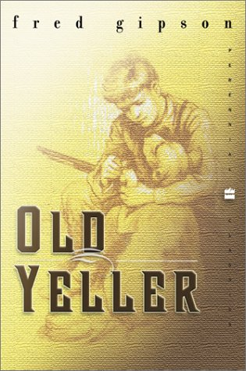  O Back to top | 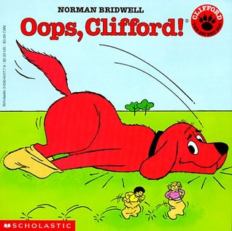
O, Say Can You See? | Keenan, Shelia | 973 KEE | 4.4 | 4
Octopuses and Squid | Legg, Gerald | 594 LEG | 5.2 | 3
Off to Bed Little Monster! (also in Spanish) | Ramos, Mario | L E RAM | 1.8 | 1
Officer Buckle and Gloria | Rathmann, Peggy | E RAT | 2.5 | 2
Oggie Cooder | Weeks, Sarah | FIC WEE | 5.7 | 7
Oh Kojo! How could you? | Aardema, Verna | E AAR | 3.7 | 2
Oh Say Can You Say? | Seuss, Dr. | E SEU | 3.5 | 2
Oh, the Places You’ll Go | Seuss, Dr. | E SEU | 3.2 | 2
Oh, the Thinks You Can Think! | Seuss, Dr. | E SEU | 2.3 | 1
Ohio - America the Beautiful | Heinrichs, Ann | 977.1 HEI | 9.0 | 6
Oklahoma - America the Beautiful | Reedy, Jerry | 976.6 REE | 9.0 | 6
Old Black Fly | Aylesworth, Jim | E AYL | 2.2 | 1
Old Ramon | Schaefer, Jack |  | 6.7 | 5
Old Yeller | Gipson, Fred | FIC GIP | 5.4 | 8
Oliver Button is a Sissy | DePaola, Tomi | E DEP | 2.8 | 2
Olivia | Falconer, Ian | E FAL | 1.9 | 1
Olivia Saves the Circus | Falconer, Ian | E FAL | 2.1 | 1
On Beyond Zebra! | Seuss, Dr. | E SEU | 3.3 | 2
On Market Street | Lobel, Arnold | 411 LOB | 1.7 | 1
On Market Street | Lobel, Arnold | E LOB | 1.7 | 1
On My Honor | Bauer, Marion | FIC BAU | 5.6 | 4
On the Banks of Plum Creek | Wilder, Laura Ingalls | FIC WIL | 5.2 | 14
On the Far Side of the Mountain | George, Jean | FIC GEO | 5.8 | 8
On the Farm | Pluckrose, Henry | 631.3 PLU | 3.9 | 1
On the Move (anthology) | Pluckrose, Henry | 629.04 PLU | 1.5 | 1
On the Way Home | Wilder, Laura Ingalls | 921WIL | 5.1 | 5
Once a Mouse | Brown, Marcia | 398.2 BRO | 3.4 | 1
One Day in Horrorland (GooseBumps) | Stine, R.L. | FIC STI | 4.4 | 6
One Day In-Tropical Rain Forest | George, Jean Craighea | 508.315 GEO | 5.5 | 3
One Fine Day | Hogrogian, Nonny | 398.2 HOG | 3.4 | 2
One Fish, Two Fish, Red … | Seuss, Dr. | E SEU | 1.1 | 2
One in the Middle is the Green Kangaroo, | Blume, Judy | E BLU | 2.1 | 2
One of Three | Johnson, Angela | E JOH | 4.3 | 1
One Well: The story of water | Strauss, Rochelle | 553.7 STR | 5.8 | 4
One-Eyed Cat | Fox, Paula | FIC FOX | 5.7 | 5
Onion John | Krumgold, Joseph | FIC KRU | 5.1 | 14
Oops! | McNaughton, Colin | E MCN | 1.5 | 1
Oops, Clifford! | Bridwell, Norman | PB B | 2.3 | 1
Oruga muy hambrienta, La | Carle, Eric | L E CAR | 3.3 | 1
The Other Side | Woodson, Jacqueline | E WOO | 2.6 | 2
Otherwise Known as Shelia the Great | Blume, Judy | FIC BLU | 4.2 | 5
Otis Spofford | Cleary, Beverly | FIC CLE | 5.1 | 6
Our Planet (Worldwise) | Steedman, Scott | 551 STE | 6.5 | 3
Our Strange New Land (My America) | Hermes, Patricia | FIC HER | 3/1 | 5
Out of the Dust | Hesse, Karen | FIC HES | 5.1 | 5
Outsiders, The | Hinton, S.E. | FIC HIN | 5.1 | 10
Over in the Meadow (book and video) | Langstaff, John | E LAN | 4.5 | 1
Owen | Henkes, Kevin | E HEN | 2.5 | 1
Owl Moon | Yolen, Jane | E YOL | 2.9 | 2
Owls | Gibbons, Gail | 598.97 GIB | 4.3 | 3
Owls in The Family | Mowat, Farley | FIC MOW | 5.9 | 6
Owney, the mail-pouch pooch (CYRM) | Kerby, Mona | E KER | 4.0 | 3
Ox-Cart Man | Hall, Donald | E HAL | 4.2 | 2
Ox-Cart Man | Hall, Donald | PB H | 4.2 | 2
Ozone Layer, The (True Book) | Donald, Rhonda | 551.51 DON | 5.8 | 3
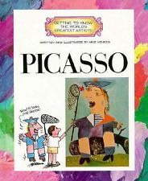
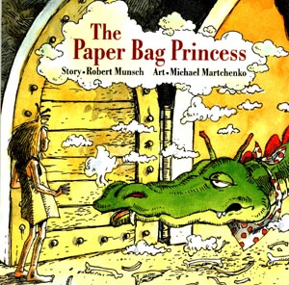

Reading Counts quiz titles. Blue titles are series books.
Call #: FIC = Fiction. E = Everybody (picture books) # = Nonfiction L = Language
P Back to top | Author | Call number | RL | Points
Paddington Bear and the Christmas Surprise | Bond, Michael | 394.2 CHR | 4.8 | 2
Paddington Helps Out | Bond, Michael | FIC BON | 5.1 | 7
Paddle-to-the-Sea | Holling, Holling | FIC HOL | 4.5 | 3
Palace of Mirrors | Haddix, Margaret | FIC HAD | 4.8 | 16
Pancakes for Breakfast | DePaola, Tomie | E DEP | 1.1 | 1
Papa Lucky's Shadow | Daly, Niki | E DAL | 4.3 | 1
Papa's Mark | Battle-Lavert, Gw | E BAT | 2.1 | 3
Paper Bag Princess, The | Munsch, Robert | E MUN | 3.5 | 1
Paper Crane, The | Bang, Molly | E BAN | 3.5 | 1
Paperboy (Holland) | Holland, Isabelle | FIC HOL | 6.1 | 9
Paperboy, The | Pilkey, Dav | E PIL | 3.5 | 1
Parrots and Other Birds | Schulte, Mary | 598 SCH | 1.6 | 1
Passage to Freedom... | Mochizuki, Ken | 940.53MOC | 4.2 | 2
Passover (True Book) | Sanders, Nancy | 296.4 SAN | 3.9 | 3
Patchwork Quilt, The | Flournoy, Valerie | E FLO | 3.5 | 2
Patriotism | Raatma, Lucia | 320.54 RAA | 1.5 | 1
Patrol: an American Soldier in VN | Myers, Walter | E MYE | 3.1 | 2
Paul Revere's Ride | Longfellow, Henr | 811 LON | 5.1 | 2
Pearl's New Skates | Keller, Holly | E KEL | 2.3 | 1
Pecos Bill: A Tall Tale | Kellogg, Steven | 398.2 KEL | 3.9 | 2
Pegasus | Mayer, Marianna | 398.2 MAY | 5.9 | 3
Penultimate Peril, The (Unfortunate) | Snicket, Lemony | FIC SNI | 6.9 | 14
Peppe the Lamplighter | Bartone, Elisa | E BAR | 4.3 | 2
Perfect Nest, The (CYRM) | Friend, Catherine | E FRI | 2.8 | 1
Perfect Pet, The | Palatini, Margie | E PAL | 2.5 | 2
Perfect Place: Joshua's Oregon (My Amer) | Hermes, Patricia | FIC HER | 3.2 | 5
Perilous Road, The | Steele, William | FIC STE | 5.6 | 7
Pete's a Pizza | Steig, William | E STE | 2.8 | 1
Peter and the Starcatchers | Barry, David | FIC BAR | 6.2 | 19
Peter and the Wolf | Vagin, Vladimir | E VAG | 2.8 | 2
Peter Pan | Barrie, J. M. | FIC BAR | 6.1 | 11
Peter's Chair | Keats, Ezra Jack | E KEA | 2.6 | 1
Petey’s Bedtime Story | Cleary, Beverly | E CLE | 3.9 | 2
Petunia | Duvoisin, Roger | audioE DUV | 2.3 | 2
Phillip Hall Likes Me, I Reckon | Greene, Bette | FIC GRE | 5.2 | 7
Phineas L. MacGuire... Erupts (CYRM) | Dowell, Frances | FIC DOW | 4.8 | 7
Phoebe the Spy | Griffin, Judith B | 973.4 GRI | 4.2 | 3
Picasso (Artists) | Venezia, Mike | 921 PIC | 5.4 | 3
Picture Book of Amelia Earhart | Adler, David | 921 EAR | 5.1 | 3
Picture Book of Anne Frank, A | Adler, David | 921 FRA | 5.2 | 2
Picture Book of Benjamin Franklin | Adler, David | 921 FRA | 3.1 | 2
Picture Book of George Washington | Adler, David | 921 WAS | 3.3 | 2
Picture Book of Harriett Tubman | Adler, David | 921 TUB | 4.7 | 2
Picture Book of Helen Keller | Adler, David | 921 KEL | 3.9 | 2
Picture Book of Jackie Robinson | Adler, David | 921 ROB | 4.9 | 2
Picture Book of Jesse Owens, A | Adler, David | 921 OWE | 5.2 | 2
Picture Book of Martin L King Jr. | Adler, David | 921 KIN | 3.5 | 2
Picture Book of Rosa Parks, A | Adler, David | 921 PAR | 5.1 | 2
Picture Book of Sojourner Truth | Adler, David | 921 TRU | 4.3 | 2
Picture Book of Thomas A. Edison | Adler, David | 921 EDI | 5.5 | 2
Pig Pig Gets a Job | McPhail, David | E MCP | 2.2 | 1
Piggie Pie | Palatine, Margie | E PAL | 2.7 | 2
Piggies | Wood, Don | E WOO | 1.5 | 1
Pigs | Munsch, Robert | E MUN | 2.1 | 2
Pigs Go to Market: Halloween Fun... Math | Axelrod, Amy | E AXE | 3.5 | 2
Pigs in the Mud in the Middle of the Rud | Plourde, Lynn | E PLO | 1.5 | 1
Pigs in the Pantry | Axelrod, Amy | E AXE | 3.9 | 2
Pigs will be Pigs | Axelrod, Amy | E AXE | 2.2 | 1
Pigsty | Teague, Mark | E TEA | 2.9 | 1
Pilgrims of Plimoth | Sewall, Marcia | 974.4 SEW | 5.8 | 3
Pill Bug's Life, A | Himmelman, John | 595.3 HIM | 2.5 | 1
Pinata Maker, The | Ancona, George | L 745.5 ANC | 4.5 | 2
Pinduli | Cannon, Janell | E CAN | 3.7 | 2
Pinkeye | Gordon, Sharon | 617.7 GOR | 1.6 | 1
Pinky and Rex and the New Neighbors | Howe, James | E HOW | 3.9 | 2
Pinky and Rex and the Perfect Pumpkin | Howe, James | E HOW | 3.8 | 2
Pinky and Rex and the Bully | Howe, James | E HOW | 3.9 | 2
Pinky and Rex and Double-Dad Week | Howe, James | E HOW | 3.6 | 2
Pioneering Women of the ... | Savage, Jeff | 978 SAV | 5.9 | 5
Pippi Longstocking | Lindgren, Astrid | FIC LIN | 5.2 | 7
Piranhas and Other Fish | Schulte, Mary | 597 SCH | 1.9 | 1
Pirates Don’t Wear Pink Sunglasses (Bailey) | Dadey, Debbie | FIC DAD | 3.8 | 3
Pirates don't Change Diapers | Long, Melinda | E LON | 2.8 | 1
Pirates of the Purple Dawn (Droon) | Abbott, Tony | FIC ABB | 4.3 | 5
Pirates Past Noon MTH | Osborne, Mary P | FIC OSB | 4.3 | 5
Pirates: a Nonfiction companion MTH | Osborne, Mary P | 910.4 OSB | 2.9 | 3
Pizza Mystery, The (Boxcar) | Warner, Gertrude | FIC WAR | 3.8 | 6
Planet of Junior Brown, The | Hamilton, Virgini | FIC HAM | 5.5 | 12
Play with Me | Ets, Marie | E ETS | 2.1 | 1
Polar Bear Night | Thompson, Laure | E THO | 2.3 | 1
Polar Bear Son | Dabcovich, Lydia | 398.24 DAB | 3.1 | 1
Polar Express | Van Allsburg, Ch | E VAN | 4.9 | 2
Policeman Lou/Policewoman Sue | Desimini, Lisa | E DES | 1.9 | 1
Pony For Keeps, A (PonyPals) | Betancourt, Jeann | FIC BET | 3.8 | 3
Pony in Trouble, A (PonyPals) | Betancourt, Jean | FIC BET | 3.9 | 3
Pony on the Porch (Animal Ark) | Baglio, Ben M. | FIC BAG | 4.5 | 5
Pony to the Rescue (PonyPals) | Betancourt, Jean | FIC BET | 3.7 | 3
Pooh Gets Stuck | Gaines, Isabel | E GAI | 1.9 | 1
Pooh's Halloween Parade | Gaines, Isabel | E GAI | 2.1 | 1
Pooh's Pumpkin | Gaines, Isabel | E GAI | 2.3 | 1
Pop's Bridge | Bunting, Eve | E BUN | 3.4 | 2
Popcorn Book, The | DePaola, Tomie | 641.6 DE | 3.3 | 2
Poppy | Avi | FIC AVI | 5.8 | 5
(Postcards from) Australia | Arnold, Helen | 994 ARN | 3.3 | 2
(Postcards from) Canada | Dawson, Zoe | 971 DAW | 3.3 | 2
(Postcards from) France | Arnold, Helen | 944 ARN | 2.8 | 2
(Postcards from) Ireland | Arnold, Helen | 941.5 ARN | 2.7 | 2
(Postcards from) Israel | Allard, Denise | 959.94 ALL | 3.5 | 2
(Postcards from) Japan | Dawson, Zoe | 952 DAW | 2.7 | 2
(Postcards from) Kenya | Arnold, Helen | 967.62 ARN | 2.2 | 2
(Postcards from) Russia | Arnold, Helen | 947 ARN | 3.1 | 2
(Postcards from) Vietnam | Allard, Denise | 959.7 ALL | 3.5 | 2
Precious and the Boo Hag | McKissack, Patri | E MCK | 3.8 | 2
Predator, The (Animorphs) | Applegote, K. A. | FIC APP | 5.1 | 8
Prince and the Pooch, The (Wishbone) | Leavitt, Caroline | FIC WIS | 4.3 | 5
Prince Caspian (Narnia) | Lewis, C.S. | FIC LEW | 5.6 | 10
Princess Academy | Hale, Shannon | FIC HAL | 4.8 | 16
Princess Furball | Huck, Charlotte | audio/398.2 | 4.7 | 2
Princess Knight, The | Funke, Cornelia | FIC FUN | 4.2 | 2
Principal from the Black Lagoon | Thaler, Mike | E THA | 2.3 | 1
Project Mulberry | Park, Linda Sue | FIC | 3.7 | 11
Promise is a Promise, A | Munsch, Robert | E MUN | 2.5 | 2
Puente hasta Terabithia, Un | Paterson, Katheri | FIC PAT | 6.9 | 7
Puppy in a Puddle (Animal Ark) | Baglio, Ben M. | FIC BAG | 4.2 | 7
Puppy Who Wanted a Boy, The | Thayer, Jane | E THA | 2.7 | 2
Purely Rosie Pearl | Cochrane, Patricia | FIC COC | 5.4 | 7
Purple, Green and Yellow | Munsch, Robert | E MUN | 2.4 | 2
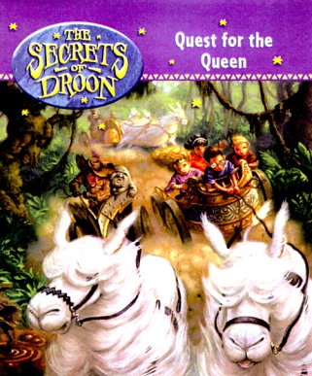
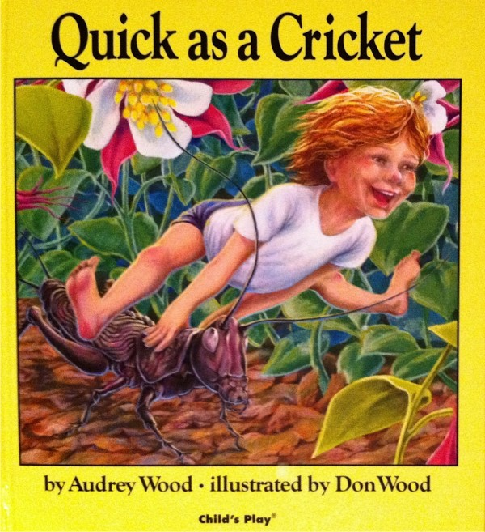
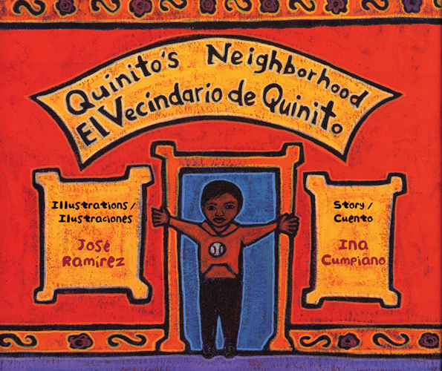

Q
Quest for the Queen (Droon) | Abbott, Tony | FIC ABB | 3.1 | 4
Quick as a Cricket | Wood, Audrey | E WOO | 2.8 | 1
Quiltmaker's Gift, The | Brumbeau, Jeff | E BRU | 5.1 | 2
Quinito's Neighborhood | Cumpiano, Ina | L E CUM | 2.5 | 1

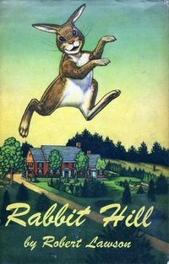
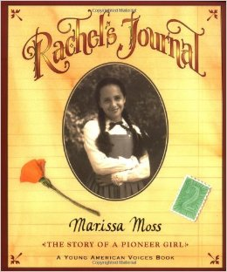
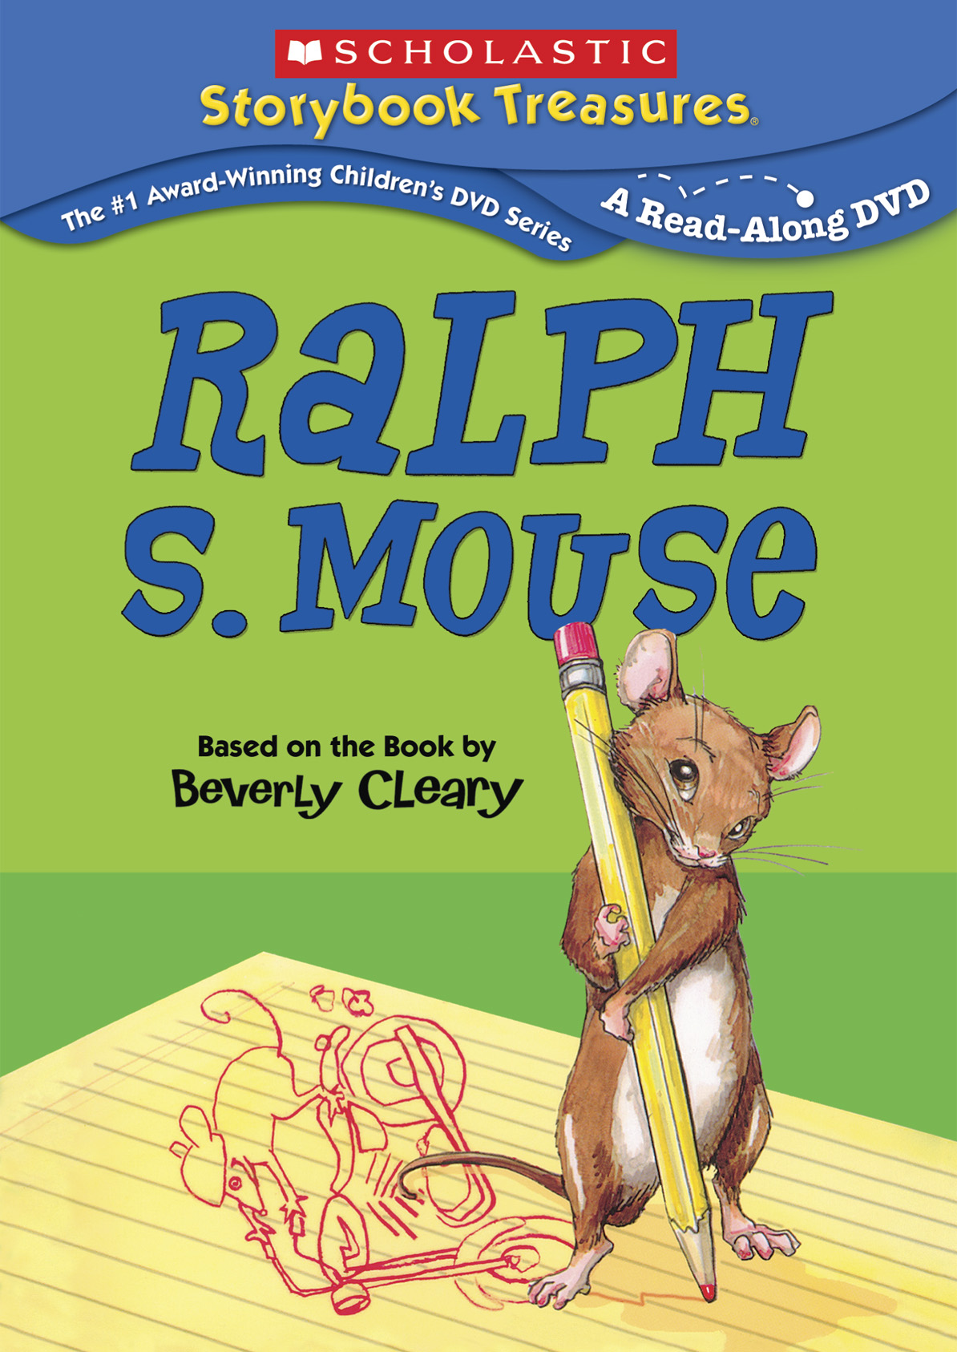
Reading Counts quiz titles. Blue titles are series books.
Call #: FIC = Fiction. E = Everybody (picture books) # = Nonfiction L = Language

R | AUTHOR | CALL # | READING LEVEL | POINTS
Rabbit Hill | Lawson, Robert | FIC LAW | 5.4 | 6
Rabbits, Pikas, and Hares | Miller, Sara | 599.32 MIL | 5.1 | 3
Race to Doobesh, The (Droon) | Abbott, Tony | FIC ABB | 3.1 | 5
Rachel's Journal | Moss, Marissa | FIC MOS | 5.2 | 3
Radio Rescue | Barasch, Lynne | E BAR | 3.6 | 2
Rag Coat, The | Mills, Lauren | E MIL | 4.1 | 2
Rain Player | Wisniewski, Dav | E WIS | 5.9 | 2
Rainbow Fish, The | Pfister, Marcus | E PFI | 3.3 | 2
Ralph S. Mouse | Cleary, Beverly | FIC CLE | 4.1 | 5
Ramona Quimby, Age 8 | Cleary, Beverly | FIC CLE | 3.5 | 6
Ramona and her Father | Cleary, Beverly | FIC CLE | 5.4 | 6
Ramona and her Mother | Cleary, Beverly | FIC CLE | 4.1 | 6
Ramona Forever | Cleary, Beverly | FIC CLE | 4.1 | 6
Ramona the Brave | Cleary, Beverly | FIC CLE | 3.5 | 5
Ramona the Pest | Cleary, Beverly | FIC CLE | 4.1 | 6
Ramona’s World | Cleary, Beverly | FIC CLE | 5.9 | 6
Rap a Tap Tap | Dillon, Leo | FIC DIL | 2.1 | 1
Rapunzel | Zelinsky, Paul | audio 398.2 | 3.8 | 2
Rascal | North, Sterling | FIC NOR | 7.1 | 12
Rats (Scary Creatures) | Legg, Gerald | 599.35LEG | 4.8 | 2
Raven: A Trickster Tale... Pacific Northwest | McDermott, Geral | 398.2 MCD | 2.8 | 2
Reaching for the the Moon | Aldrin, Buzz | 921 ALD | 4.3 | 3
Reaction, The (Animorphs) | Applegate, K. A. | FIC APP | 5.3 | 8
Real Hole, The | Cleary, Beverly |  | 2.4 | 2
Reason for a Flower, The | Heller, Ruth | 582 HEL | 3.4 | 1
Reasons for Seasons, The | Gibbons, Gail | 525.5 GIB | 4.4 | 2
Rechenka’s Eggs | Polacco, Patricia | E POL | 3.5 | 2
Red Dancing Shoes | Patrick, Denise | E PAT | 2.7 | 2
Red Dog | Wallace, Bill | FIC WAL | 5.2 | 7
Red-Eyed Tree Frog | Cowley, Joy | 597.8 COW | 2.8 | 1
Redwall (Redwall) | Jacques, Brian | FIC JAC | 7.8 | 22
Relatives Came, The | Rylant, Cynthia | E RYL | 3.1 | 1
Remarkable Farkle McBride, The | Lithgow, John | E LIT | 4.5 | 1
Report to the Principal’s Office | Spinelli, Jerry | FIC SPI | 5.6 | 5
Reptile Room, The (Unfortunate) | Snicket, Lemony | FIC SNI | 6.4 | 9
Return of the Indian (Indian in the cupbrd) | Banks, Lynne Rei | FIC BAN | 5.5 | 8
Return of the King (Lord of the Rings) | Tolkien, J. R.R. | FIC TOL | 9.0 | 27
Return of the Mummy (GooseBumps) | Stine, R. L. | FIC STI | 4.6 | 6
Reunion, The (Animorphs) | Applegate, K. A. | FIC APP | 5.4 | 8
Revolutionary War on Wed. (MTH) | Osborne, | FIC OSB | 2.2 | 3
Revolutionary War, The | January, Brendan | 973.3 JAN | 4.3 | 2
Reward for Josefina, A (American Girls) | Tripp, Valerie | FIC TRI | 5.2 | 3
Riddle of the Rosetta Stone | Giblin, James | 493 GIB | 5.5 | 3
Riddle of Zorfendork Castle (Droon) | Abbott, Tony | FIC ABB | 3.1 | 5
Riding Freedom | Ryan, Pam Munoz | FIC RYA | 4.8 | 5
Rikki-Tikki-Tavi | Kipling, Rudyard | audioFICKIP | 6.4 | 3
Ring of Endless Light, A | L’Engle, Madelei | FIC LEN | 5.5 | 19
Rip Van Winkle (Irving) | Irving, Washingto | FIC IRV | 4.2 | 3
River, The | Paulsen, Gary | FIC PAU | 6.3 | 6
River Friendly River Wild | Kurtz, Jane | E KUR | 3.6 | 3
Roberto Clemente: Pride of... | Winter, Johah | 796.357WIN | 3.4 | 2
Rocks in his Head | Hurst, Carol Otis | E HUR | 2.6 | 2
Roll of Thunder, Hear My Cry | Taylor, Mildred | FIC TAY | 6.9 | 15
Roller Skates | Sawyer, Ruth | FIC SAW | 6.7 | 9
Romans | Marks, Anthony | 937 MAR | 5.9 | 7
Room One: A Mystery or Two | Clements, Andre | FIC CLE | 5.0 | 8
Rooster Crows, The | Petersham, Maud | 398 PET | 3.4 | 2
Rosa (Giovanni) | Giovanni, Nikki | 921 PAR | 5.1 | 2
Rosie’s Walk | Hutchins, Pat | E HUT | 1.5 | 1
Rowan of Rin | Rodda, Emily | FIC ROD | 4.6 | 9
Royal Bee, The | Park, Frances | E PAR | 3.6 | 2
Ruby Holler (CYRM) | Creech, Sharon | FIC CRE | 5.4 | 12
Ruby in Her Own Time (CYRM) | Emmet, Jonathan | E EMM | 1.7 | 1
Ruby's Wish (CYRM) | Bridges, Shirin Yim | E BRI | 3.3 | 2
Rules (CYRM) | Lord, Cynthia | FIC LOR | 4.5 | 9
Rumpelstiltskin | Zelinsky, Paul | 398.2 ZEL | 4.1 | 2
Runaway Bunny, The | Brown, Margaret | E BRO | 2.8 | 1
Runaway Pony, The (Pony Pals) | Betancourt, Jeann | FIC BET | 3.3 | 3
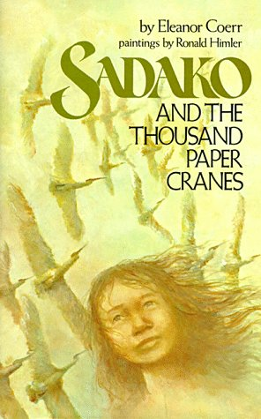  Runaway Ralph | Cleary, Beverly | FIC CLE | 4.1 | 6
Russia | Fontes, Justine | 947 FON | 4.3 | 3
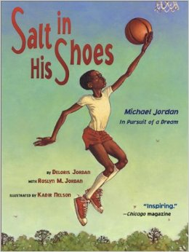  Russia (Postcards from) | Arnold, Helen | 947 ARN | 3.1 | 2
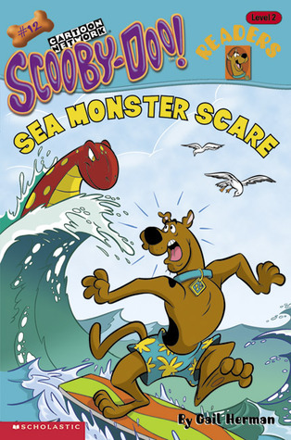  S Back to top | Author | Call # | Reading Level | Points
Sabertooths & the Ice Age Research Gde | Osborne, Mary Po | FIC OSB | 3.7 | 3
Sadako &-Thousand Paper Cranes | Coerr, Eleanor | 921 SAS | 5.2 | 3
Saint George and the Dragon | Hodges, Margaret | 398.2 HOD | 5.9 | 3
Salsa Stories | Delacre, Lulu | FIC DEL | 5.9 | 5
Salt in his Shoes | Jordan, Deloris | E JOR | 3.1 | 3
Sam and the Lucky Money | Chinn, Karen | E CHI | 3.5 | 2
Sam and the Tigers | Lester, Julius | E LES | 2.8 | 2
Sam, Bangs, and Moonshine | Ness, Evaline | E NES | 3.8 | 2
Sam I Am | Cooper, Ilene | FIC COO | 5.3 | 12
Sam, the Minuteman | Benchley, Nathani | E BEN | 2.2 | 2
Samantha Saves the Day (Amer Girls) | Tripp, Valerie | FIC TRI | 4.5 | 3
Samantha Saves the Wedding (Amer Girls) | Tripp, Valerie | FIC TRI | 4.1 | 3
Sammy Keyes and the Hotel Thief | Van Draanen, W | FIC VAN | 5.9 | 9
Sammy Keyes and the Sisters of Mercy | Van Draanen, W | FIC VAN | 6.3 | 14
Santa Claus Doesn’t Mop Floors (Bailey) | Dadey, Debbie | FIC DAD | 3.8 | 3
Sarah, Plain and Tall | MacLachlan, Patri | FIC MAC | 4.2 | 3
Sasquatch | Smith, Roland | FIC SMI | 5.2 | 10
Satch & Me (Baseball cards) | Gutman, Dan | FIC GUT | 3.5 | 9
Saturday Night at the Dinosaur Stomp | Shields, Carol D. | E SHI | 3.9 | 1
Saturn (Galaxy) | Vogt, Gregory | 523.46 VOG | 2.5 | 3
Save My Rainforest | Zak, Monica | 333.73 ZAK | 4.9 | 2
Scarecrow walks at midnight GooseBps: | Stine, R. L. | FIC STI | 4.7 | 6
School Bus Driver / Black Lagoon | Thaler, Mike | E THA | 2.8 | 1
School Story, The | Clements, Andrew | E CLE | 4.7 | 8
Science in Ancient Greece | Gay, Kathlyn | 509.38 GAY | 6.9 | 3
Science in Ancient Rome | Harris, Jacqueline | 509.37 HAR | 7.2 | 3
Scooby-Doo: Alien Invaders | McCann, Jesse L | E SCO | 2.6 | 2
Scooby-Doo: And the Opera Ogre | McCann, Jesse L | E SCO | 1.9 | 2
Scooby-Doo: Carnival Creeper | Gelsey, James | E SCO | 2.9 | 3
Scooby-Doo: Catnapped Caper | Barbo, Maria S. | E SCO | 1.2 | 1
Scooby-Doo: Caveman Caper | Glesey, J | E SCO | 2.9 | 4
Scooby-Doo: Deep-Sea Diver | Gelsey, James | FIC GEL | 2.9 | 4
Scooby-Doo: Dinosaur Dig | Soderberg, Erin | E SCO | 1.3 | 1
Scooby-Doo: Frankenstein Monster | Gelsey, James | E SCO | 2.1 | 4
Scooby-Doo: Ghostly Gorilla | Gelsey, James | E SCO | 2.9 | 3
Scooby-Doo: Groovy Ghost | Gelsey, James | FIC GEL | 2.5 | 3
Scooby-Doo: Haunted Castle | Gelsey, James | FIC GEL | 2.8 | 3
Scooby-Doo: Haunted Pumpkins | Nagler, Michelle | E SCO | 1.6 | 1
Scooby-Doo: In Jungle Jeopardy | McCann, Jesse | E SCO | 1.9 | 2
Scooby-Doo: Masked Magician | Gelsey, James | E SCO | 2.9 | 4
Scooby-Doo: Parade Puzzle | Nagler, Michelle | E SCO | 1.6 | 1
Scooby-Doo: Phony Fortune-Teller | Gelsey, James | E SCO | 2.7 | 4
Scooby-Doo: Pizza Place Ghost | Class 1-208 | E SCO | 1.9 | 1
Scooby-Doo: Rowdy Rodeo | Gelsey, James | E SCO | 2.8 | 3
Scooby-Doo: Sea Monster Scare | Herman, Gail | E SCO | 2.1 | 2
Scooby-Doo: Search for Scooby Snacks | Wasserman, Robi | E SCO | 1.4 | 1
Scooby-Doo: Spooky Strikeout | Gelsey, James | E SCO | 2.8 | 3
Scooby-Doo: Sunken Ship | Gelsey, James | E SCO | 2.5 | 3
Scooby-Doo: Toy Store Terror | Gelsey, James | E SCO | 2.8 | 4
Scorpions, the sneaky stingers | Lassieur, Allison | 595.4 LAS | 5.1 | 3
Scorpions | Myers, Walter | FIC MYE | 7.1 | 12
Scrambled Eggs Super | Seuss, Dr. |  | 3.7 | 2
Se venden gorras | Slobodkina, Esph |  | 2.9 | 2
Sea of Monsters, the (Percy Jackson) | Riordan, Rick | FIC RIO | 4.7 | 16
Seabird | Holling, Clancy | FIC HOL | 4.9 | 4
Seahorses and Sea Dragons | Rhodes, Mary Jo | 597 RHO | 3.6 | 3
Searching for Dragons | Wrede, Patricia | FIC WRE | 6.5 | 14
Season of the Sandstorms | Osborne, Mary P | FIC OSB | 2.5 | 5
Second Bend in the River, The | Rinaldi, Ann | FIC RIN | 4.8 | 13
Secret Garden, The | Burnett, Frances | FIC BUR | 6.8 | 18
Secret of the Andes | Clark, Ann | FIC CLA | 5.5 | 7
Secret of the Indian, The (IndianInCpbrd) | Banks, Lynne Rei | FIC BAN | 6.1 | 8
Secret School, The | Avi | FIC AVI | 4.2 | 7
Secret Soldier: Deborah Sampson | McGovern, Ann | 973.3 MCG | 4.3 | 3
Seeds of Hope | Gregory, Kristian | FIC GRE | 6.1 | 9
Seeing Stone, The | DiTerlizzi & Blac | FIC DIT | 4.1 | 4
Seekers: Great Bear Lake (2) | Hunt, Erin | FIC HUN | 4.6 | 18
Seekers: Smoke Mountain (3) | Hunt, Erin | FIC HUN | 4.5 | 16
Seekers: The quest begins (1) | Hunt, Erin | FIC HUN | 5.0 | 19
Sees Behind Trees | Dorris, Michael | FIC DOR | 5.9 | 6
Series of Unfortunate Austere Academy | Snicket, Lemony | FIC SNI | 6.8 | 10
Series of Unfortunate: Bad Beginning | Snicket, Lemony | FIC SNI | 6.1 | 7
Series of Unfortunate: Carnivorous Carniv | Snicket, Lemony | FIC SNI | 6.8 | 12
Series of Unfortunate: End, The | Snicket, Lemony | FIC SNI | 6.8 | 14
Series of Unfortunate Ersatz Elevator | Snicket, Lemony | FIC SNI | 6.7 | 11
Series of Unfortunate Grim Grotto, The | Snicket, Lemony | FIC SNI | 8.6 | 11
Series of Unfortunate Hostile Hospital | Snicket, Lemony | FIC SNI | 6.8 | 11
Series of Unfortunate Miserable Mill, The | Snicket, Lemony | FIC SNI | 6.6 | 9
Series of Unfortunate Penultimate Peril | Snicket, Lemony | FIC SNI | 6.9 | 14
Series of Unfortunate: Reptile Room | Snicket, Lemony | FIC SNI | 6.4 | 9
Series of Unfortunate Slippery Slope, The | Snicket, Lemony | FIC SNI | 6.9 | 13
Series of Unfortunate: Vile Village | Snicket, Lemony | FIC SNI | 6.5 | 11
Series of Unfortunate Wide Window, The | Snicket, Lemony | FIC SNI | 6.9 | 9
Seven Wheels of Power | Barnes, Dawn | FIC BAR | 2.7 | 5
Seven Wonders of Sassafras Springs CYRM | Birney, Betty | FIC BIR | 4.5 | 9
Shadow | Brown, Marcia | E BRO | 3.7 | 2
Shadow of a Bull | Wojciechowska,M | FIC WOJ | 5.8 | 9
Shadowgate (Dragons of Deltora) | Rodda, Emily | FIC ROD | 3.5 | 10
Shadrach | DeJong, Meindert | FIC DEJ | 4.8 | 7
Shamrocks, Harps & Shillelagh | Barth, Edna | 394.2 BAR | 5.6 | 5
Shape of Me and Other Stuff | Seuss, Dr. | E SEU | 2.4 | 1
Sharks | Simon, Seymour | 597.31 SIM | 5.8 | 2
Shattering (Guardians Of Ga'Hoole) | Lasky, Kathryn | FIC LAS | 4.5 | 11
Sheep (Hobbs) CYRM | Hobbs, Valerie | FIC HOB | 4.3 | 9
Sheep in a jeep | Shaw, Nancy | E SHA | 1.2 | 1
Sheep in a shop | Shaw, Nancy | E SHA | 1.8 | 1
Sheep on a ship | Shaw, Nancy | E SHA | 1.8 | 1
Sheep out to eat | Shaw, Nancy | E SHA | 1.7 | 1
Sheila Rae the Brave | Henkes, Kevin | E HEN | 2.3 | 1
Shh! We’re Writing the Constitution | Fritz, Jean | 342.73 FRI | 4.7 | 3
Shhhh | Henkes, Kevin | E HEN | 1.4 | 1
Shiloh | Naylor, Phyllis | FIC NAY | 5.7 | 8
Shoeshine Girl | Bulla, Clyde Robe | FIC BUL | 2.2 | 3
Show and Tell | Munsch, Robert | E MUN | 3.5 | 2
Show Way | Woodson, Jacquel | E WOO | 3.9 | 9
Si le das un panecillo (If you give a moose | Numeroff, Laura | L E NUM | 2.7 | 1
Si le das una galletita (If you give a mouse | Numeroff, Laura | L E NUM | 3.2 | 1
Sign of the Beaver, The | Speare, Elizabeth | FIC SPE | 5.7 | 7
Signs at School | Hill, Mary | E HIL | 1.4 | 1
Signs at the Pool | Hill, Mary | E HIL | 1.5 | 1
Signs at the Store | Hill, Mary | E HIL | 1.4 | 1
Signs on the Road | Hill, Mary | E HIL | 1.7 | 1
Silk Umbrellas | Marsden, Carolyn | FIC MAR | 5.2 | 5
Silver Chair, The (Narnia series) | Lewis, C. S. | FIC LEW | 5.7 | 11
Silverwing | Oppel, Kenneth | FIC OPP | 4.2 | 14
Sing Down the Moon | O’Dell, Scott | FIC ODE | 5.3 | 6
Single Shard, A | Park, Linda Sue | FIC PAR | 6.8 | 10
Sister of the South (Dragons of Deltora) | Rodda,Emily | FIC ROD | 4.5 | 10
Sixth Grade Can Really Kill You | DeClements, Bart | FIC DEC | 6.1 | 9
Skeleton Inside You, The | Balestrino, Philip | 612 BAL | 2.7 | 2
Skeleton Man | Bruchac, Joseph | FIC BRU | 5.4 | 7
Skeletons Don’t Play Tubas | Dadey, Debbie | FIC DAD | 3.1 | 3
Skippyjon Jones in the Dog House | Schachner, Judy | E SCH | 4.4 | 2
Skirt, The | Soto, Gary | FIC SOT | 4.7 | 3
Skunk Scout | Yep, Laurence | FIC YEP | 4.8 | 8
Sky Dogs | Yolen, Jane | FIC YOL | 4.6 | 2
Slave Dancer, The | Fox, Paula | FIC FOX | 6.4 | 10
Sleds On Boston Common | Borden, Louise | E BOR | 4.9 | 3
Slippery Slope (series of unfortunate events) | Snicket, Lemony | FIC SNI | 6.9 | 13
Smoky Night | Bunting, Eve | E BUN | 2.5 | 2
Smoky the Cowhorse | James, Will | FIC JAM | 6.6 | 19
Snakes and Other Reptiles | Schulte, Mary | 597.9 SCH | 1.8 | 1
Snowballs | Ehlert, Lois | E EHL | 2.7 | 1
Snowflake Bentley | Briggs, Jacqueline | 551.57 BRI | 4.1 | 2
Snowy Day, The | Keats, Ezra | E KEA | 3.2 | 1
So Far From Home | Denenberg, Barry | FIC DEN | 3.5 | 5
So Totally Emily Ebers | Yee, Lisa | FIC YEE | 3.6 | 16
Soccer Around the World | West, Tracey | E WES | 2.2 | 1
Soccer Mom From Outer Space | Saltzberg, Barney | E SAL | 2.1 | 2
Socks | Cleary, Beverly | FIC CLE | 5.4 | 5
Sod Houses on the Great Plains | Rounds, Glen | 693.2 ROU | 2.6 | 2
Solid, Liquid, or Gas? | Hewitt, Sally | 530.4 HEW | 4.2 | 2
Solution, The (Animorphs) | Applegate, K. A. | FIC APP | 5.3 | 8
Some Smug Slug | Edwards, Pamela | E EDW | 3.8 | 1
Somebody and the Three Blairs | Tolhurst, Marilyn | E TOL | 2.1 | 1
Something Good | Munsch, Robert | E MUN | 2.8 | 2
Something to Remember Me By | Bosak, Susan | FIC BOS | 4.5 | 3
Somewhere in the Darkness | Myers, Walter | FIC MYE | 5.5 | 11
Song and Dance Man | Ackerman, Karen | E ACK | 3.8 | 2
Songs From the Loom | Roessel, Monty | 746.1 ROE | 4.5 | 3
Sophie's Masterpiece | Spinelli, Eileen | E SPI | 3.1 | 2
SOS Titanic | Bunting, Eve | FIC BUN | 6.5 | 4
Sounder | Armstrong, Willia | FIC ARM | 4.9 | 6
Souperchicken | Auch, Mary Jane | E AUC | 2.9 | 2
South Carolina – America the Beautiful | Stein, R. Conrad | 975.7 STE | 9.0 | 6
Space Case | Marshall, Edward | E MAR | 3.3 | 1
Space: Magic Tree House Research Guide | Osborne, Will | 520 OSB | 3.5 | 3
Speak to Me and I will listen betwn... lines | English, Karen | E ENG | 3.5 | 3
Spiders (Simon) | Simon, Seymour | 595.4 SIM | 6.4 | 2
Spiders of North America | Squire, Ann | 595.4 SQU | 4.9 | 3
Spiderwick: #1 The field guide | DiTerlizzi& Black | FIC DIT | 4.1 | 4
Spiderwick: #2 The seeing stone | DiTerlizzi& Black | FIC DIT | 4.1 | 4
Spiderwick: #4 The ironwood tree | DiTerlizzi& Black | FIC DIT | 4.1 | 4
Spiderwick: #5 The wrath of Mulgarath | DiTerlizzi& Black | FIC DIT | 4.5 | 4
Spotting the Leopard | Myers, Anna | FIC MYE | 5.8 | 7
Squids Will Be Squids | Scieszka, Jon | FIC SCI | 6.1 | 3
Stage Fright on a Summer Night (MTH) | Osborne, Mary P | FIC OSB | 2.4 | 3
Standing in the Light (Captive Story) | Osborne, Mary P | FIC OSB | 4.8 | 6
Stanford Wong flunks big-time | Yee Lisa | FIC YEE | 5.2 | 16
Stanley and Rhoda | Wells, Rosemary | E WEL | 2.6 | 2
Stanley's Party | Bailey, Linda | E BAI | 1.5 | 1
Stanley's Wild Ride | Bailey, Linda | E BAI | 2.5 | 1
Star Fisher, The | Yep, Laurence | FIC YEP | 6.1 | 9
Starry Messenger (Galileo) | Sis, Peter | 921 GAL | 5.9 | 2
Statue of Liberty | Penner, L. | 730.92 PEN | 2.1 | 1
Stellaluna | Cannon,Janell | E CAN | 4.9 | 2
Stephanie’s Ponytail | Munsch, Robert | E MUN | 3.2 | 2
Stinky Cheese Man … Fairly Stupid Tales | Scieszka, Jon | FIC SCI | 3.9 | 2
Stone Fox | Gardiner, John R | FIC GAR | 3.2 | 3
Stone Soup | McGovern, Ann | 398.2 MCG | 2.1 | 2
Storm in the Night | Stolz, Mary | E STO | 3.9 | 2
Story, A Story, A | Haley, Gail E. | 398.2 HAL | 4.2 | 2
Story About Ping, The | Flack, Marjorie | E FLA | 4.2 | 2
Story of a seagull and the cat who | Sepulveda, Luis | FIC SEP | 5.3 | 6
Story of Ferdinand, The | Leaf, Munro | E LEA | 4.1 | 2
Story of Jumping Mouse, The | Steptoe, John | 398.2 STE | 4.1 | 2
Story of Money, The | Maestro, Betsy | 332.4 MAE | 5.7 | 3
Story of the Statue of Liberty | Maestro, Betsy | 730.92 MAE | 4.6 | 2
Story Of-Surrender At Yorktown | Kent, Zachary | 973.3 KEN | 6.9 | 3
Story Snail, The | Rockwell, Anne | E ROC | 2.2 | 2
Strange Mysteries From | Simon, Seymour | 001.9 SIM | 6.6 | 4
Stranger In The Woods | Sams, Carl R. | 591.03 SAM | 2.9 | 2
Strawberry Girl | Lenski, Lois | FIC LEN | 4.6 | 7
Strega Nona | dePaola, Tomie | 398.2 DEP | 4.4 | 2
Strider | Cleary, Beverly | FIC CLE | 5.6 | 7
String in the Harp, A | Bond, Nancy | FIC BON | 7.1 | 24
Stringbean's Trip to the Sea | Williams, Vera | E WIL | 4.3 | 2
Stuart Little | White, E. B. | FIC WHI | 3.9 | 5
Stupids Die, The | Allard, Harry | E ALL | 3.1 | 1
Stupids Step Out, The | Allard, Harry | E ALL | 3.3 | 1
Sugaring Time | Lasky, Kathryn | 633.6 LAS | 4.8 | 4
Summer Ball | Lupica, Mike | FIC LUP | 5.9 | 17
Summer of the Monkeys | Rawls, Wilson | FIC RAW | 5.1 | 20
Summer of the Swans, The | Byars, Betsy | FIC BYA | 5.2 | 6
Sun, The | Lassieur, Allison | 523.7 LAS | 3.1 | 3
Sun Song | Marzollo, Jean |  | 2.1 | 1
Sunny Day, A | Nelson, Robin | 551.5 NEL | 1.4 | 1
Sunset Of The Sabertooth (MTH) | Osborne, Mary P | FIC GRE | 2.8 | 3
Sunwing | Oppel, Kenneth | FIC OPP | 4.5 | 17
Superdog: the heart of a hero CYRM | Buehner, Caralyn | E BUE | 2.5 | 1
Superfudge | Blume, Judy | FIC BLU | 4.2 | 9
Surprise Island | Warner, Gertrude | FIC WAR | 3.3 | 7
Surviving Aunt Marsha | Laguna, Sofie | FIC LAG | 5.5 | 8
Suspicion, The | Applegate, K.A | FIC APP | 5.3 | 8
Swamp Angel | Isaacs, Anne | 398.22 ISA | 5.3 | 2
Sweet Whispers, Brother Rush | Hamilton, Virgini | FIC HAM | 5.3 | 9
Swift Rivers | Meigs, Cornelila | FIC MEI | 6.5 | 16
Swimmy | Lionni, Leo | E LIO | 3.5 | 1
Swindle | Korman, Gordon |  | 4.4 | 10
Swiss Family Robinson | Wyss, Johann |  | 8.9 | 28
Sylvester and the Magic Pebble | Steig, William | E STE | 3.8 | 2
Sylvester and the Magic Pebble | Steig, William | FIC STE | 3.8 | 2

