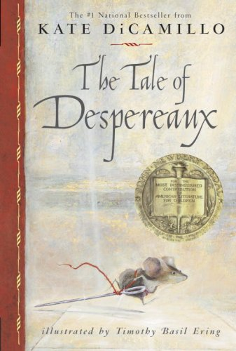
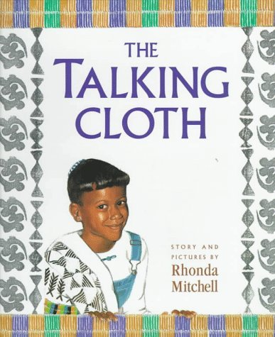
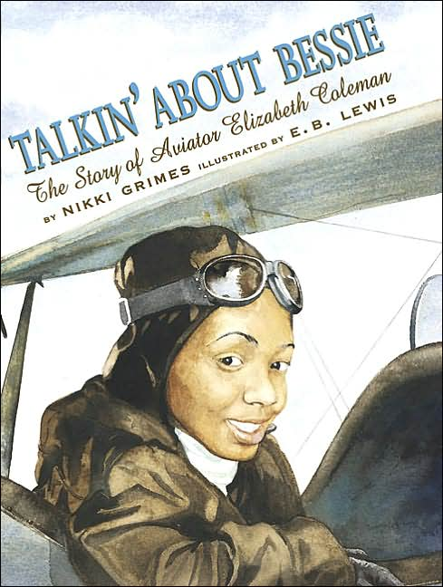
Reading Counts quiz titles. Blue titles are series books.
Call #: FIC = Fiction. E = Everybody (picture books) # = Nonfiction L = Language
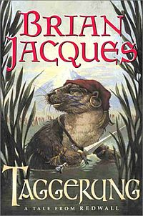  T | AUTHOR | CALL # | READING LEVEL | POINTS
T Back to top
Taggerung (Redwall) | Jacques, Brian |  | 6.9 | 26
Tale of Despereaux, The | DiCamillo, Kate | FIC DIC | 4.8 | 9
Tale of Peter Rabbit, The | Potter, Beatrix | E POT | 3.5 | 2
Talent Show from the Black Lagoon | Thaler, Mike | E THA | 3.5 | 2
Tales from Shakespeare | Packer, Tina | 822.3 PAC | 5.4 | 11
Tales of a Fourth Grade Nothing | Blume, Judy | FIC BLU | 4.9 | 7
Talkin' About Bessie | Grimes,Nikki | 921 COL | 4.9 | 4
Talking to Dragons | Wrede, Patricia | FIC WRE | 6.8 | 16
Talking Cloth, The | Mitchell, Rhonda | E MIT | 2.8 | 1
Tallchief: America's Prima.... | Tallchief, Maria | 792 TAL | 4.9 | 3
Tapenum's day | Waters, Kate | 970.004 WAT | 3.5 | 2
Tar Beach | Ringgold, Faith | E RIN | 2.9 | 1
Taran Wanderer | Alexander, Lloyd | FIC ALE | 6.6 | 12
Tchaikovsky Discovers America | Kalman, Esther | FIC KAL | 3.9 | 3
Teach Us, Amelia Bedelia | Parish, Peggy | E PAR | 2.8 | 3
Teacher from the Black Lagoon | Thaler, Mike | E THA | 2.1 | 1
Ted | DiTerlizzi, Tony | E DIT | 2.7 | 2
Teddy Bear Cures a Cold | Gretz, Susanna |  | 1.5 | 2
Teddy Bear, The | McPhail, David | E MCP | 2.0 | 1
Ten Kings | Meltzer Milton | 920 MEL | 4.9 | 9
Ten Mile Day | Fraser, Mary Ann | 385 FRA | 5.9 | 3
Ten, Nine, Eight | Bang, Molly |  | 2.2 | 1
Tenth City, The (Land of Elyon) | Carman, Patrick | FIC CAR | 5.5 | 12
Texas - America the Beautiful | Heinrichs, Ann | 976.4 HEI | 9.0 | 6
Thank You, Jackie Robinson | Cohen, Barbara | FIC COH | 6.5 | 7
Thank You, Mr. Falker | Polacco, Patricia | E POL | 4.8 | 2
Thanksgiving On Thursday | Osborne, Mary P | FIC OSB | 2.2 | 3
Thelonius Monster’s Sky-High Fly Pie CYRM | Sierra, Judy | E SIE | 2.5 | 1
There is a bird on your head! | Willems, Mo | E WIL | 1.5 | 1
There’s a Nightmare in My Closet | Mayer, Mercer | E MAY | 3.4 | 1
There’s a Wocket in My Pocket | Seuss, Dr. | E SEU | 2.1 | 1
There’s an Owl in the Shower | George, Jean | FIC GEO | 5.5 | 4
These Happy Golden Years | Wilder, Laura I | FIC WIL | 5.2 | 14
They Call Me Woolly | DuQuette, Keith | 591.5 DUQ | 2.7 | 1
Thief, The | Whalen, Megan | FIC WHA | 5.5 | 15
Thief lord, The | Funke, Cornelia | FIC FUN | 4.9 | 20
Thimble Summer | Enright, Elizabeth | FIC ENR | 4.9 | 7
Thirteen Colonies | Sakurai, Gail | 973.2 NOB | 5.7 | 3
Thomas’ Snowsuit | Munsch, Robert | E MUN | 3.9 | 1
Three Against The Tide | Love, D. Anne | FIC LOV | 8.2 | 10
Three Bears, The | Galdone, Paul | 398.2 GAL | 3.4 | 2
Three Pebbles and a Song | Spinelli, Eileen | E SPI | 2.2 | 1
Throne of Fire, The (Kane Chronicles) | Riordan, Rick | FIC RIO | 4.4 | 26
Through Grandpa’s Eyes | MacLachlan, Patr | E MAC | 3.7 | 2
Through My Eyes | Bridges, Ruby | 921 BRI | 5.6 | 3
Thunder Cake | Polacco, Patricia | E POL | 3.5 | 2
Thy Friend, Obadiah | Turkle, Brinton | E TUR | 3.3 | 2
Tigers At Twilight (Magic Tree House) | Osborne, Mary P | FIC OSB | 2.3 | 3
Tiny Green Thumbs | Guest, C. Z. | G UGE | 2.5 | 2
Tiny Seed, The | Carle, Eric | 582 CAR | 3.2 | 2
Titan’s Curse, The Bk 3 (Percy Jackson) | Riordan, Rick | FIC RIO | 4.3 | 18
To Space and Back | Ride, Sally | 629.45 RID | 5.1 | 4
Toad | Brown, Ruth | 597.8 | 3.1 | 1
Tombs of Atuan, The | Le Guin, Ursula | FIC LE | 5.8 | 10
Tonight On The Titanic (Magic Tree H) | Osborne, Mary P | FIC OSB | 2.2 | 3
Tonka/Working Hard/Busy Fire T | Horowitz, Jordan | 628.9 HOR | 2.2 | 2
Too Many Frogs | Asher, Sandy | E ASH | 2.8 | 1
Too Many Pumpkins | White, Linda | E WHI | 3.9 | 2
Too Many Tamales | Soto, Gary | E SOT | 4.2 | 2
Tornadoes (What on Earth) | Orme, David | 551.55 ORM | 5.0 | 3
Town Mouse, Country Mouse | Brett, Jan | E BRE | 4.4 | 2
Traction Man is Here! CYRM | Grey, Mini | E GRE | 3.8 | 1
Train Song | Siebert, Diane | E SIE | 3.5 | 1
Train to Somewhere | Bunting, Eve | E BUN | 2.8 | 2
Travel Team | Lupica, Mike | FIC LUP | 6.0 | 17
Treasure Island | Stevenson, Robert | FIC Ste | 7.1 | 17
Treasure, The | Shulevitz, Uri | FIC STE | 2.9 | 1
Tree is Nice, A | Udry, Janice | E UDR | 2.3 | 1
Tree Of Freedom | Caudill, Rebecca | FIC CAU | 5.7 | 14
Trees Of The Dancing Goats | Polacco, Patricia | E POL | 4.8 | 2
Trek, The | Jonas, Ann | E JON | 1.8 | 1
Triss (Redwall) | Jacques, Brian | FIC JAC | 7.1 | 25
Troodon, The Smartest Dinosaur | Lessem, Don | 567.9 LES | 6.1 | 3
Trouble On Thunder Mountain | Hoban, Russell | FIC HOB | 3.4 | 3
Trouble River | Byars, Betsy | FIC BYA | 5.8 | 5
Trouble with Bernie, The | Bushell, Sharon | CD BUS | 5.2 | 8
Trouble with Tuck, The | Taylor, Theodore | FIC TAY | 4.1 | 5
Trucks, Trucks, Trucks | Sis, Peter | E SIS | 1.3 | 1
True Confessions of Charlotte Doyle, The | Avi | FIC AVI | 6.9 | 13
True Scary Places (America’s Most H) | Zullo | 133.1 ZUL | 5.4 | 8
True Story of theThree Little Pigs | Scieszka, Jon | 398.24 MAR | 2.5 | 2
Trumpet of the Swan, The | White, E.B. | FIC WHI | 5.1 | 8
Tsunamis (What on Earth?) | Orme, David | 551.46 ORM | 5.3 | 3
Tuck Everlasting | Babbitt, Natalie | FIC BAB | 5.9 | 6
Tuesday | Wiesner, David | E WIE | 1.7 | 1
Turtle in Paradise CYRM | Holm, Jennifer | FIC HOL | 3.4 | 8
Tutankhamun: The Life And | Murdoch, David | 932 MUR | 7.3 | 5
Twenty-One Balloons, The | Du Bois, William | FIC DU | 5.7 | 9
Twister On Tuesday (Magic Tree House) | Osborne, Mary P | FIC OSB | 2.4 | 3
Two Dog Biscuits | Cleary, Beverly | E CLE | 2.2 | 2
Two Towers, The (Lord of the Rings) | Tolkien,. R.R. | FIC TOL | 8.4 | 31
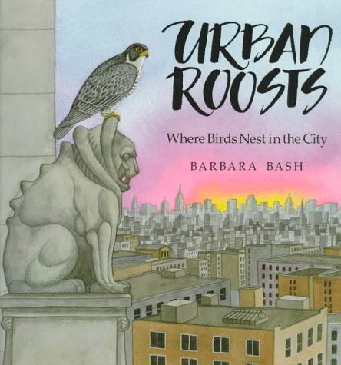  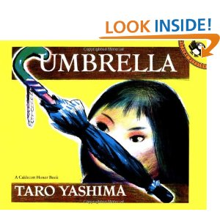  U | 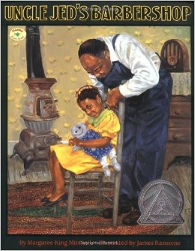  AUTHOR | 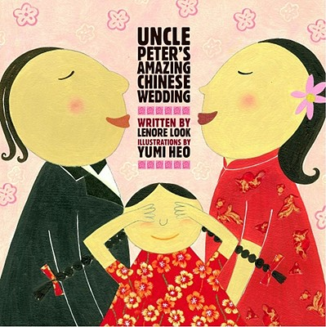  CALL # | READING LEVEL | POINTS
U Back to top
Ugly Duckling, The | Andersen, Hans | FIC AND | 3.1 | 2
Umbrella | Yashima, Taro | E YAS | 3.1 | 1
Uncle Jed's Barbershop | Mitchell, Margare | E MIT | 4.5 | 2
Uncle Peter's Amazing Chinese CYRM | Look, Lenore | E LOO | 5.2 | 2
Uncommon Traveler | Brown, Don | 916.6 BRO | 3.3 | 2
Under The Serpent Sea (Droon) | Abbott, Tony | FIC ABB | 3.1 | 5
Under The Quilt Of Night | Hopkinson, Debo | FIC HOP | 3.4 | 2
Unicorns Don’t Give Sleigh Rides (Bailey) | Dadey, Debbie | FIC DAD | 3.5 | 3
United Tates of America | Danziger, Paula | FIC DAN | 4.1 | 9
Upon the Head of the Goat | Siegal, Aranka | 921 SIE | 5.6 | 15
Unwanteds, The CYRM | McMann, Lisa | FIC MCM | 5.7 | 17
Upside Down Boy, The | Herrera, Juan Feli | E HER | 3.5 | 2
Upstairs Room, The | Reiss, Johanna | 921 REI | 5.9 | 12
Uranus (Galaxy) | Vogt, Gregory L. | 523.9 VOG | 2.5 | 3
Urban Roosts | Bash, Barbara | FRED KIT | 4.5 | 2
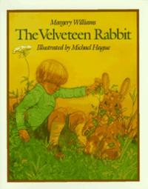  Utahraptor: Deadliest Dinosaur | Lessen, Don | 567.9 LES | 5.5 | 3
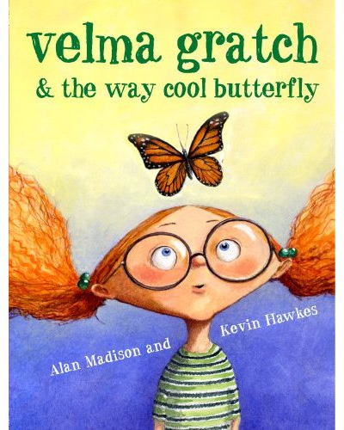  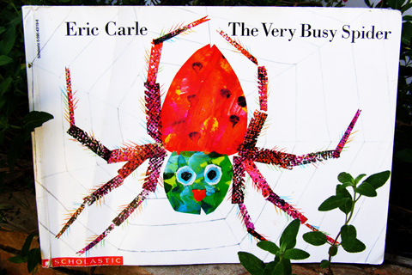  V | AUTHOR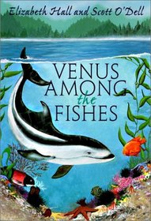 | CALL # | READING LEVEL | POINTS
V Back to top
Vacation Under The Volcano (Magic T H) | Osborne, Mary P | FIC OSB | 2.2 | 3
Valley Of The Moon | Garland, Sherry | FIC GAR | 5.6 | 10
Vampires Don’t Wear Polka Dots (Bailey) | Dadey, Debbie | FIC DAD | 4.2 | 3
Velma Gratch and the way cool... CYRM | Madison, Alan | E MAD | 4.3 | 2
Velveteen Rabbit | Willians, Margery | FIC WEL | 4.2 | 2
Venus (Galaxy) | Kipp, Steven L. | 523.42 KIP | 2.5 | 3
Venus Among the Fishes | Hall, Elizabeth | FIC HAL | 4.1 | 6
Very Busy Spider, The | Carle, Eric | E CAR | 2.6 | 1
Very Hungry Caterpillar, The | Carle, Eric | E CAR | 2.6 | 1
Very Important Day, A | Herold, Maggie R | E HER | 4.7 | 2
Vietnam (Postcards From) | Allard, Denise | 959.7 KAL | 3.5 | 2
View from Saturday, The | Konigsburg, E.L. | FIC KON | 4.8 | 9
Viking Ships At Sunrise (Magic Tree H) | Osborne, Mary P | FIC OSB | 2.3 | 3
Vile Village, The (Unfortunate) | Snicket, Lemony | FIC SNI | 6.5 | 11
Village of Round and Square Houses | Grifalconi, Ann | 398.2 GRI | 3.8 | 2
Violet Raines Almost got struck by Lightning | Haworth, Dannette | FIC HAW | 3.2 | 8
Virginia – America the Beautiful | Blashfield, Jean | 975.5 BLA | 8.5 | 6
Visit to William Blake’s Inn | Willard, Nancy | 811 WIL | 4.8 | 2
Visiting Day | Woodson, Jacquel | E WOO | 2.9 | 1
Visitor, The (Animorphs) | Applegate, K.A. | FIC APP | 5.2 | 9
Visitor for Bear, A CYRM | Becker, Bonny | E BEC | 2.4 | 1
Voice Of Her Own | Lasky, Kathryn | 921 WHE | 5.2 | 3
Voices of Ancient Egypt | Winters, Kay | FIC OSB | 4.5 | 3
Volcano | Lauber, Patricia | 551.2 LAU | 4.5 | 3
Volcanoes (Worldwise) | Clarke, Penny | 551.21 CLA | 5.6 | 3
Vote! | Christelow | 324.97 CHR | 3.7 | 3
Voyage of the Dawn Treader (Narnia) | Lewis, C.S. | FIC LEW | 5.5 | 12
Voyage of the Frog | Paulsen, Gary | FIC PAU | 6.3 | 8
Voyage on the Great Titanic | White, Ellen | FIC WHI | 5.4 | 9
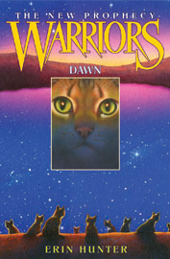  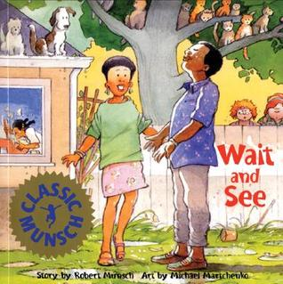  Voyages Of Doctor Dolittle | 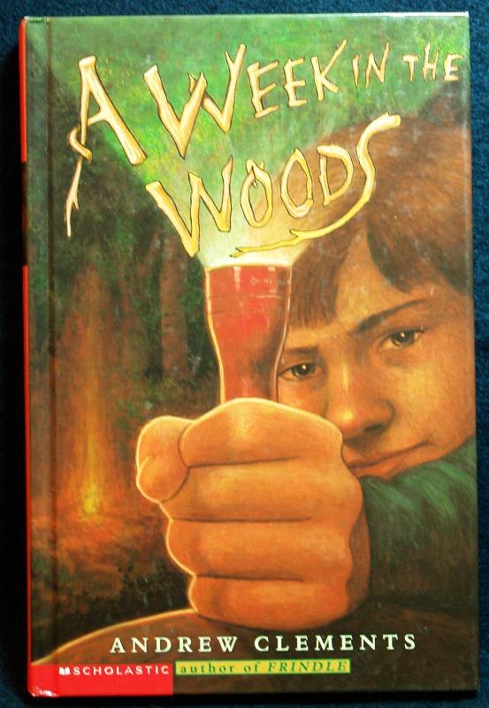  Lofting, Hugh | FIC LOF | 7.1 | 17
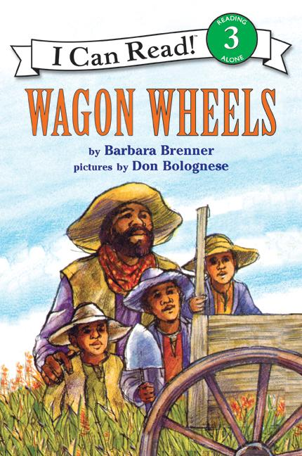  W | AUTHOR | CALL # | READING LEVEL | POINTS
W Back to top
Wabi Sabi CYRM | Reibstein, Mark | E REI | 3.7 | 2
Wagon Wheels | Brenner, Barbara | E BRE | 2.9 | 2
Wait and See | Munsch, Robert | E MUN | 2.5 | 2
Walk in Wolf Wood, A | Stewart, Mary | FIC STE | 5.6 | 8
Walk Two Moons | Creech, Sharon | FIC CRE | 6.6 | 13
Walking To The Bus-Rider Blues | Robinet, Harriette | FIC ROB | 4.5 | 9
Wanda's Roses | Brisson, Pat | E BRI | 4.3 | 2
War Of The Worlds, The | Wells, H.G. | FIC WEL | 8.1 | 15
Warriors: New Prophecy - Dawn | Hunter, Erin | FIC HUN | 4.8 | 18
Warriors: New Prophecy - Midnight | Hunter, Erin | FIC HUN | 5.6 | 18
Warriors: New Prophecy - Moonrise | Hunter, Erin | FIC HUN | 5.2 | 17
Washington, D.C. America the Beautiful | Stein, R. Conrad | 975.3 STE | 9.0 | 6
Water Horse, The | King Smith, Dick | FIC KIW | 5.2 | 6
Water Pollution | Donald, Rhonda | 363.739 DON | 5.1 | 3
Watsons Go to Birmingham – 1963 CYRM | Curtis, Christophe | FIC CUR | 5.5 | 12
We are in a book! CYRM | Willems, Mo | E WIL | 1.0 | 1
Weather, The (My First Reader) | George, Olivia | E GEO | 1.3 | 1
Weather Words And What They | Gibbons , Gail | 551.6 GIB | 3.2 | 2
Web Files, The | Palatini, Margie | E PAL | 2.8 | 2
Wedding For Wiglaf?, A | McMullan, K.H. | FIC MCM | 3.1 | 5
Week in the Woods, A | Clements, Andr | FIC CLE | 5.4 | 10
Weekend with Wendell, The | Henkes, Kevin | E HEN | 3.1 | 1
Welcome Comfort | Polacco, Patricia | E POL | 3.9 | 2
Welcome to Dead House (Goosebumps) | Stine, R.L. | FIC STI | 4.9 | 7
Wemberly Worried | Henkes, Kevin | E HEN | 2.1 | 2
Werewolf skin (GooseBumps) | Stine, R. L. | FIC STI | 4.4 | 6
Werewolves Don’t Go to Summer Camp | Dadey, Debbie | FIC DAD | 4.6 | 3
Weslandia | Fleischman, Paul |  | 3.5 | 2
West to a Land of Plenty | Murphy, Jim | FIC MUR | 4.8 | 11
Westing Game, The CYRM | Raskin , Ellen | FIC RAS | 6.1 | 13
Westward To Home: Joshua's | Hermes, Patricia | FIC HER | 3.1 | 5
Whales passing | Bunting, Eve | E BUN | 2.5 | 1
What Do You Say, Dear? | Joslin, Sesyle | 395.122 JOS | 3.9 | 1
What Game Shall We Play? | Hutchins, Pat | E HUT | 1.4 | 1
What Hearts | Brooks, Bruce | FIC BRO | 6.9 | 8
What is a Dinosaur? | Walker, Niki | 567.9 WAL | 2.5 | 3
What Jamie Saw | Coman, Carolyn | FIC COM | 6.8 | 5
What Makes A Shadow? | Bulla, Clyde Rob | 535.4 BUL | 1.7 | 1
What Makes You Cough-Shiver | Stangl, Jean | 612.8 STA | 4.5 | 3
What Was I Scared Of? | Seuss, Dr. | E SEU | 1.5 | 1
What Would Joey Do? | Gantow, Jack | FIC GAN | 5.3 | 12
What's the Big Idea, Ben Franklin | Fritz, Jean | 921 FRA | 4.6 | 3
Wheel on the School, The | DeJong, Meindert | FIC DEJ | 5.7 | 15
Wheels On The Race Car, The | Zane, Alexander | E ZAN | 1.5 | 1
When Jessie Came Across.... | Hest, Amy | E HES | 3.5 | 3
When Marian Sang | Ryan, Pam Muno | 291 AND | 3.9 | 2
When Marion Copied | Berg, Brook | 808 BER | 3.5 | 3
When Sophie Gets Angry... | Bang, Molly | E BAN | 1.9 | 1
When The Circus Came To Town | Yep, Laurence | FIC YEP | 4.9 | 6
When Uncle Took The Fiddle | Gray, Libba Moo | E GRA | 2.9 | 1
When Will This Cruel War Be..Dear Amer | Denenberg, Barry | FIC DEL | 6.5 | 4
Where Does the Garbage Go? | Showers, Paul | 628.4 SHO | 3.1 | 2
Where Land Meets Sea | Fowler, Allan | 551.45 FOW | 3.2 | 1
Where the Buffaloes Begin | Baker, Olaf | 398.2 BAK | 4.8 | 3
Where the Lilies Bloom | Cleaver, Vera | FIC CLE | 5.5 | 11
Where the Red Fern Grows | Rawls, Wilson | FIC RAW | 6.4 | 18
Where the Sidewalk Ends | Silverstein, Shel | 811 SIL |  | 3
Where the Mountain Meets the Moon CYRM | Lin, Grace | FIC LIN | 5.4 | 10
Where the Wild Things Are | Sendak, Maurice | E SEN | 4.4 | 1
While A Tree Was Growing | Bosveld, Jane | 585.5 BOS | 6.7 | 3
Whingdingdilly | Peet, Bill | E PEE | 3.7 | 3
Whipping Boy, The | Fleischman, Sid | FIC FLE | 4.8 | 3
White Snow, Bright Snow | Tresselt, Alvin | E TRE | 4.8 | 2
White Stallion, The | Shub, Elizabeth | E SHU | 3.1 | 2
Whittington | Armstrong, Alan |  | 4.6 | 9
Who Really Killed Cock Robin? | George, Jean C | FIC GEO | 5.9 | 8
Who Settled The West? | Kalman, Bobbie | 978 KAL | 3.5 | 3
Who Stole the Wizard of Oz? | Avi | FIC AVI | 4.8 | 3
Who Was King Tut? | Edwards, Roberta | 932 EDW | 3.7 | 4
Why don't you get a horse Sam Adams | Fritz, Jean | VC | 4.6 | 2
Why Frogs are Wet | Hawes, Judy | 597 HAW | 3.4 | 2
Why I’m Afraid of Bees (Goosebumps) | Stine, R.L. | FIC STI | 4.8 | 6
Why Mosquitoes Buzz in People’s Ears | Aardema, Verna | 398.2 AAR | 4.2 | 2
Wide Window, The (Unfortunate) | Snicket, Lemony | FIC SNI | 6.9 | 9
Wild About Books | Sierra, Judy | E SIE | 2.5 | 1
Wild Colorado, The | Maurer, Tichard | 917.91 MAU | 7.5 | 7
Wild in the City | Thornhill, Jan | E THO | 3.9 | 2
Wild Year: Joshua's Oregon Trail (Dear A) | Hermes, Patricia | FIC HER | 4.1 | 5
Will I have A Friend? | Cohen, Miriam | E COTT | 2.6 | 1
Will You Be My Friend? | Tafuri, Nancy | E TAF | 1.4 | 1
Will You Sign Here, John... | Fritz, Jean | 921 HAN | 4.8 | 3
Willy and Max, a holocaust story CYRM | Littlesugar, Amy | E LIT | 3.3 | 2
Wilma Unlimited | Krull, Kathleen | FRED KIT | 4.8 | 2
Wind Blew, The | Hutchins, Pat | E HUT | 3.3 | 1
Windy Days | Burke, Jennifer S. | 551.51 BUR | 1.6 | 1
Winged Cat, The | Lattimore, Debor | FIC LAT | 5.3 | 2
Wingwalker | Wells, Rosemary | FIC WEL | 4.2 | 3
Winter Days In The Big Woods | Wilder, Laura Inga | E WIL | 3.3 | 1
Winter Of Red Snow (Dear Amer) | Gregory, Kistiana | VC | 4.8 | 7
Winter of the Ice Wizard (Magic Tree H) | Osborne, Mary | FIC OSB | 2.8 | 5
Winter Room, The | Paulsen, Gary | FIC PAU | 5.6 | 6
Wisconsin – America the Beautiful | Blashfield, Jean F. | 977.5 BLA | 9.0 | 6
Wise Old Woman, The | Uchida, Yoshiko | 398.21 UCH | 6.8 | 2
Wish Giver, The | Brittain, Bill | FIC BRI | 4.7 | 6
Witch of Blackbird Pond, The | Speare, Elizabeth | FIC SPE | 6.9 | 14
Witches Don’t Do Blackflips (Bailey) | Dadey, Debbie | FIC DAD | 3.8 | 3
Witches of Worm, The | Keatley, Zilpha | FIC KEA | 5.6 | 9
Witches, Pumpkins, and Grinning Ghosts | Barth, Edna | 394.2 BAR | 6.8 | 4
Wizard In The Tree, The | Alexander, Lloyd | FIC ALE | 7.6 | 7
Wizard of Oz (Junior Classics) | Baum, L. Frank |  | 6.9 | 11
Wizards Don’t Need Computers (Bailey) | Dadey, Debbie | FIC DAD | 3.5 | 3
Wolf Brother | Paver, Michelle | FIC PAV | 4.2 | 15
Wolf! CYRM | Bloom, Becky | E BLO | 3.5 | 2
Wolf! Wolf! CYRM | Rocco, John | E ROC | 3.3 | 2
Wolves of Willoughby Chase | Aiken, Joan | FIC AIK | 5.6 | 11
Women In Earth Science Careers | Kahn, Jetty | 550 KAH | 6.9 | 3
Wonderful Story Of Henry Sugar | Dahl, Roald | FIC DAH | 6.5 | 13
Working Cotton | Williams, Sherley | E WIL | 3.9 | 1
World War II Heroes, ten true tales | Zullo, Allan | 940.53 ZUL | 5.5 | 10
Worst of Friends: Thomas Jefferson CYRM | Jumai, Suzanne | E JUM | 5.4 | 2
Worth CYRM | LaFaye, A. | FIC LAF | 5.0 | 8
Wrath of Mulgarath, The (Spiderwick) | DiTerlizzi & Blac | FIC DIT | 4.5 | 4
Wrestling (True Book) | Ditchfield, Christ | 796.812 Dit | 5.1 | 3
Wright Brothers At Kitty Hawk | Sobol, Donald J. | 920 SOB | 4.3 | 7
Wringer | Spinelli, Jerry | FIC SPI | 5.5 | 10
Wrinkle In Time, A | L'Engle, Madelei | FIC LEN | 5.8 | 12
Wump World, The | Peet, Bill | E PEE | 3.2 | 2
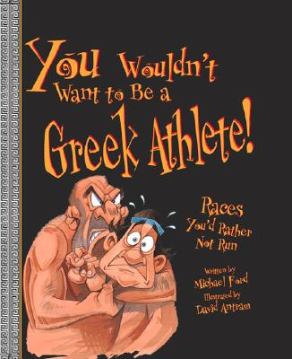  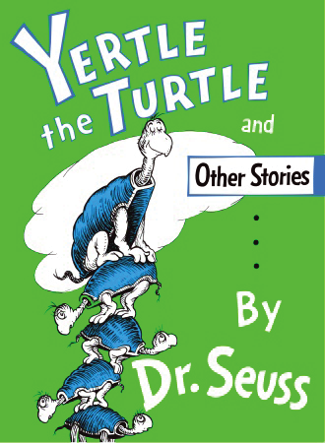  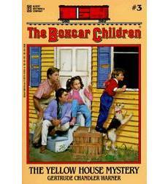  XYZ | AUTHOR | CALL # | READING LEVEL | POINTS
XYZ Back to top
Yankee Doodle | Kellogg, Steven | 782.42 KEL | 3.8 | 2
Yard Sale! | Modarressi, Mitra |  | 2.9 | 2
Year Down Yonder | Peck, Richard | FIC PEC | 4.9 | 9
Year Of Miss Agnes, The CYRM | Hill, Kirkpatrick | FIC HIL | 4.6 | 6
Year Of The Panda, The | Schlein, Miriam |  | 5.3 | 3
Yearling, The | Rawlings, Marjori | FIC RAW | 5.2 | 25
Yellow House Mystery, The (Boxcar) | Warner, Gertrude |  | 3.1 | 7
Yellow Star CYRM | Deedy, Carmen Ag | E DEE | 3.5 | 2
Yertle the Turtle and Other Stories | Seuss, Dr. | E SEU | 3.8 | 3
Yo! Yes? | Raschka, Chris | audio E RAS | 1.2 | 1
Yoko | Wells, Rosemary | E WEL | 2.5 | 2
Yolanda's Genius | Fenner, Carol | FIC FEN | 4.2 | 11
You can't scare me (GooseBumps) | Stine, R. L. | FIC STI | 4.8 | 6
You forgot your skirt, Amelia | Corey, Shana | 305.42 COR | 1.9 | 1
You want women to vote, Lizzie Stan | Fritz, Jean | 324.623 FRI | 6.6 | 5
You wouldn't want … American Colonist! | Morley, Jacqueline | 973.2 MOR | 4.8 | 3
You wouldn't want… American Pioneer! | Morley, Jacqueline | 978 MOR | 4.7 | 3
You wouldn't want … Sir Francis Drake! | Stewart, David | 942.5 STE | 5.6 | 3
You wouldn't want… Mammoth Hunter! | Malam, John | 930.1 MAL | 5.2 | 3
You Wouldn't want …. on the Mayflower! | Cook, Peter | 973.2 COO | 5.9 | 3
You Wouldn't want … a Roman Gladiator! | Malam, John | 796.8 MAL | 4.7 | 3
You wouldn't want to be a Greek Athlete! | Ford, Michael | 796.48 FOR | 5.5 | 3
You wouldn't want sick ..the16thCentury | Senior, Kathryn | 610 SEN | 5.1 | 3
Young Cam Jansen & Lost Tooth | Adler, David A. | FIC ADL | 2.2 | 2
Young Fu of the Upper Yangtze | Foreman, E | FIC FOR | 6.7 | 12
Young man and the sea, The | Philbrick, R | FIC PHI | 4.8 | 13
Young Unicorns, the | L'Engle, M | FIC LEN | 7.1 | 13
Your pet gerbil | Landau, Elaine | 636 LAN | 4.8 | 3
Your Pet Iguana | Landau, Elaine | 597.95 LAN | 4.8 | 3
Your pet tropical fish | Landau, Elaine | 639.3 LAN | 4.8 | 3
Yours Truly, Goldilocks | Ada, Alma | E ADA | 3.5 | 2
Zin! Zin! Zin! A Violin | Moss, Lloyd | audio E MOS | 3.5 | 1
Zombies Don’t Play Soccer (Bailey) | Dadey, Debbie | FIC DAD | 2.6 | 3
Zucchini Warriors, The | Korman, Gordan | FIC KOR | 5.4 | 11

